

User Training Manual – Production Control

Prepared for

**Technica International**

Version: **5.0**

Prepared by:

Mahmoud Karim

Table of Contents

Contents

1. Purpose 3

2. Scope 3

3. Production configuration 3

a. Resource group 3

b. Resources 10

c. Update a general calendar 11

d. Update a Resource Calendar 12

e. Product creation 14

f. Routes 28

g. BOMs 37

h. BOM Tree 40

i. Where used 41

j. The difference between item BOM and production BOM 42

4. Production Processes 45

a. Firming the production order from MRP and processing the production order 45

b. Create a manual production order 76

c. Add BOMs manually or take a copy from the existing BOM 80

d. To edit any BOM for a production order 83

e. Add routes manually or take a copy from existing route. 85

f. Removing an already produced item (Stock adjustment) 87

g. BOM journal for dismantling 88

h. Release Sales order, Packing and containerization 91

i. Returning the unconsumed raw material to the inventory (Transfer journal) 99

5. Revision Cases 101

6. Production control reports and workspaces 102

a. Production floor management 102

b. Productions started 103

c. Current production job 105

d. Delayed production orders 106

e. Cost estimates and costing 108

f. Overview costing report. 109

g. Capacity reservation screen and report. 109

h. Production overview. 110

# Purpose

The purpose of this document is to provide users with practical guidance on managing production processes in Microsoft Dynamics 365 Finance and Operations. It explains how to plan, schedule, release, and track production orders to ensure efficient manufacturing operations, proper resource utilization, and accurate cost control.

# Scope

This training manual covers the core functionalities of the Production Control module, including the creation of production orders, BOM and route usage, material consumption, resource scheduling, production reporting, and cost calculation.

# Production configuration

## Resource group

A resource group is a set of operations resources that represents the granularity at which you want to schedule resources when you use the operations scheduling method. The resource group defines the site, production unit, and warehouse context for operations resources that are assigned to the group.  You don't have to assign the operations resources that you create to a resource group. However, an operations resource must be assigned to a resource group before it can be scheduled to perform work.

1. Navigate to production control > setup > resources> resource groups.

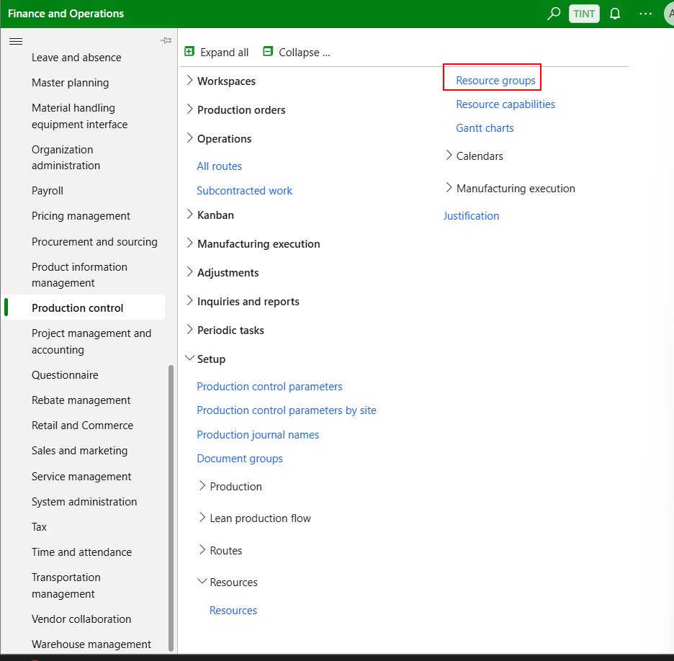

1. Click new to create a new resource group
2. Enter name for the resource group, specify description and select a site

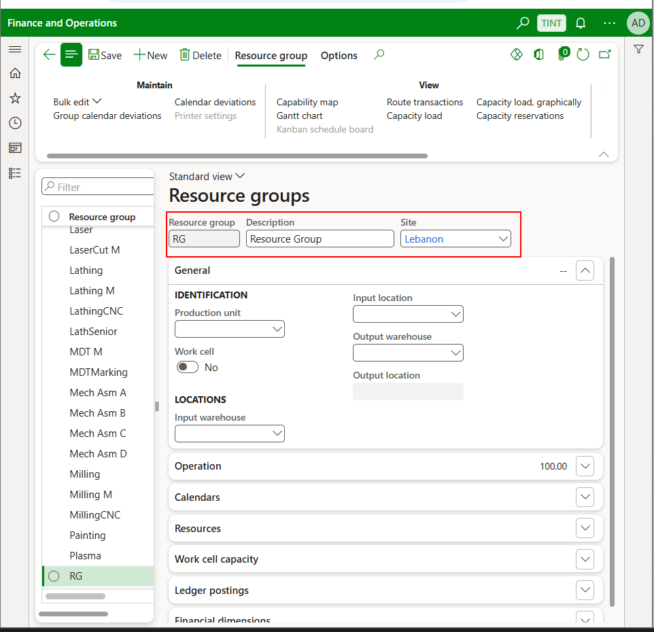

1. You can link it to a production unit

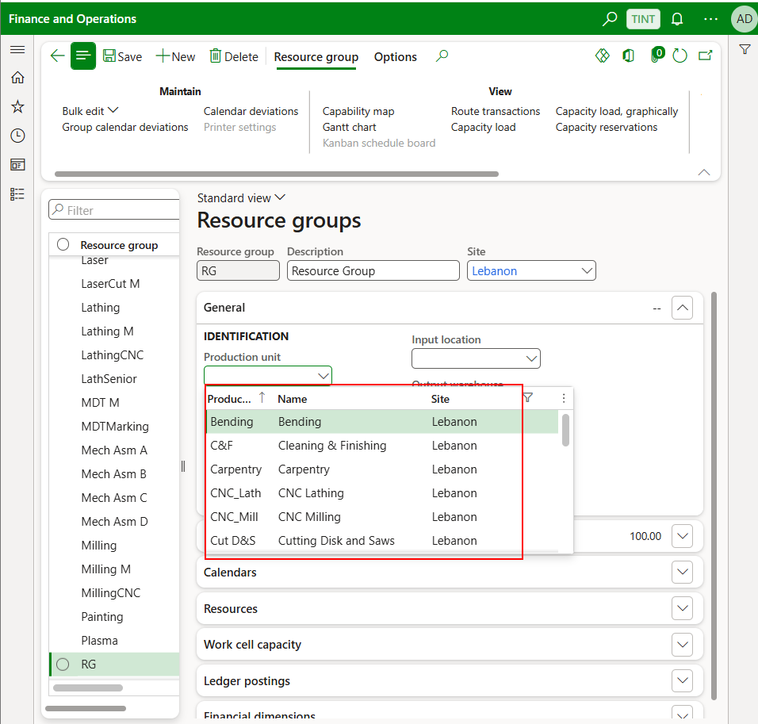

1. You can default the setup category, run time category at this level. The cost categories will be used when adding routes (Explained later in this training manual)

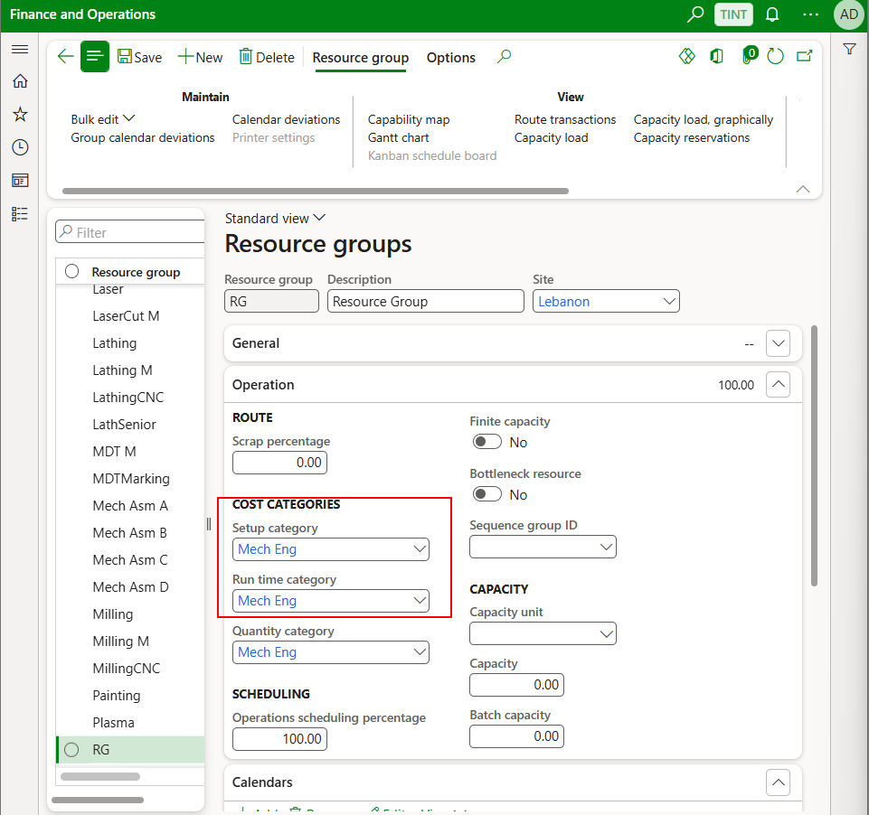

1. Specify a calendar

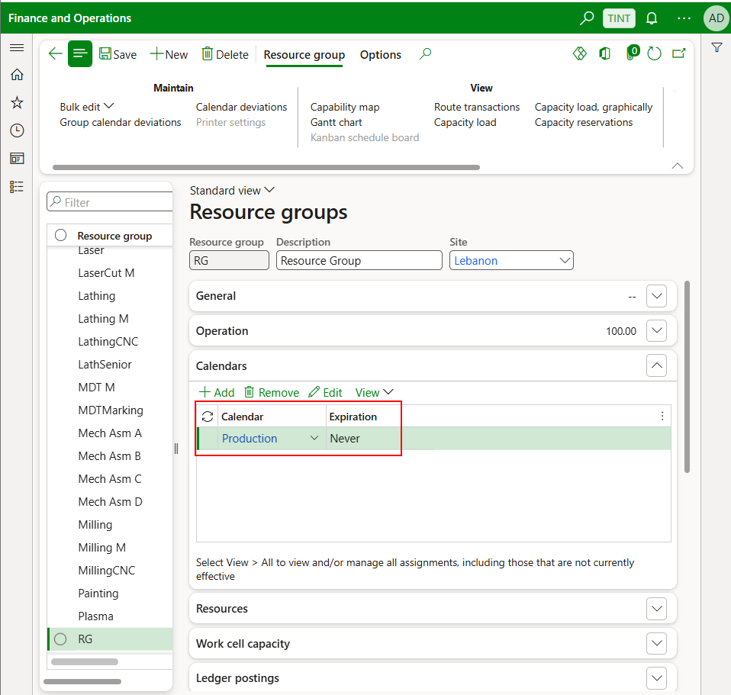

1. Add resources. Resources setup is explained below. When adding a resource, you can specify the expiration of the resource in that resource group. When it expires, the system will not consider that resource when scheduling.

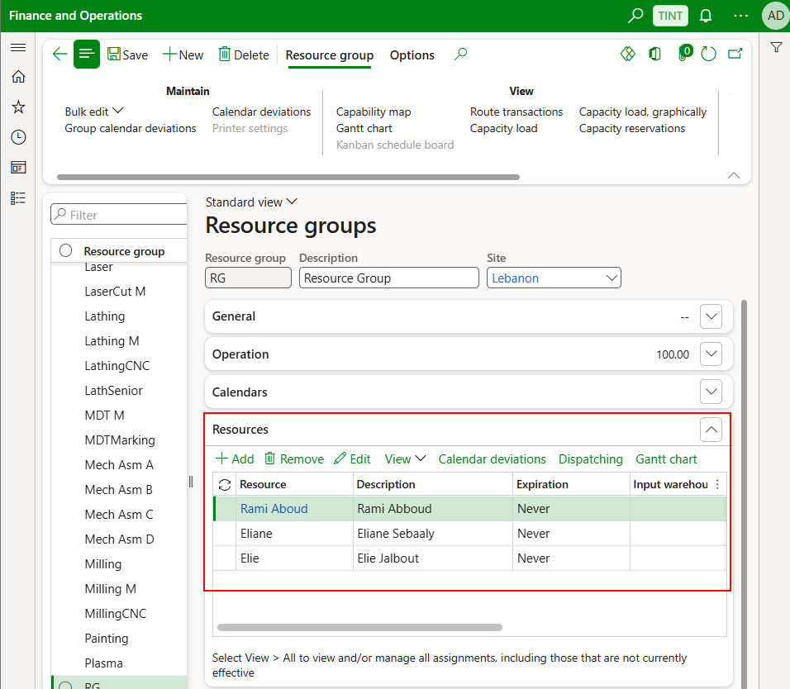

1. Resource group is set up data and rarely modified and added. The ledger postings need to be provided by finance.

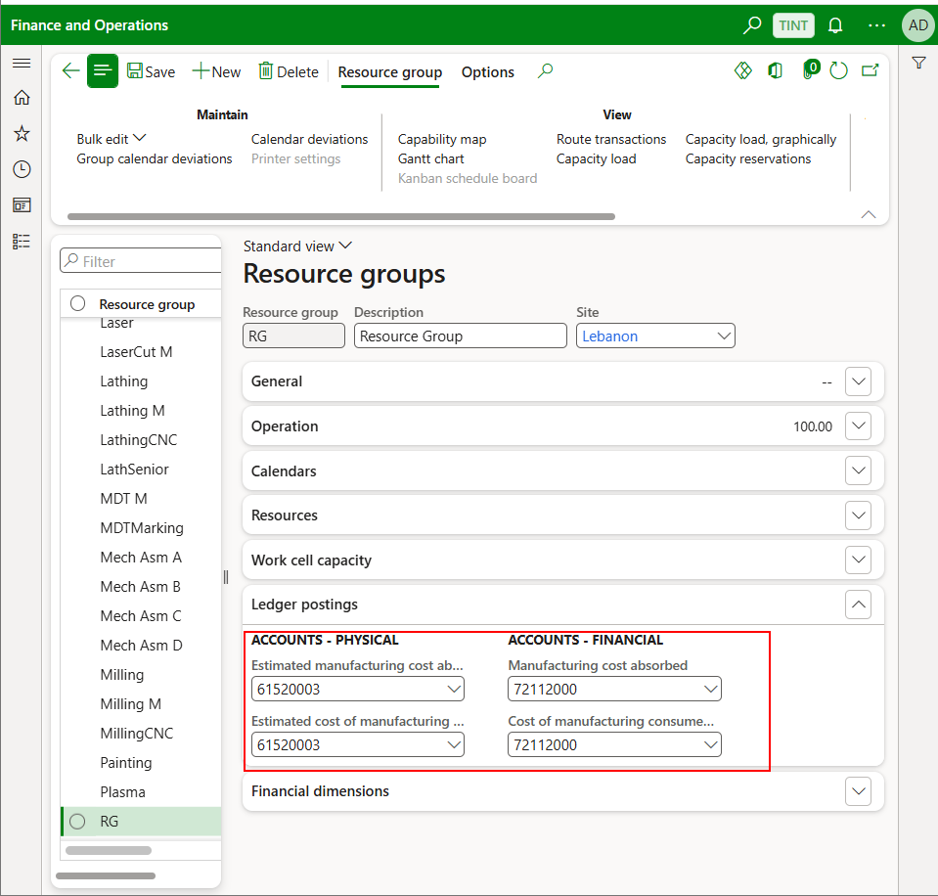

## Resources

Operations resources are the machines, tools, workers, facilities, physical areas, or vendors that perform the activities of a project or a production process. They can be of type:

* + **Vendor**
  + **Human resources**
  + **Machine**

1. Production control > Setup > Resources > Resources

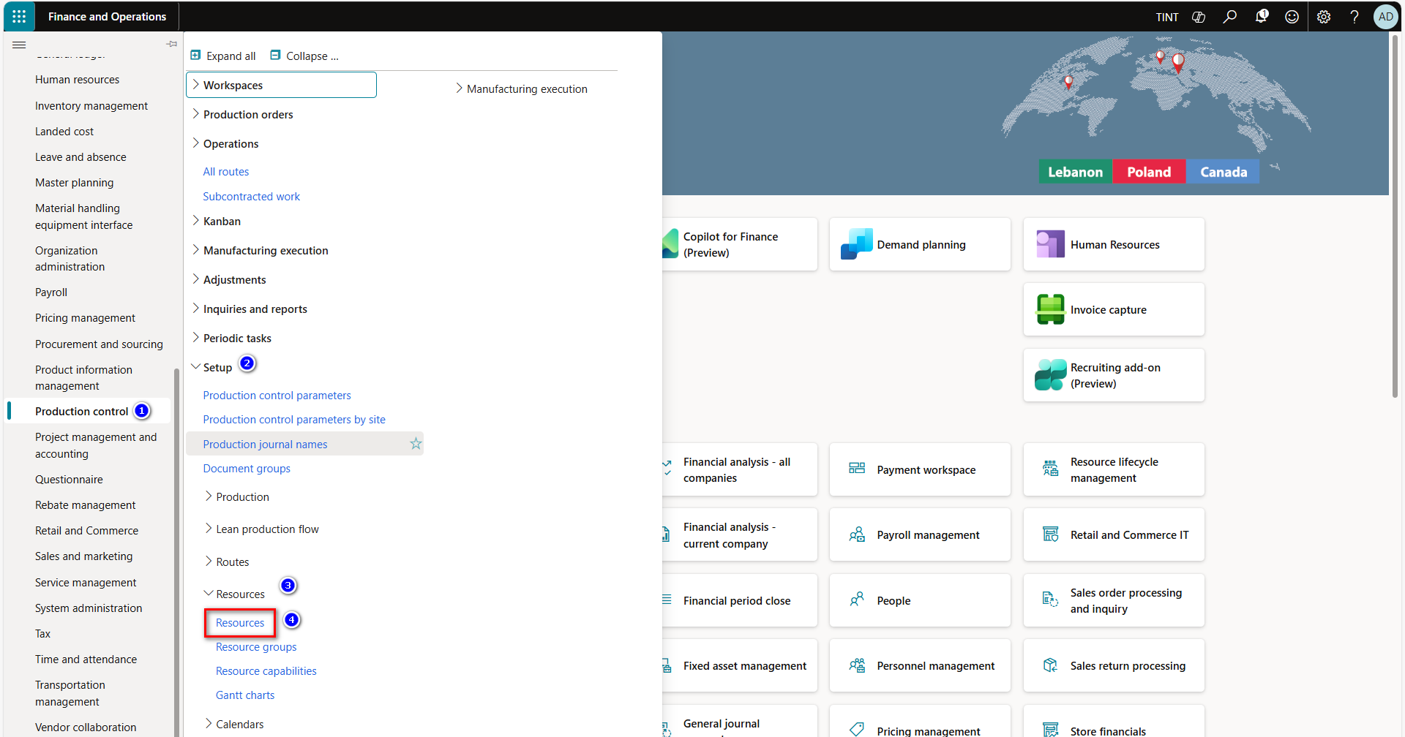

1. Press on new from the top of the screen to create a new resource
2. Provide the resource with a descriptive code & a description
3. Choose the resource type from the following options:

* Machine.
* Human resources.
* Vendor.

1. In the operation fast tab defines some production information related to the resource:
   1. Link the resource to a run time cost category
   2. Define the resource’s run time
   3. Specify the efficiency & operations scheduling percentage of the resource.
   4. Mark the finite capacity checkbox to specify that the resource has limited capability
   5. In the calendars fast tab specify the calendar used by the resource.
   6. Determine working days & working hours.

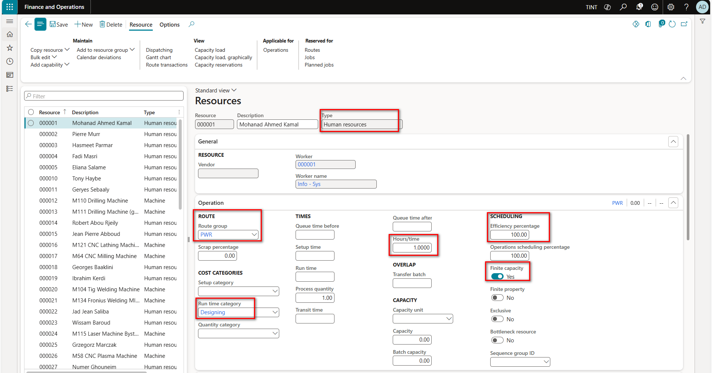

1. In the resource group fast tab, you can link the resource to a resource group
   1. Grouping resources that have similar characteristics (ex. machines & workers).

* Most of the data defined on the resource will be specified on the route operations as resources are shared between multiple routes.

1. In the ledger postings fast tab define the ledger accounts for the estimated & actual direct manufacturing cost.
2. In the financial dimensions fast tab define the mandatory financial dimensions on the resource level.

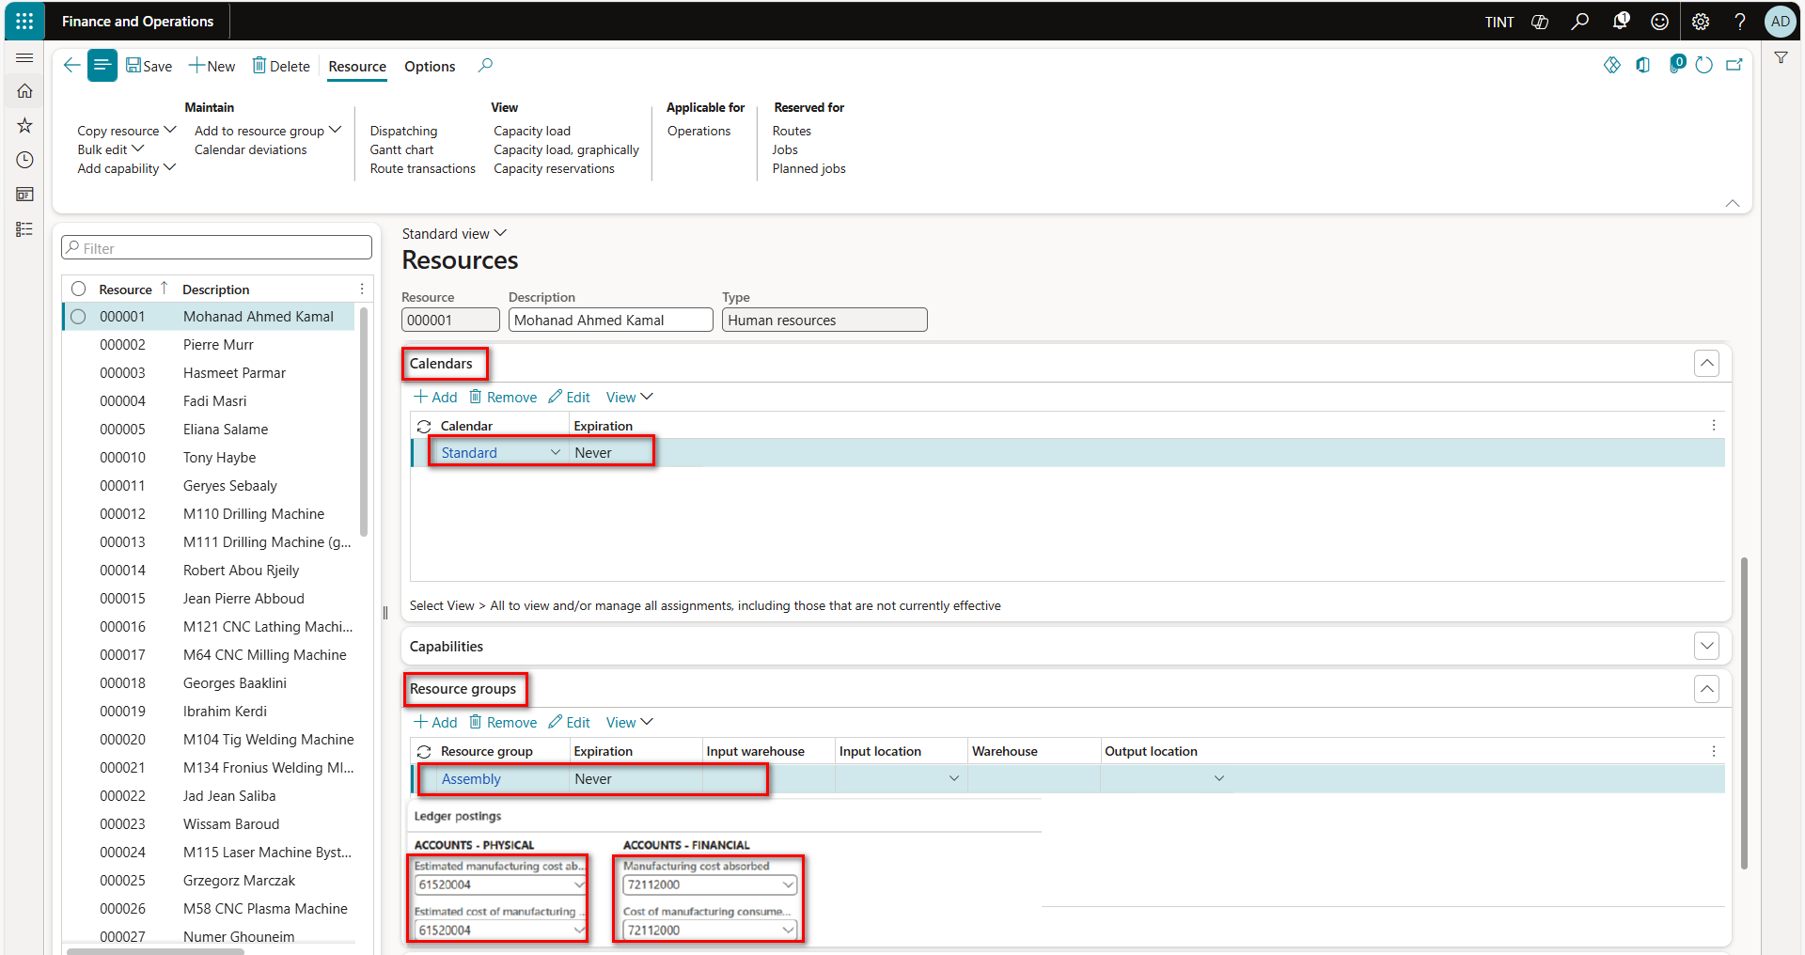

## Update a general calendar

A calendar can be assigned to an operations resource and describes the capacity (in hours) of that resource. The working times of the operations resource are determined by the calendar that is assigned to the resource group that the operations resource is part of. You can set an effective date and an expiration date for the assigned calendar. You can then assign more than one calendar to an operations resource. However, the dates of the assigned calendars can't overlap, and the operations resource can be assigned only one calendar at a time.

* Navigate to Organization Administration > Setup > Calendars, Calendar
* Choose the related Calendar
* Ensure to choose the required date
* Update to closed if needed or Add a new line in the “working times” section

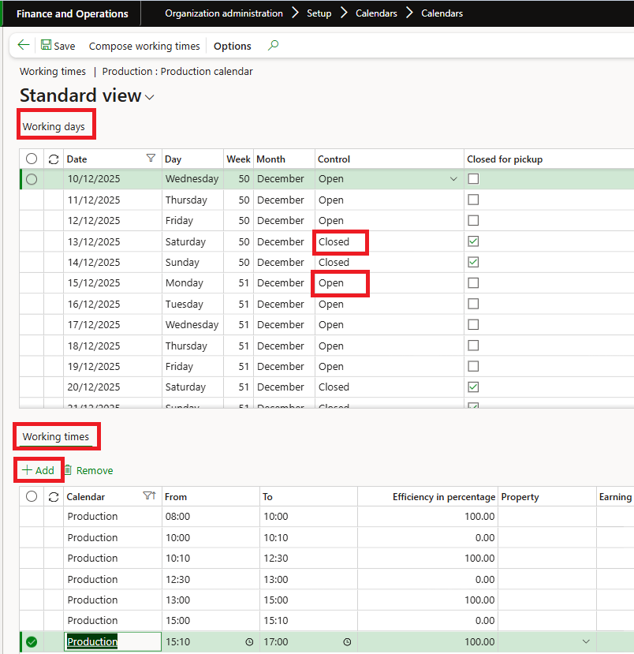

## Update a Resource Calendar

It is also possible to modify the calendar for a specific resource. The resource will have a general calendar like any other resource however if a specific resource has some deviation, it is possible to modify that following the steps below:

Navigate to production control > setup > resources> resources

Select the resource

Under resource > maintain. Select calendar deviation

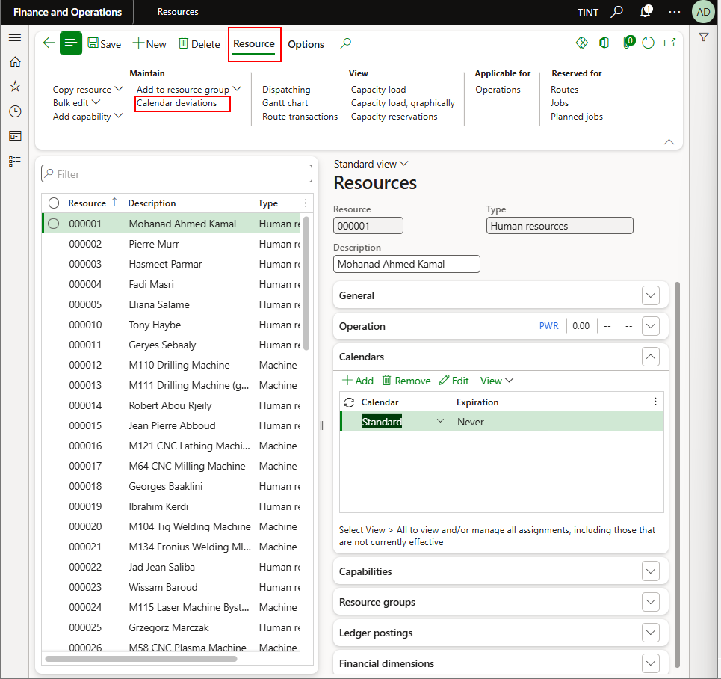

In calendar deviation, you can specify a specific calendar for a specific day for this resource

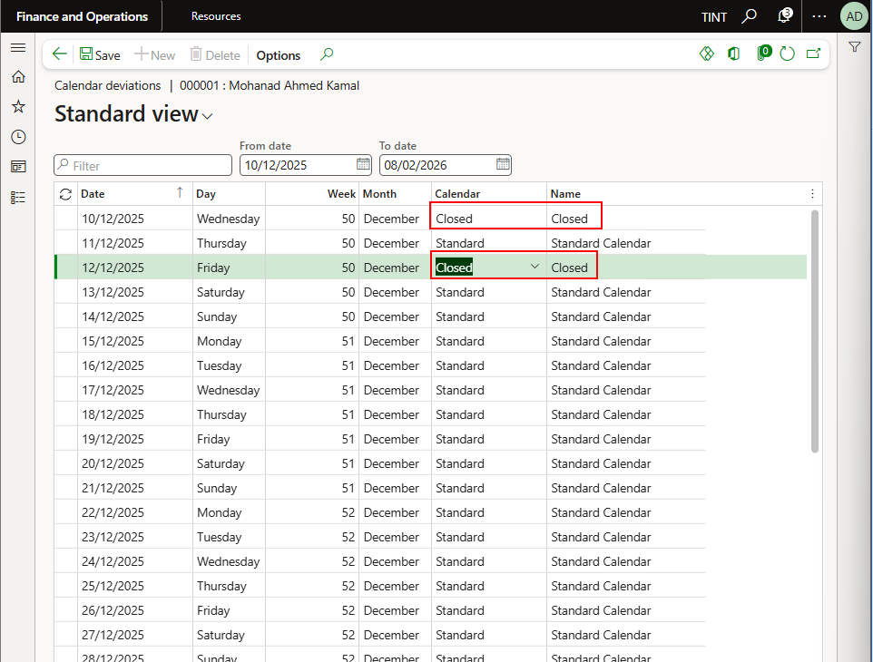

## Product creation

1. Navigate *Product Information Management > Products > Released products*

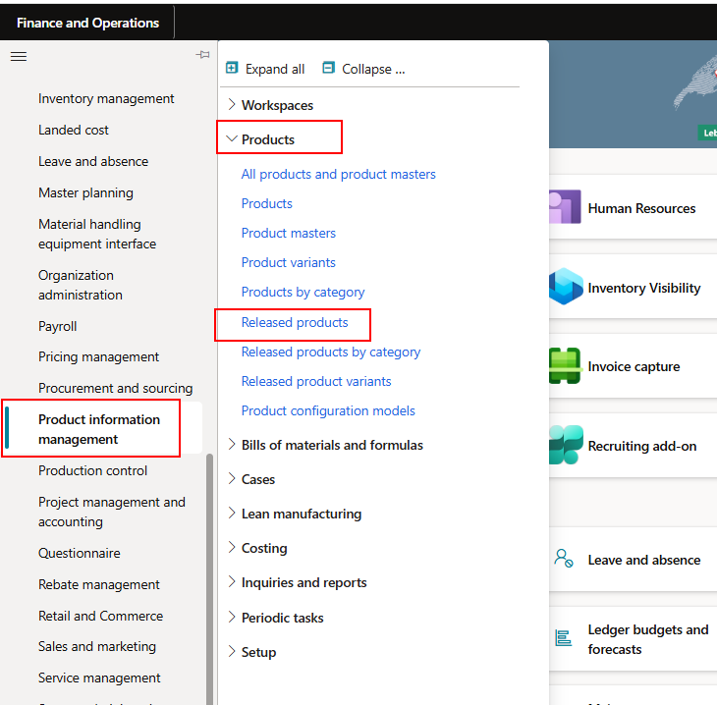

1. Click on New

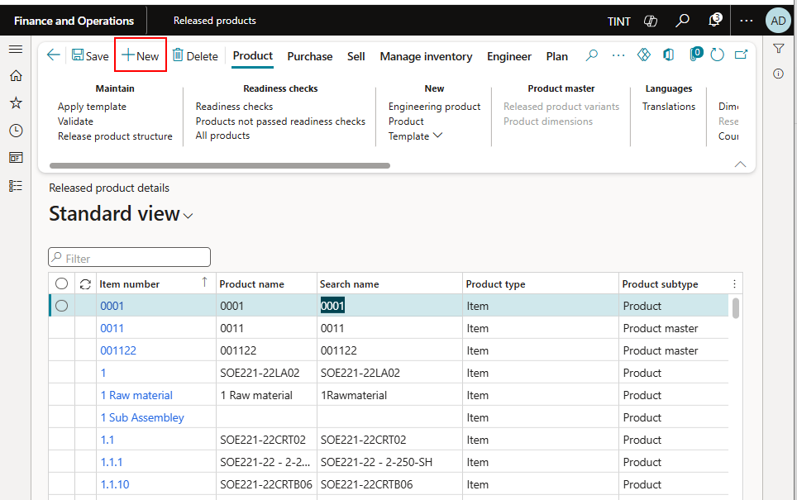

1. Enter the following information

Product type: Item

Product subtype = Product

Product number

Product name

Select an item model group (Weighted average)

Item groups as per the below list:

|  |  |
| --- | --- |
| **Items Code** | **Items Group** |
| CRM | Component & RM |
| SFP | Semi-finished product |
| FIP | Finished Product |
| FAC | Factory Consumables |
| OEM | OEM Equipment |
| INS | Installation |
| PAF | Packing & Freight |
| SER | Services |
| DIG | Digital Services |
| SUB | Subcontracting |

Storage dimension group: Select SiteWHLoc

Specify a reservation hierarchy (Standard)

Specify the unit sequence group ID as the inventory unit

Tracking dimension group: None; Serial might be used in a later stage

Specify inventory unit, purchase unit, sales unit, and BOM unit

Specify the item sales tax group

If there is a specified vendor, specify a vendor

Specify the vendor item number

Specify the purchase price, sales price, inventory price if known.

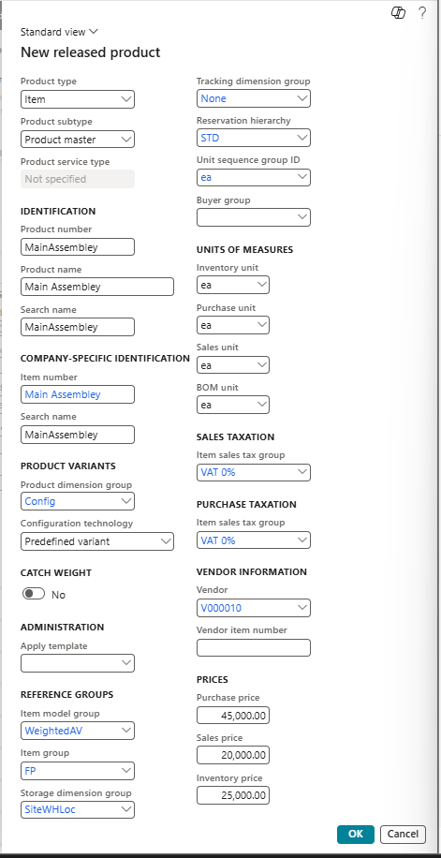

1. Press OK
2. An item record is created

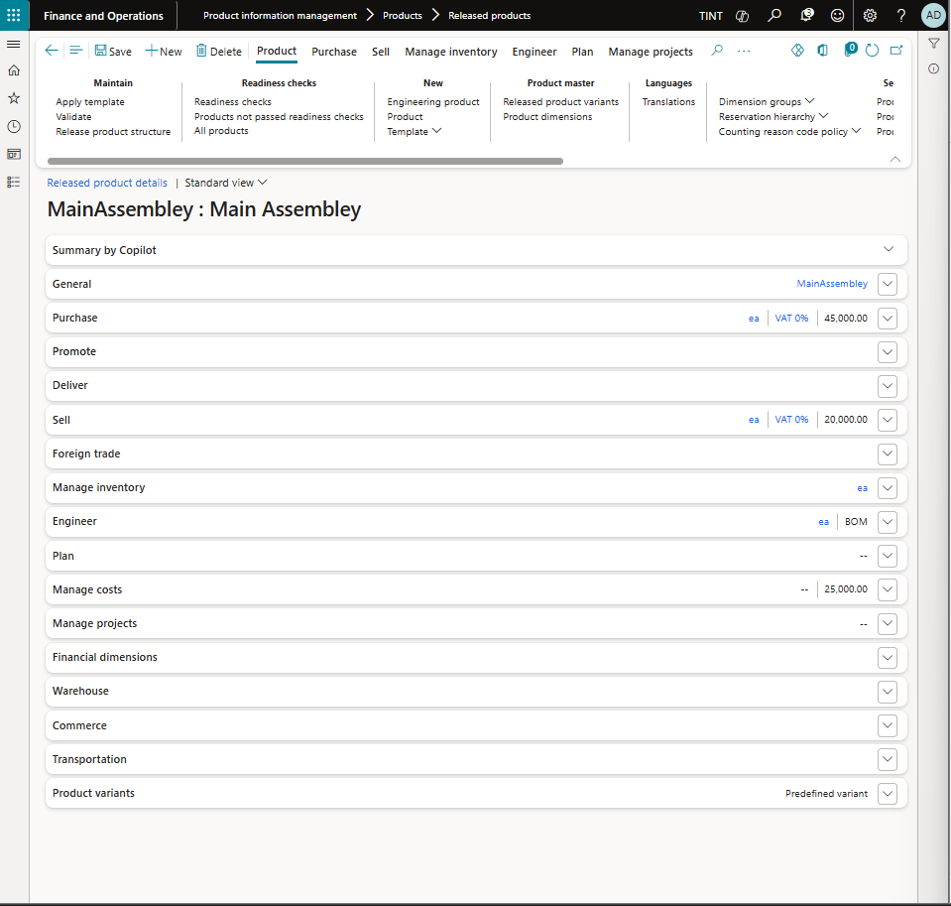

1. Under General, specify a description
   1. Select product number

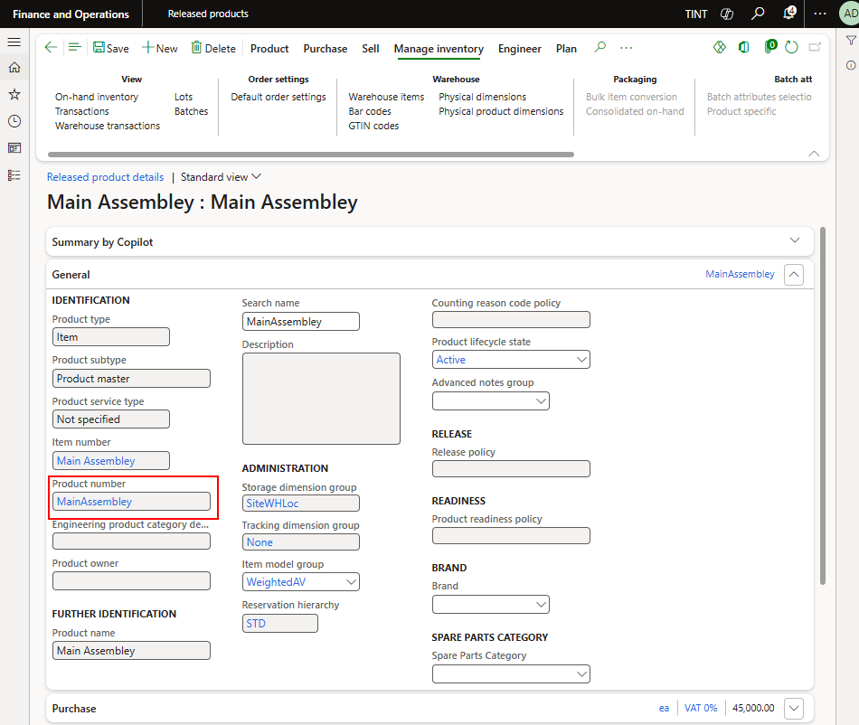

* 1. Enter description

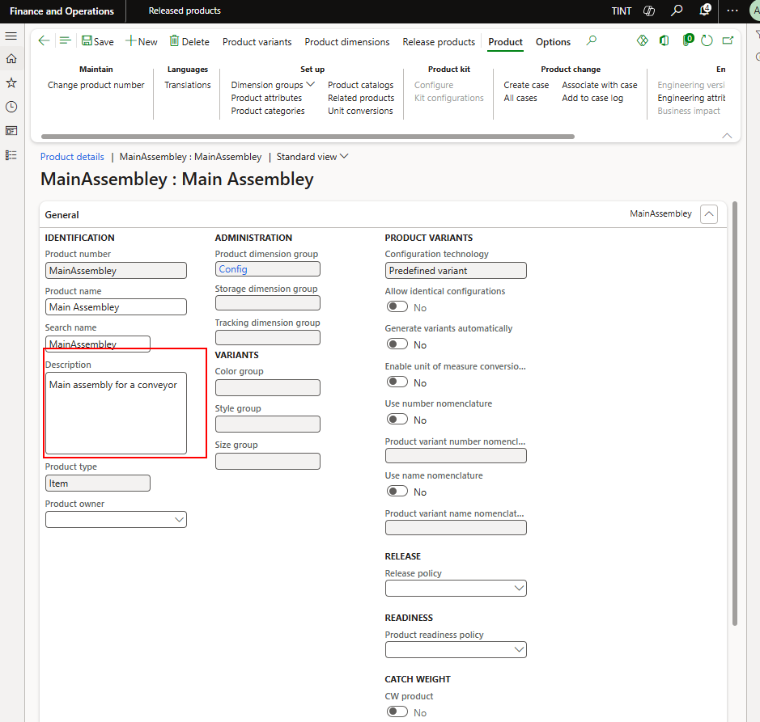

* 1. Go back to the Released product
  2. Refresh

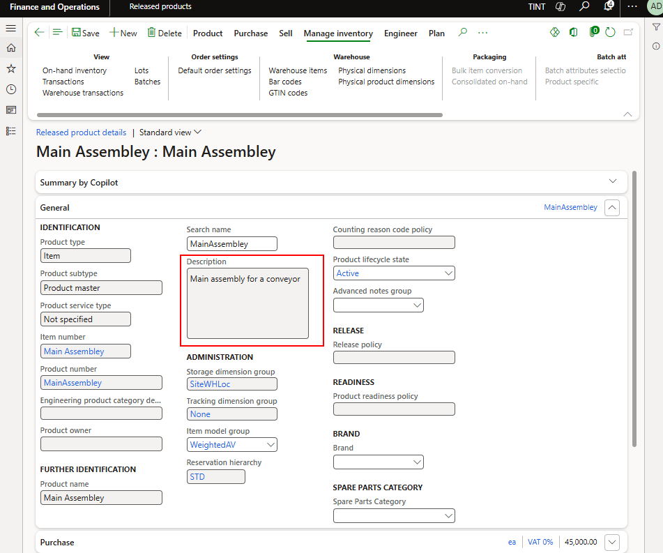

1. Specify the brand

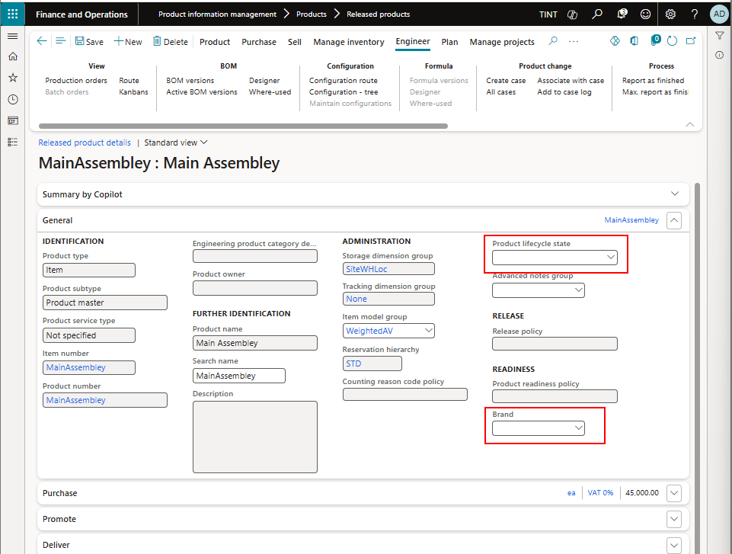

1. Under manage projects, specify a project category for the item- Projitem

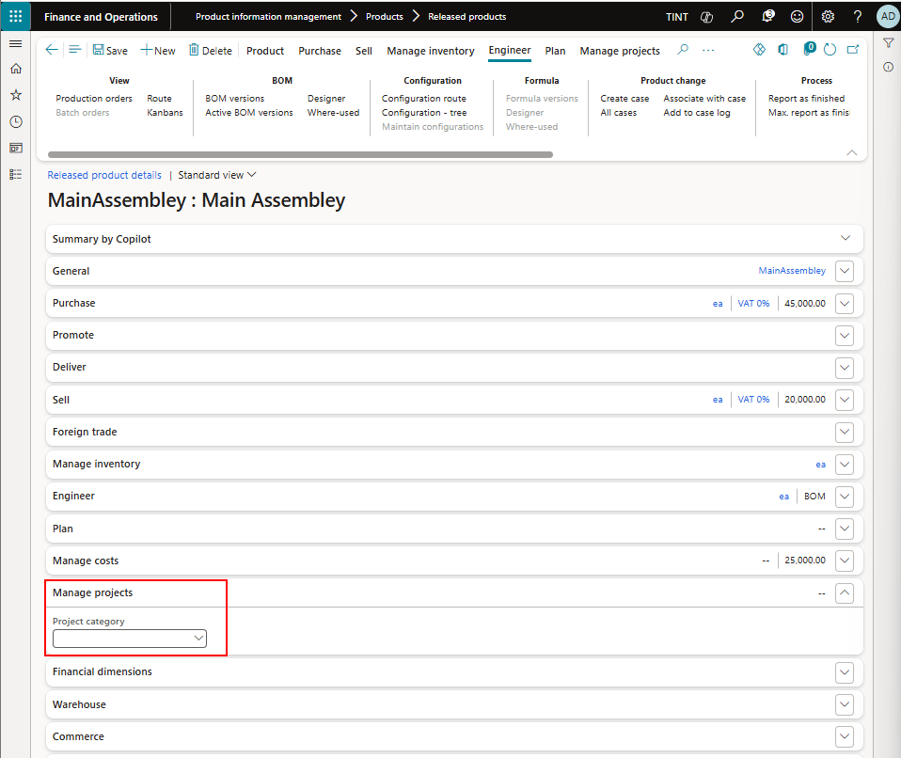

1. Under Plan, specify a coverage group for the item. The coverage group is used by the system to calculate the need for the item based on demand. It should be Require to create a planned order for each requirement needed or it should be minimum/maximum in case a replenishment for stock is needed.

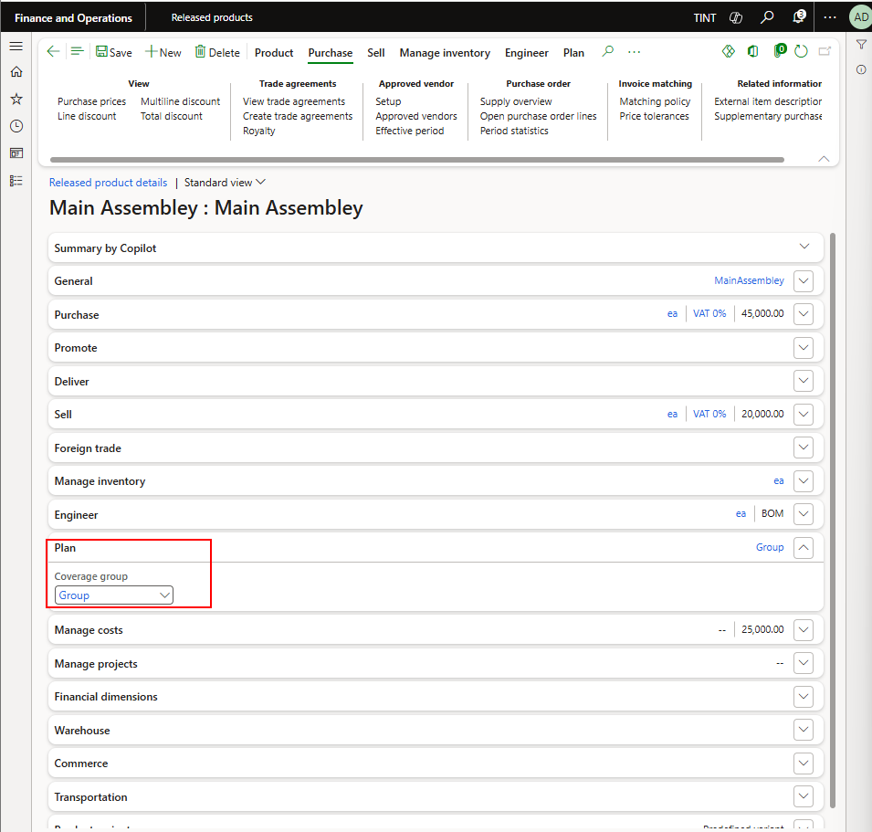

To specify the min/max for the item. Under Plan > Coverage> item coverage

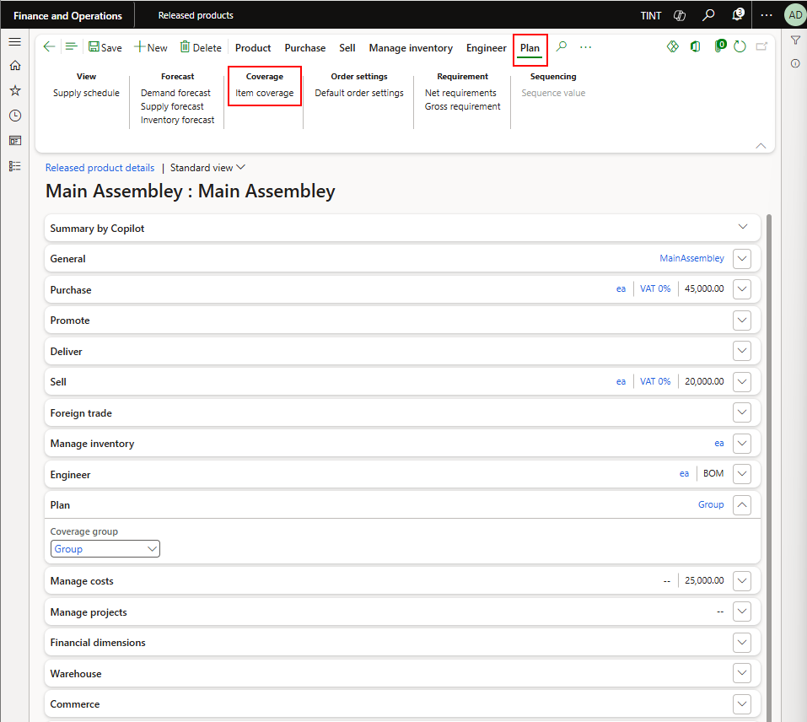

Add New line

Specify site, configuration, warehouse, minimum and maximum

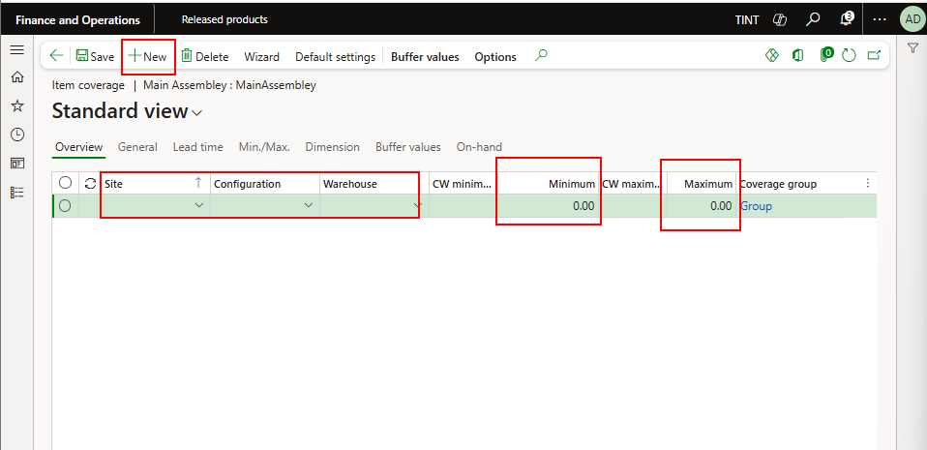

1. Go back
2. Under manage costs > costing. Specify a cost group

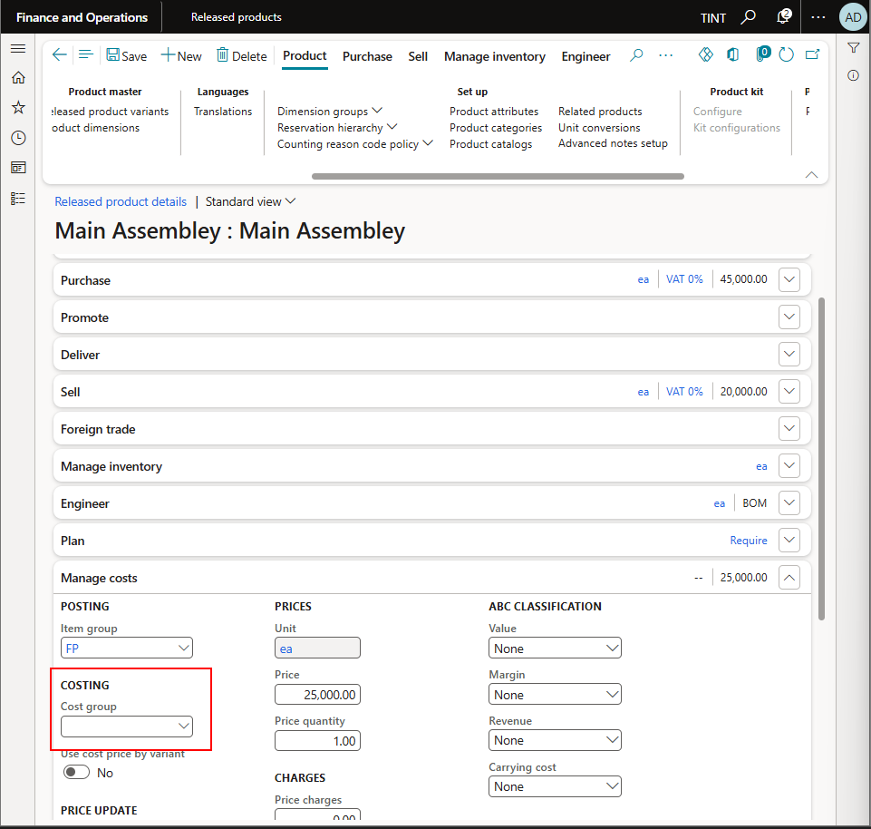

1. Under Product > Setup > Product categories. Specify the categories for the item

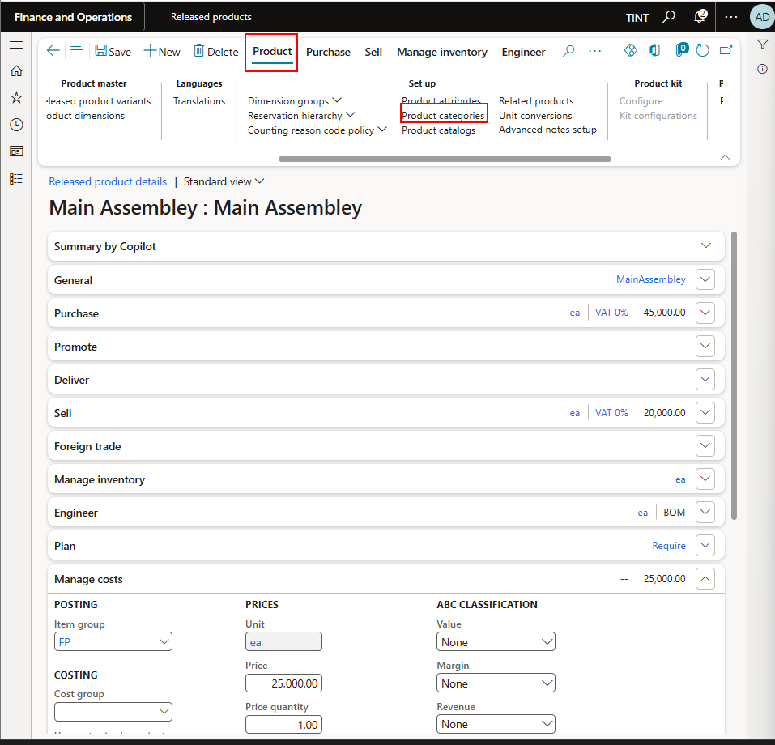

1. Attributes
   1. Under Product > Setup > product attributes. Specify the attributes for the item

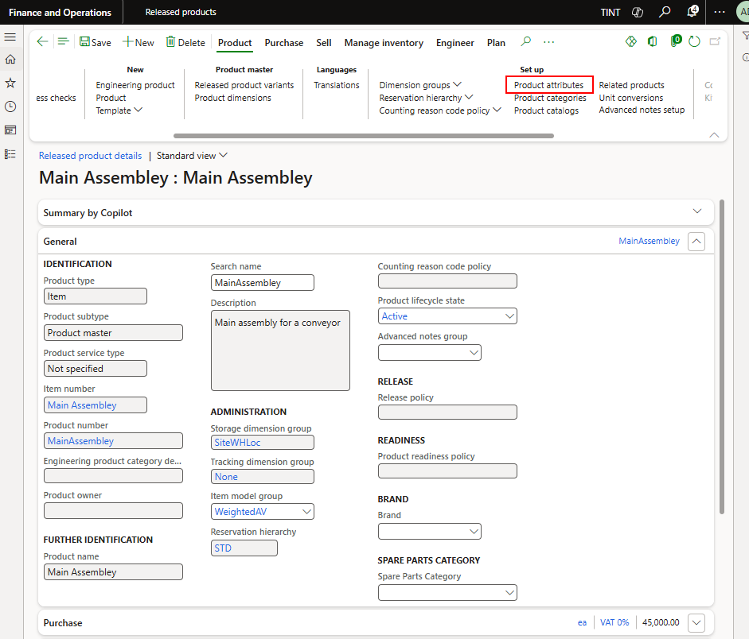

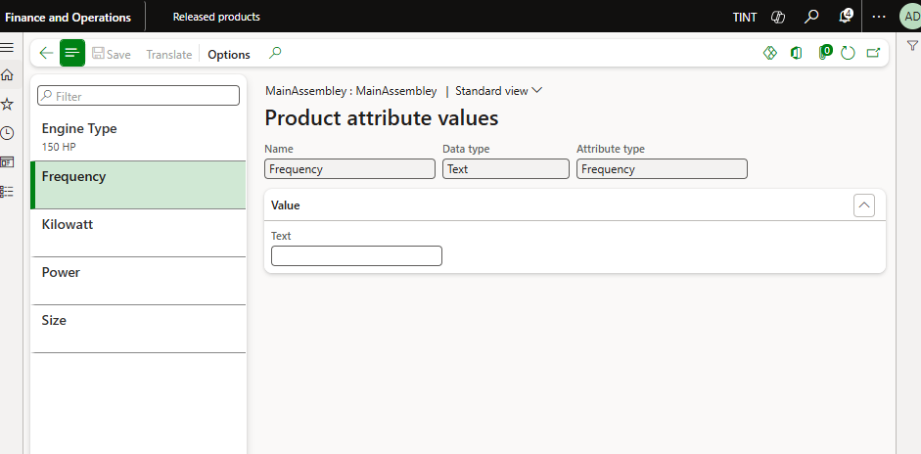

* 1. Create new attribute record
     1. Under product information management > setup > categories and attributes > attributes
     2. Click New

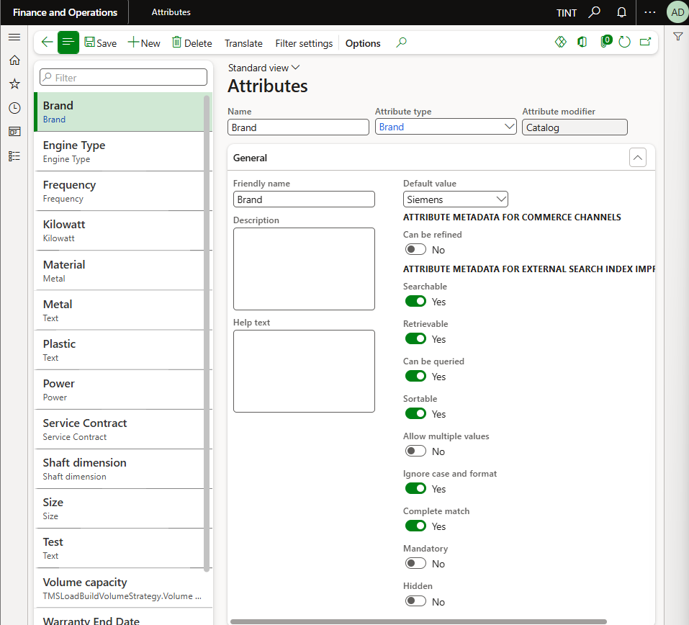

* + 1. Specify the name, attribute type, enter a description if applicable.

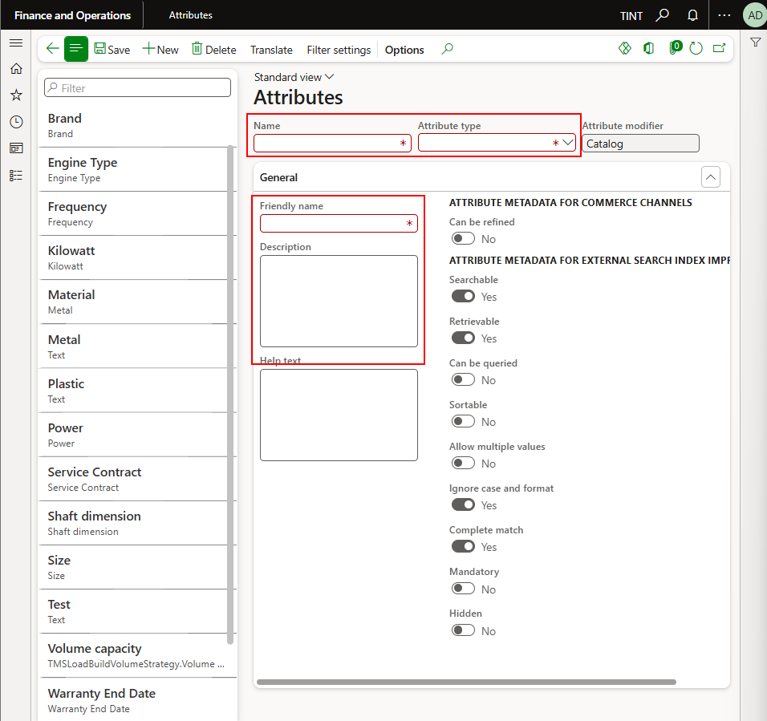

* + 1. Link the attribute to the procurement category

Procurement and sourcing > procurement categories.

Select a procurement category.

Under production attribute

Click New and add the attributes that you want

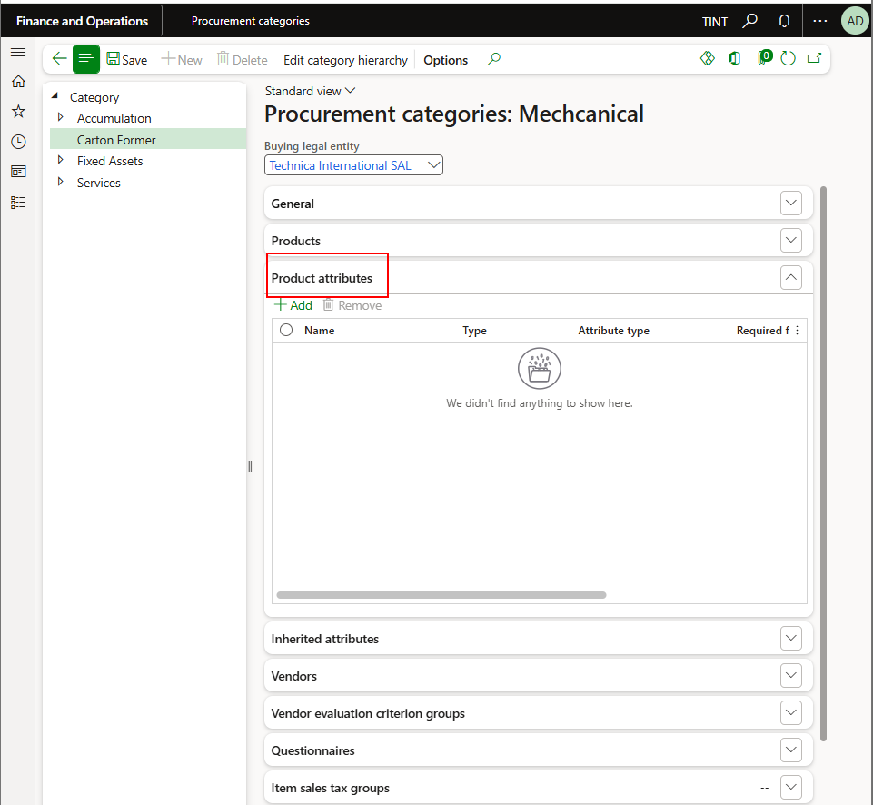

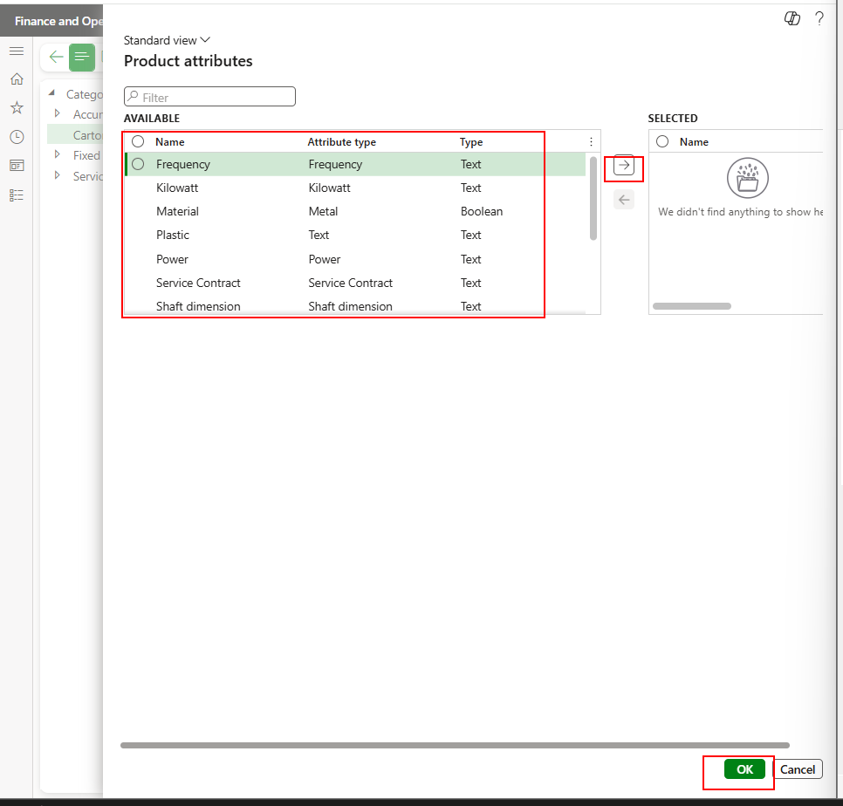

* + 1. When linking the item to the procurement category, the attributes added to the procurement category will show on the level of the item.

1. Select a category hierarchy and a category

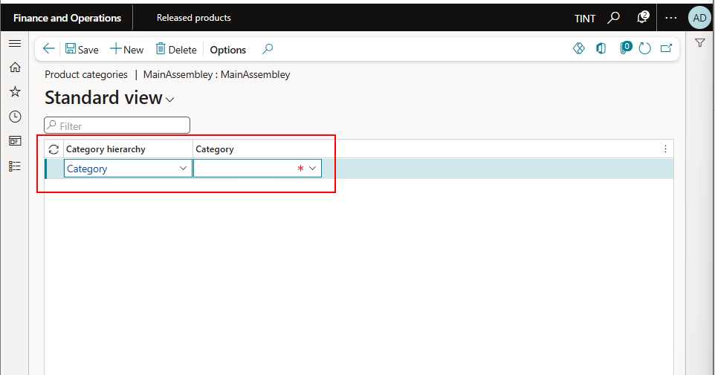

1. Go back to the Released product
2. Under Product > Product Master > Product dimension, specify the configuration

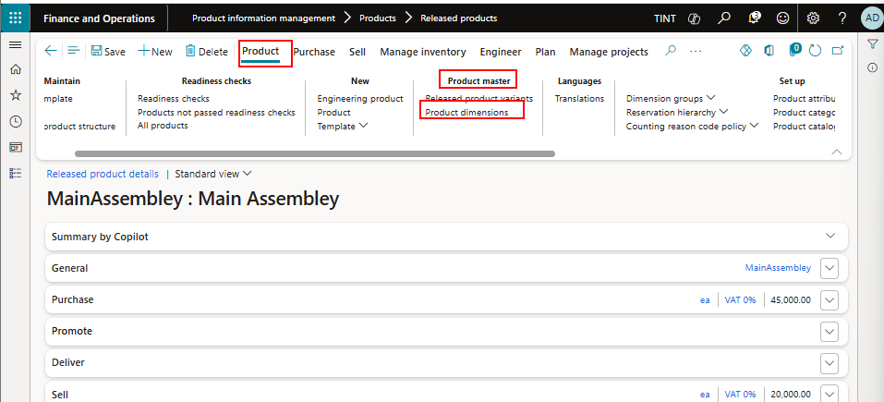

Click New and add a configuration

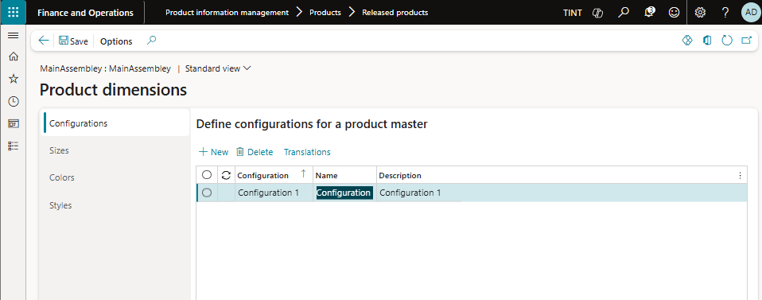

1. Go Back to the Released product
2. Under product > product master > Released product variants, Add new and fill the product name and configuration.

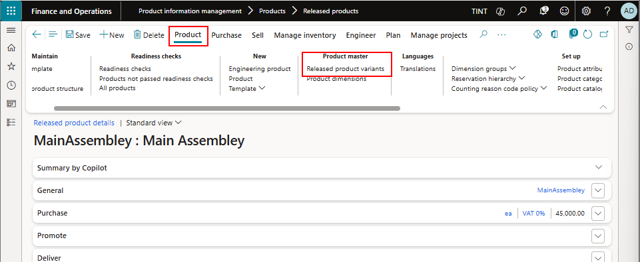

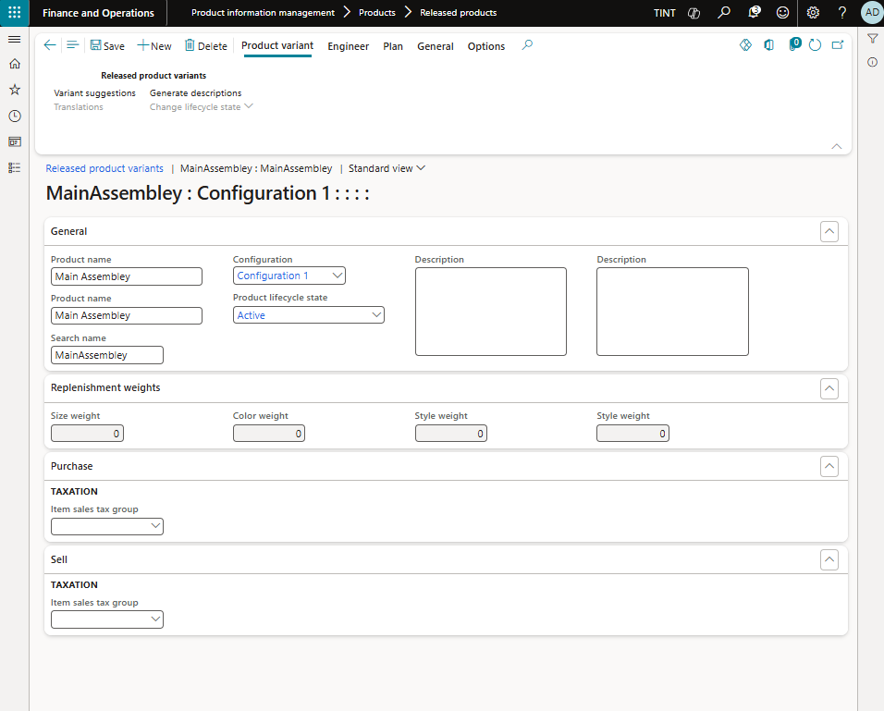

1. Go back to the Released product
2. Under Manage inventory > Order settings > Default order settings. Specify if the item is purchased or produced and specify the default site and warehouse for purchase, sales, and inventory orders. The default site is Lebanon and the default warehouse is Main.

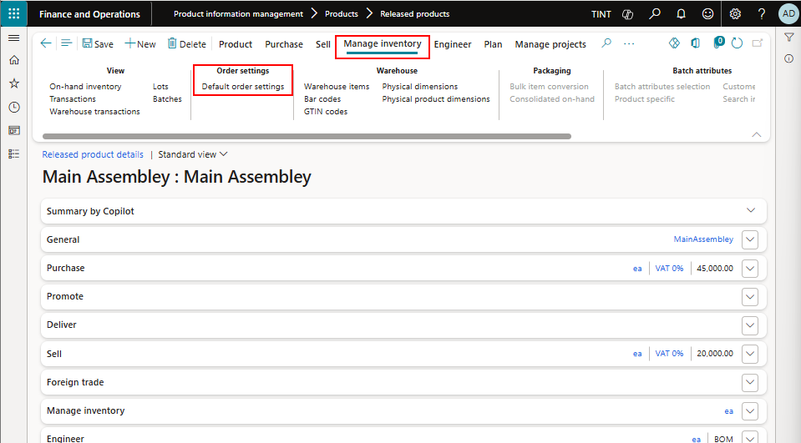

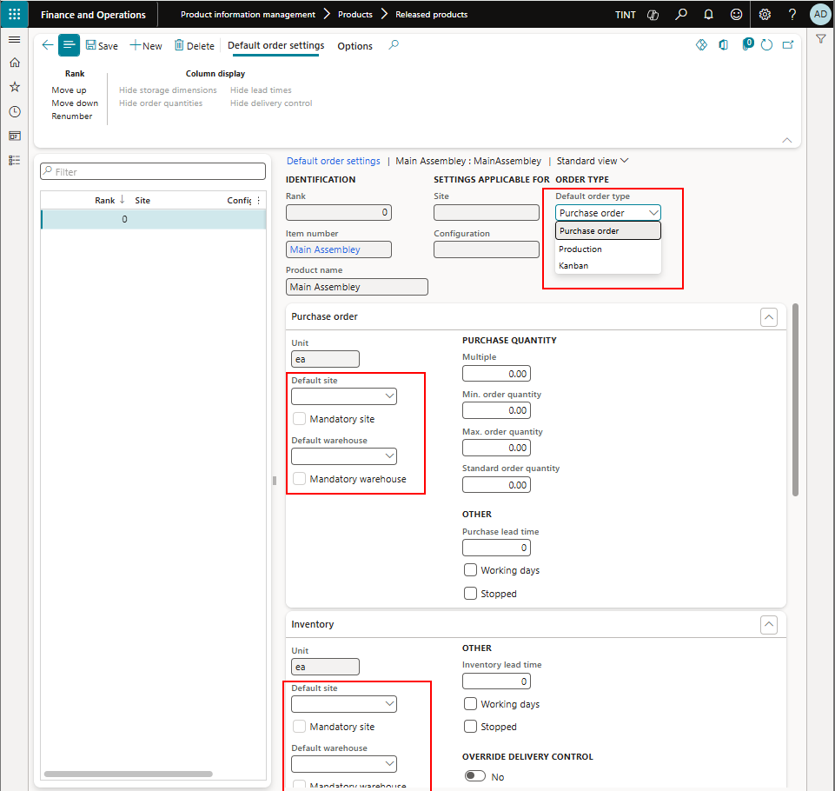

## Routes

* A **route** describes the **order of operations** that is required to produce a product
* For each operation, the route also defines the **operations resources** that are required, **the time that is required** to set up and perform the operation, and how the cost should be calculated.
* The **same route** can be used to produce **multiple products**
* Navigate to Production control > all routes

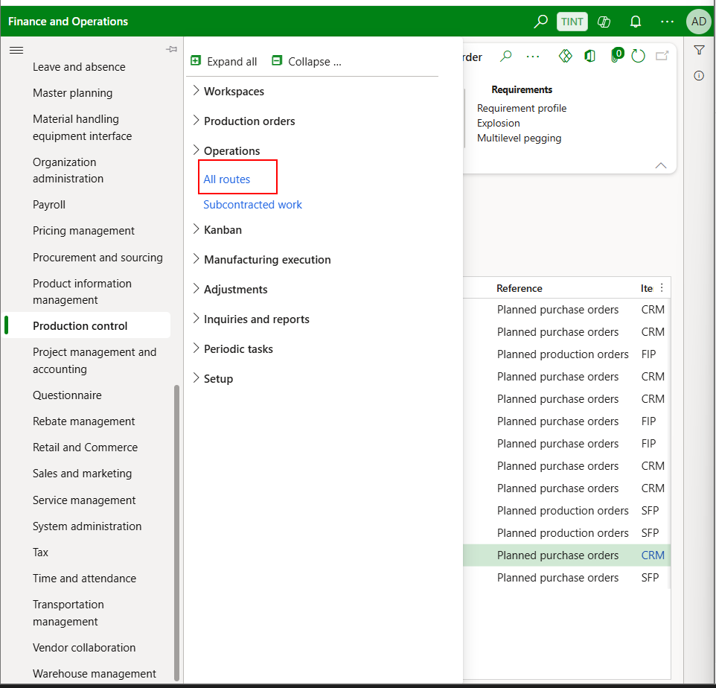

* Click on New

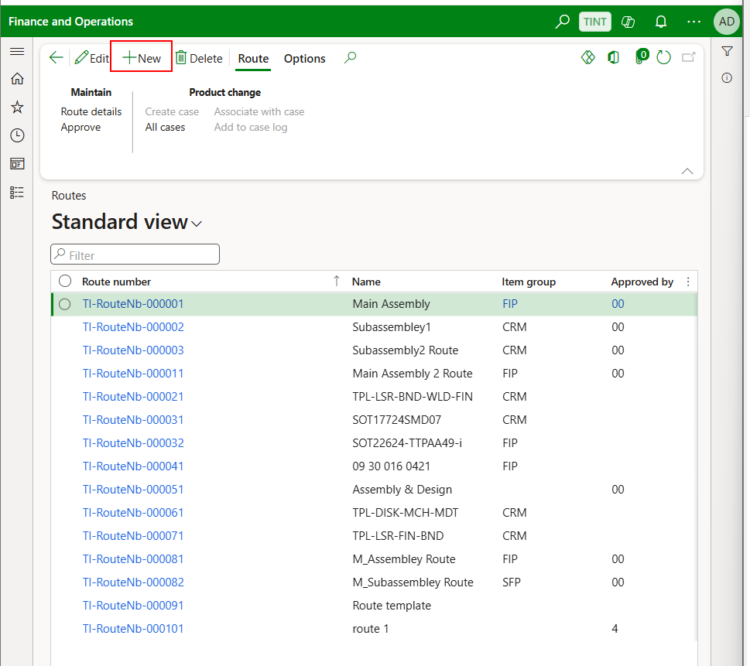

* A number will be automatically assigned to the route. Enter a name and item group

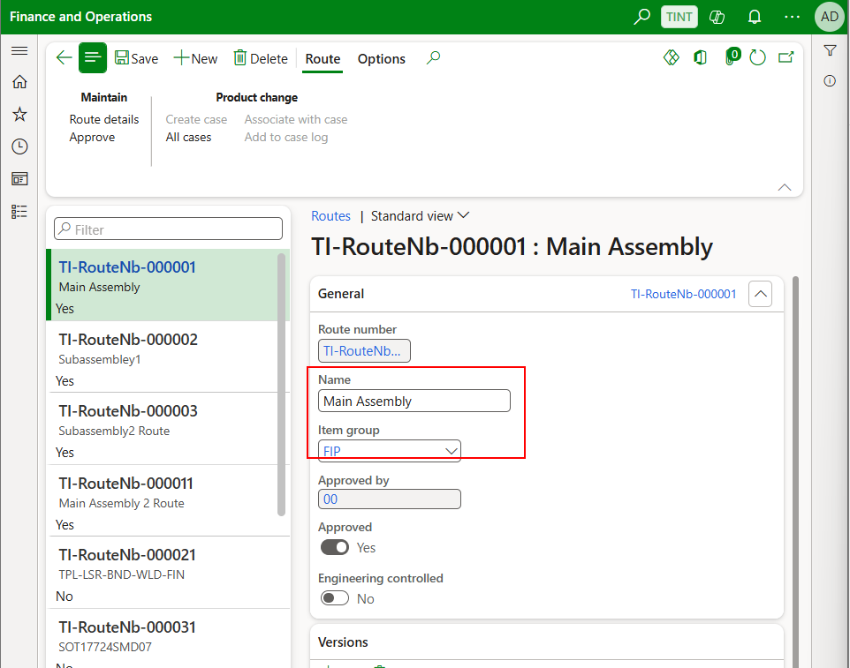

* Under Maintain > Route details. You can add the sequence for the operations, add the resource requirements, and add times.

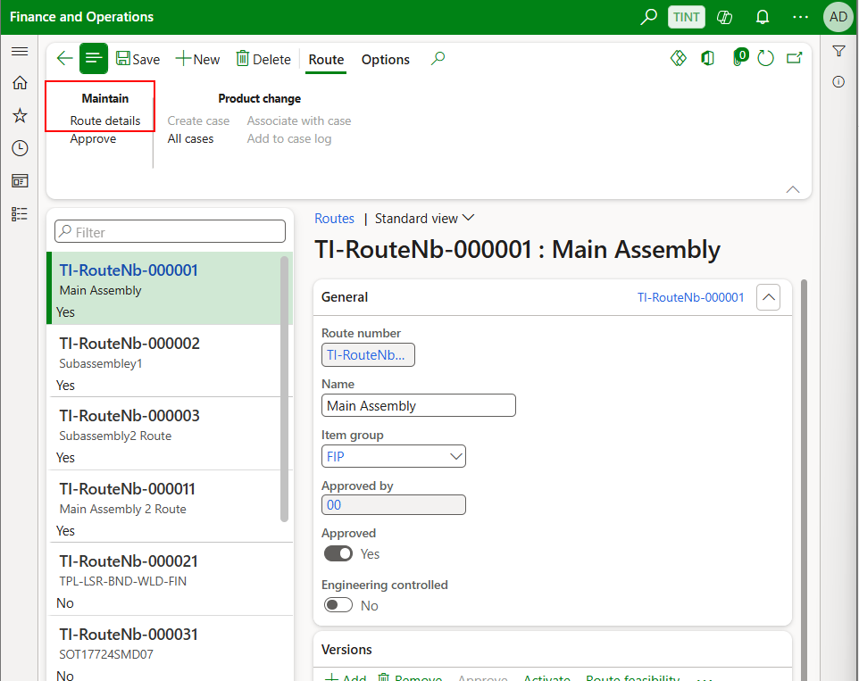

* Click on New to add an operation. Enter Operation number, priority and operation name. Specify Next operation to create the sequence.

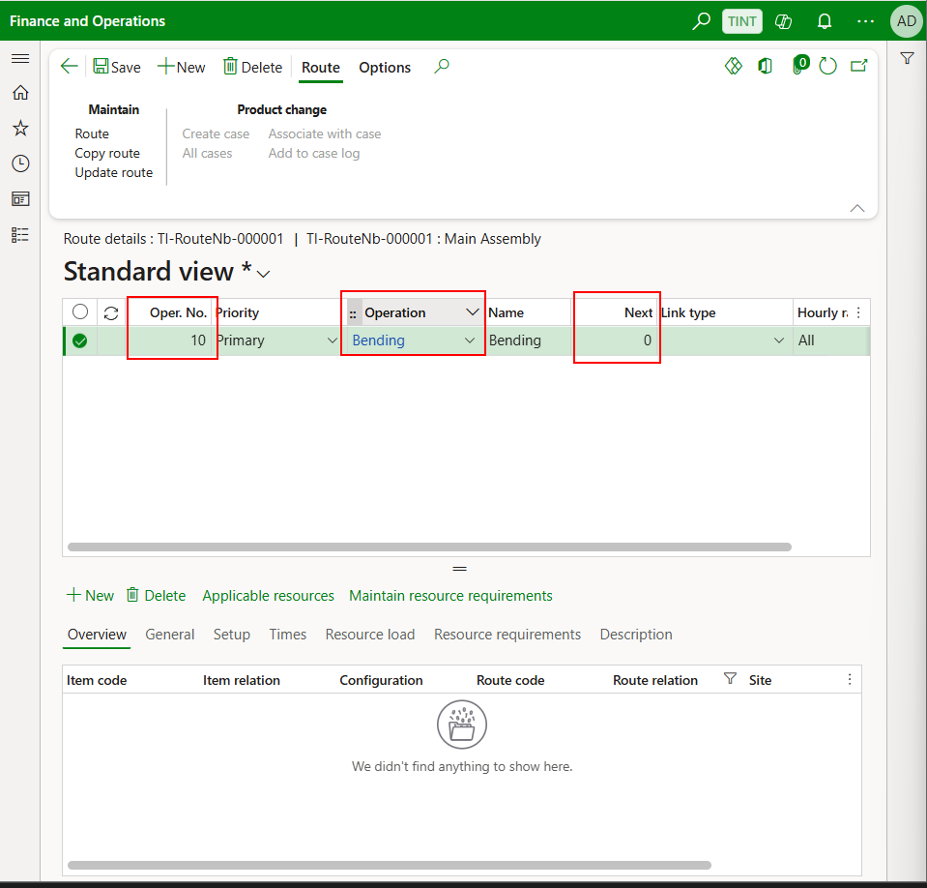

* After an operation is added, select new under the table to add times, categories, and resource requirements. Each will be explained below.

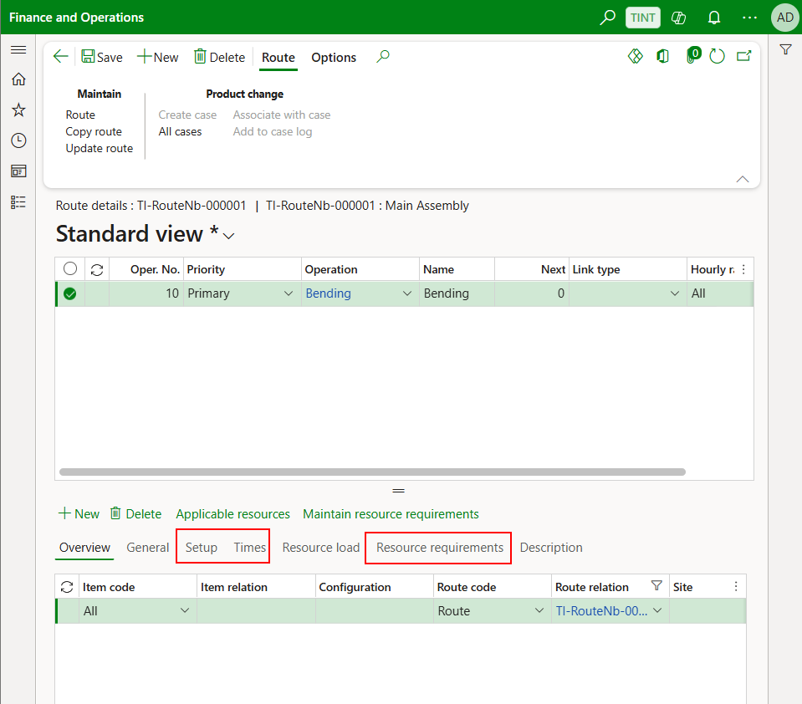

* Under general, specify the route group. The route group specifies the common attributes if the operations such as what times to be considered ( The run time only, the run time and setup time, a and so on)

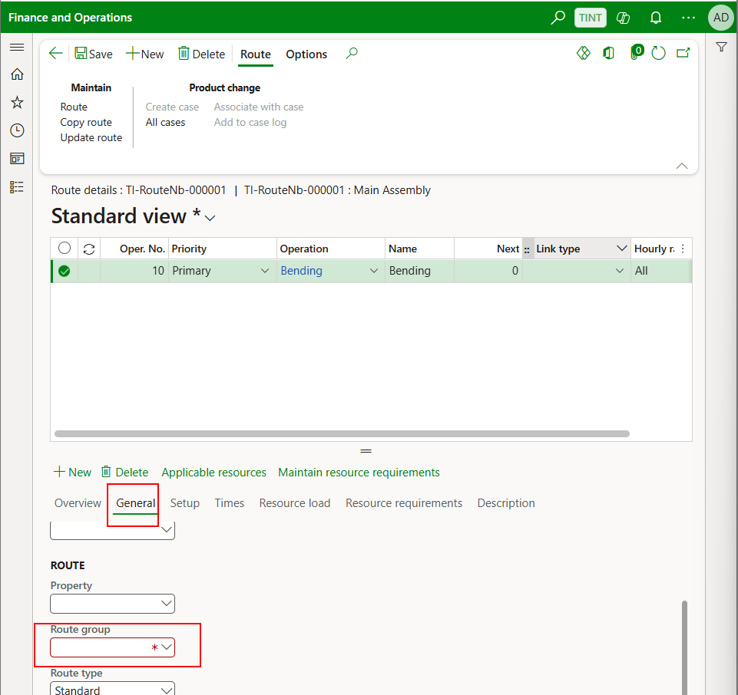

* Under setup, specify the cost categories (Setup category and the run category). These categories will be used to calculate the actual cost for the operation upon ending the production order.

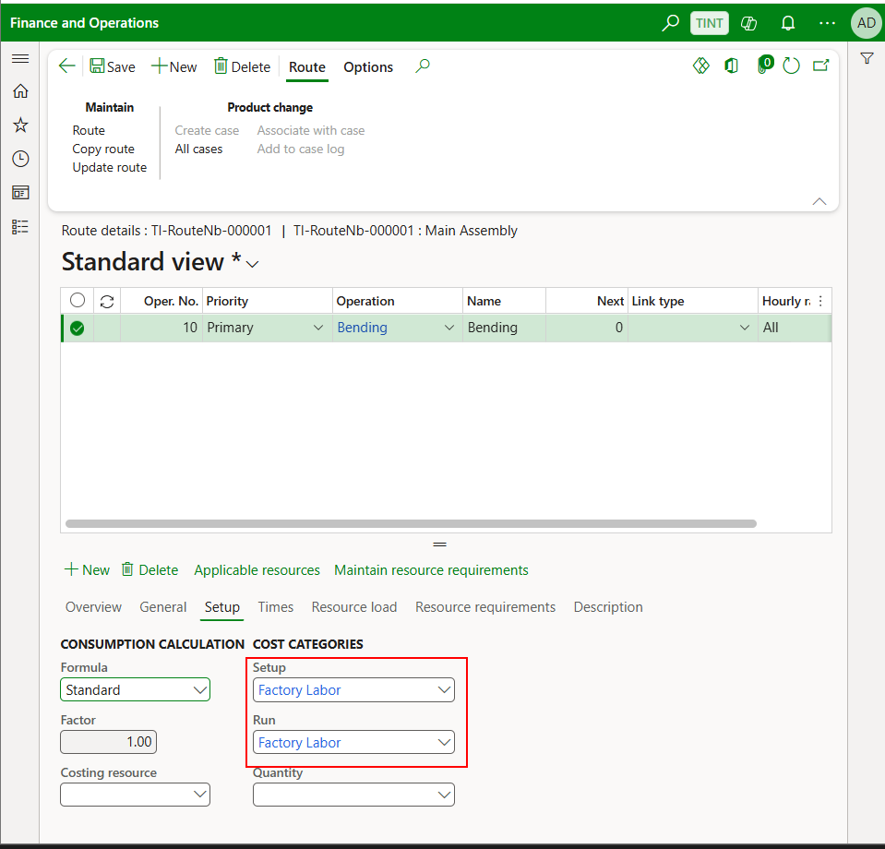

* Under times, specify the setup time and the run time for the operation. This is used to keep track and to schedule the production order related to this route.

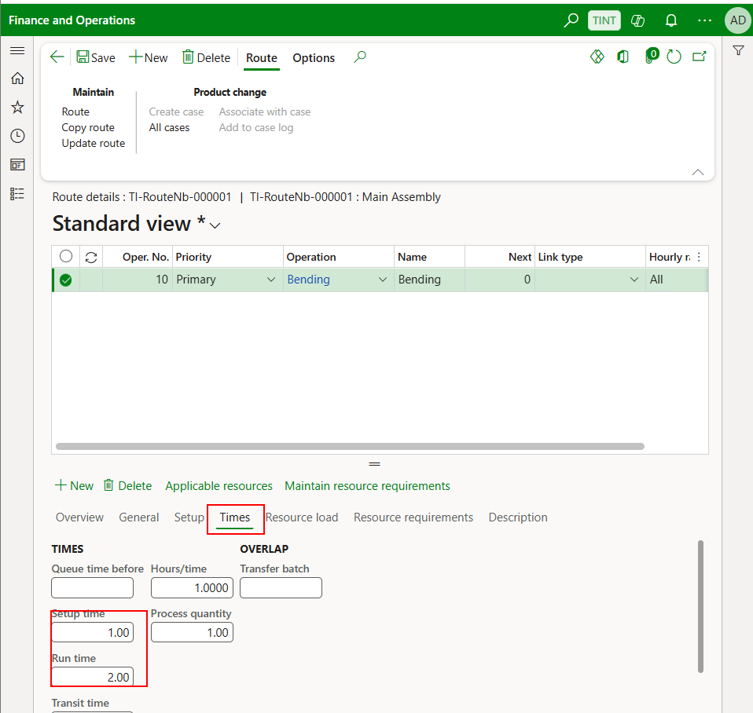

* Under resource requirements, click on new and specify the applicable resource. The field can be a specific resource, resource group (the most used type), resource type (machine or labor). It is important to note that you can only schedule one resource per operation.

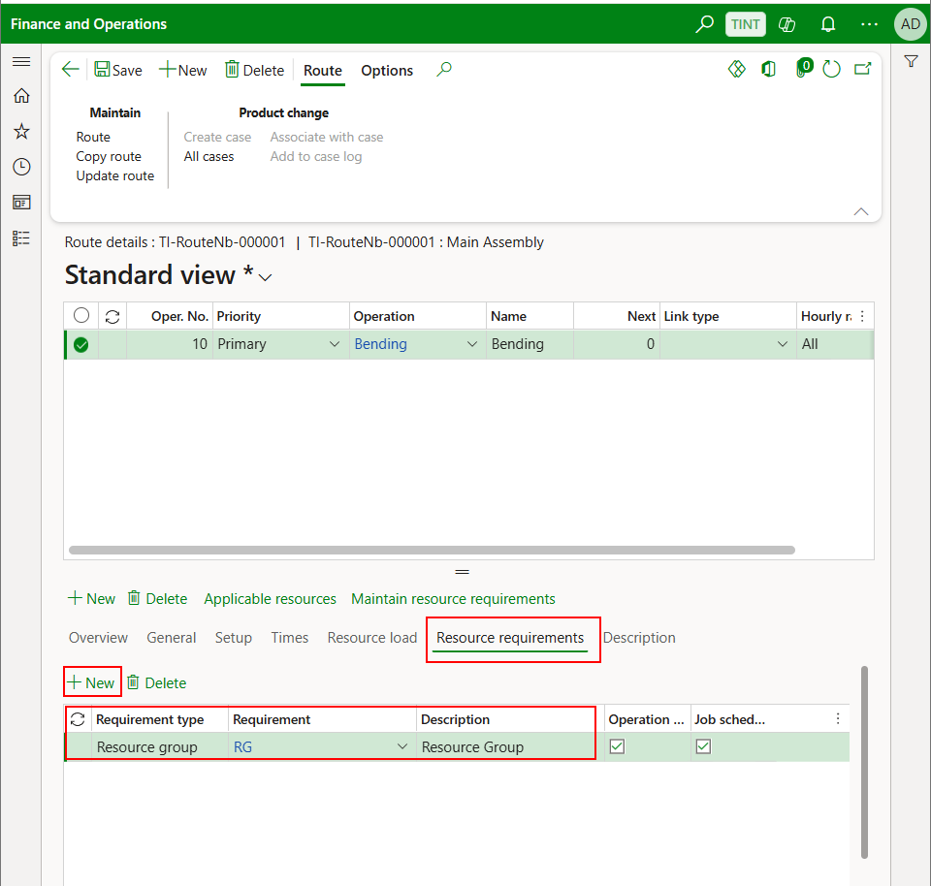

* To add a simultaneous operation, you need to give the operation the same number as the one running in parallel and to select secondary 1 as a priority. Please note that you need to add a different operation (for example BendingSec in the screenshot). If adding the same operation as the primary, the system will see it as duplicated and will give an error. The times for the secondary operations are the same as the primary so it is better to put the bottleneck operation as the primary since the time of the primary will be used in scheduling.

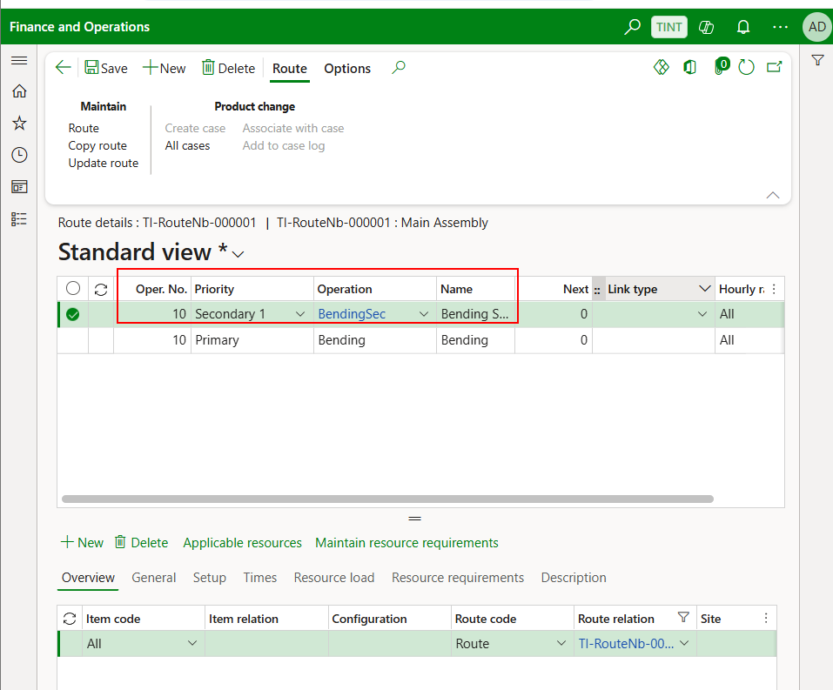

* Go back
* Under Route > Maintain. Click on Approve. This approval is for the route only meaning that this is the correct sequence, correct resources and the correct times for the specified operations.

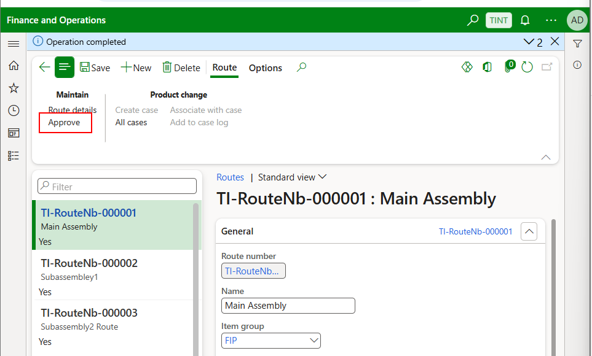

* Under versions, specify the item number, configuration and site

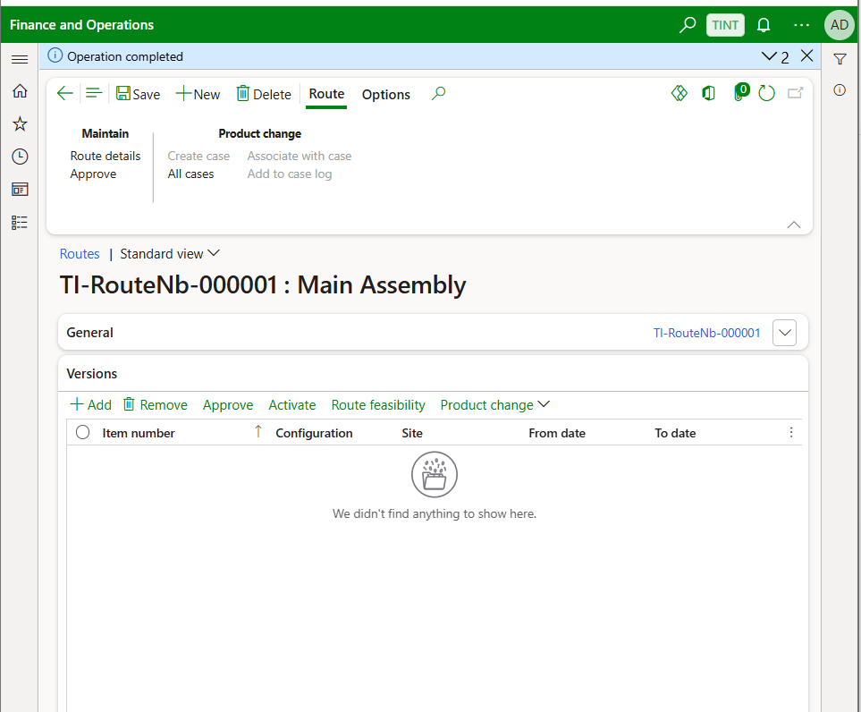

* Approve and activate the route version. With this approval, it means that the specific item specified under the versions is following that specific route. And the activation step is required for the route to be considered in the production order scheduling and the resources to be booked after firming the planned production order.

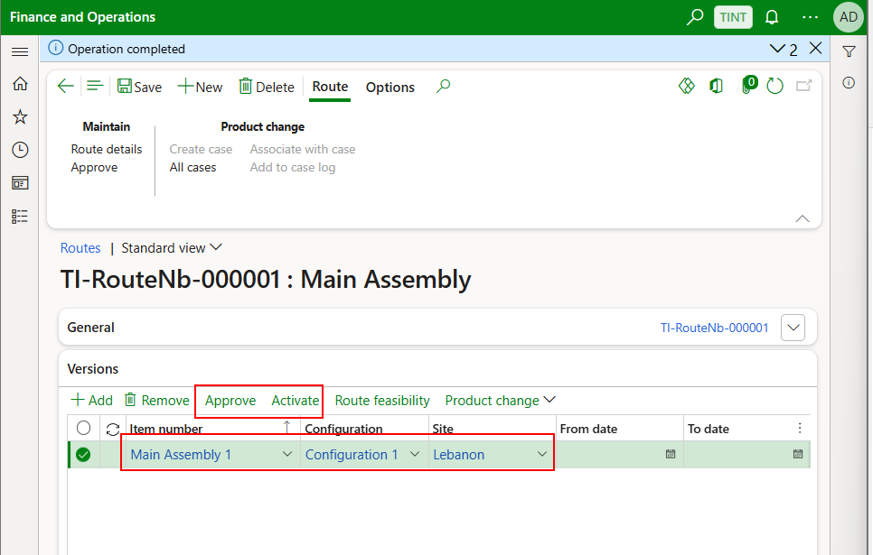

## BOMs

* **A bill of materials (BOM)** defines the components that are required to produce a product.
* **The BOM and BOM versions will be integrated into D365 from inventor; however, below is the way to create a BOM and BOM version manually.**

1. Product information management > Bill of materials and formulas > Bill of materials

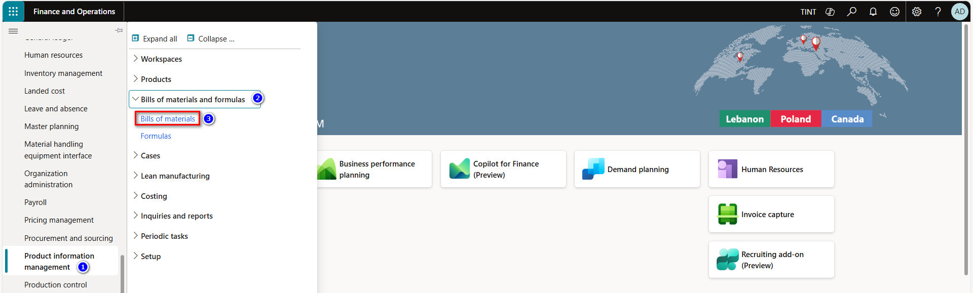

1. Press on new, to create a new BOM, & provide it with a description. The BOM takes an automatic code according to the number sequence
2. Link the BOM to a site.

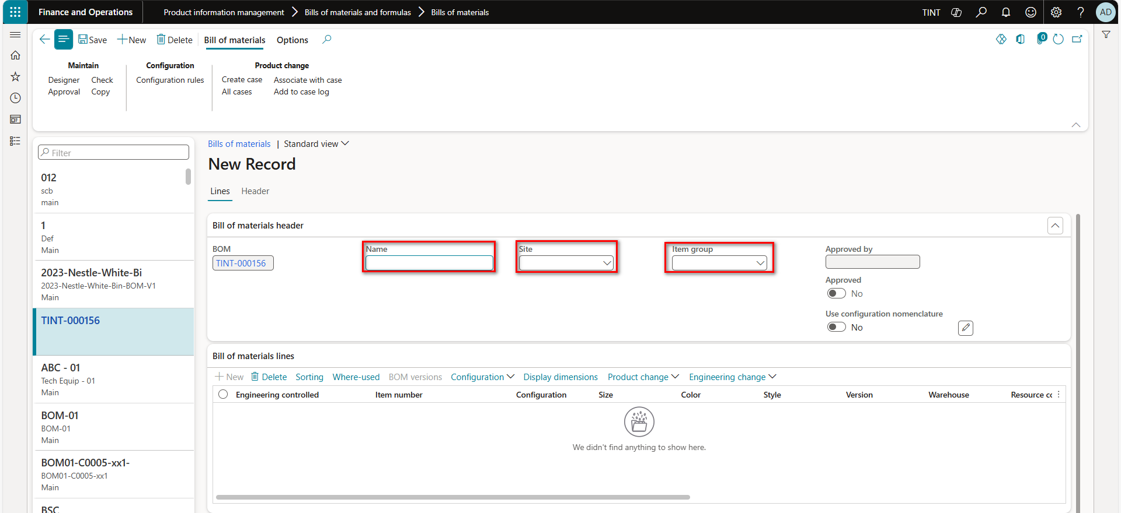

1. From bill of material header > BOM versions, select the item that you want to create a BOM for.

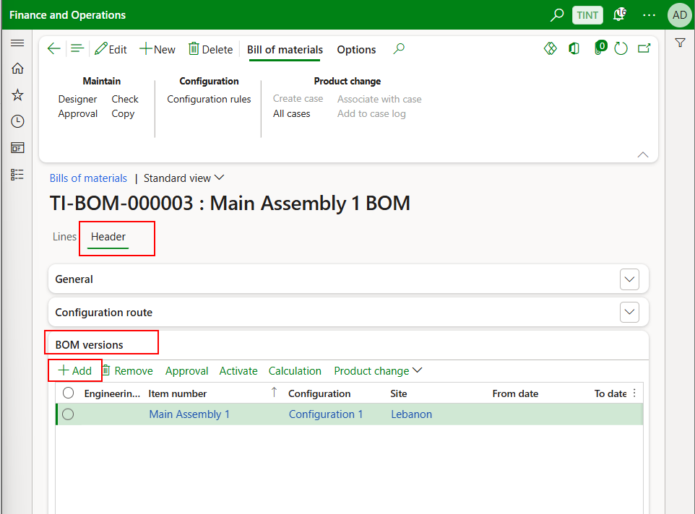

1. From Lines > Bill of materials lines. Add the components, raw materials and semi-finished products.

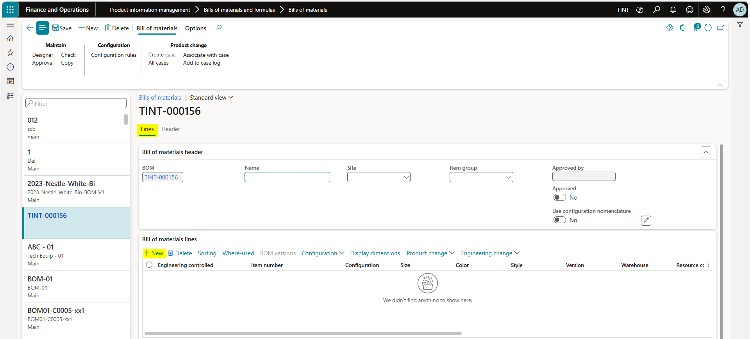

1. Add items, quantity, and warehouse. The line type needs to be **pegged supply**. Pegged supply is used when a component is not normally stocked and must be procured or produced only when needed.

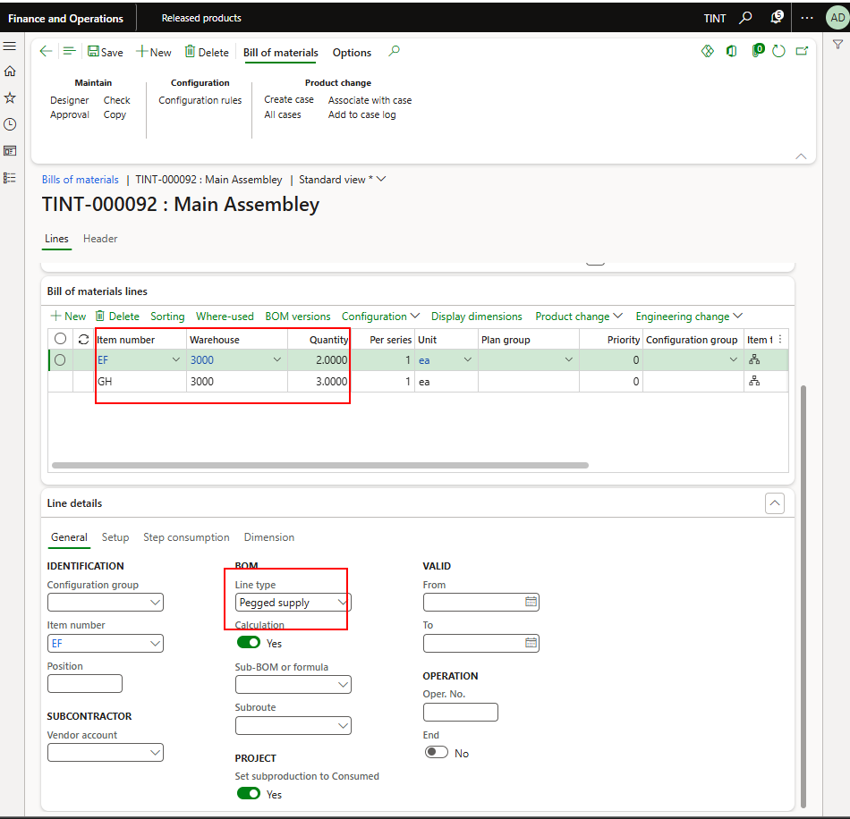

1. Approve the BOM from the maintain fast tab. This approval step is approving that the BOM contains the lines Subassembley 1 and Subassembly 2. At this step, we are not establishing the link between the main assembly and the subassemblies.

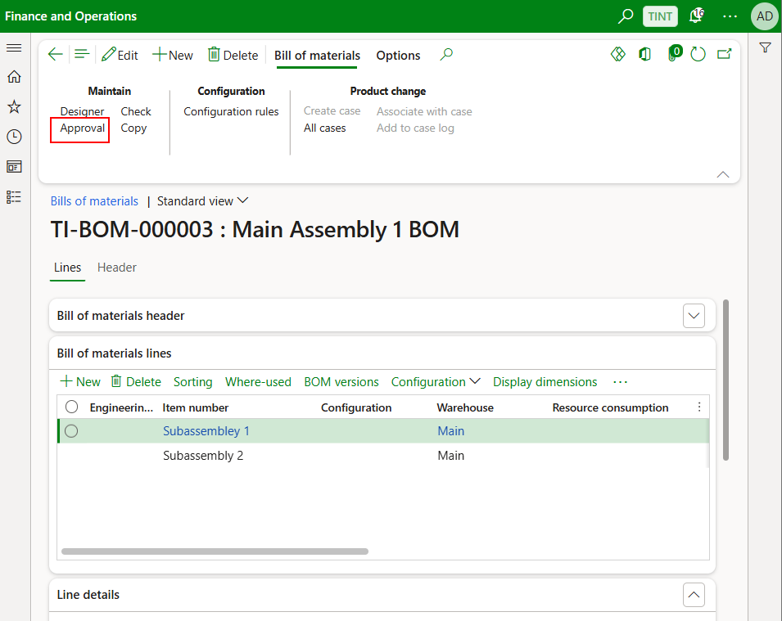

1. Approve & activate the desired BOM versions. This approval and activation is telling the system that the item Main assembly contains the BOM lines which are subassembly 1 and subassembly 2.

Without approving and activating the BOM, any **MRP run** will only take the Main assembly into consideration and not the BOM lines for the Main assembly. This is why this step is mandatory when creating any new BOM.

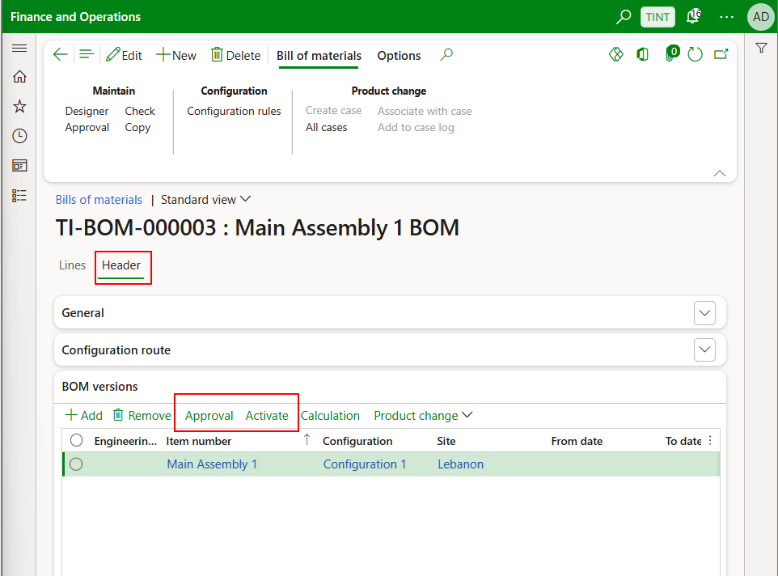

* **Copy from existing BOM**

1. From maintain fast tab > Press copy.

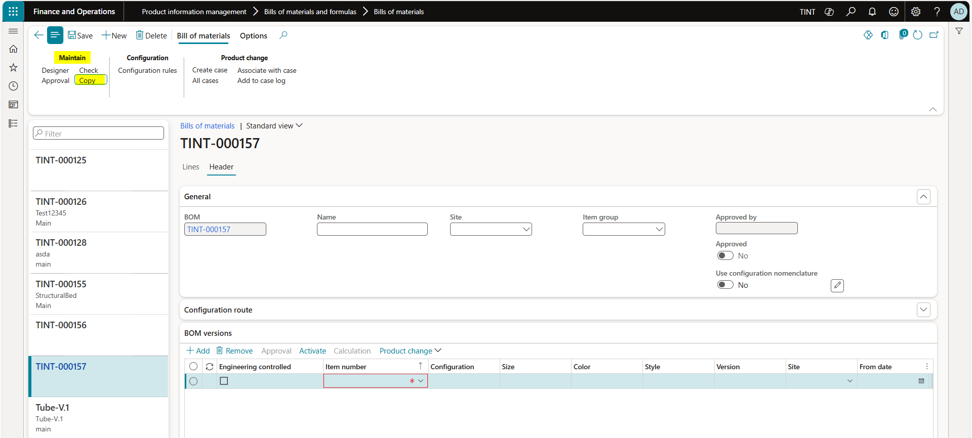

1. Select the item number that you want to take a copy from.
2. Select the BOM that you want to take a copy from.
3. Choose add to create a new BOM.
4. Click OK.

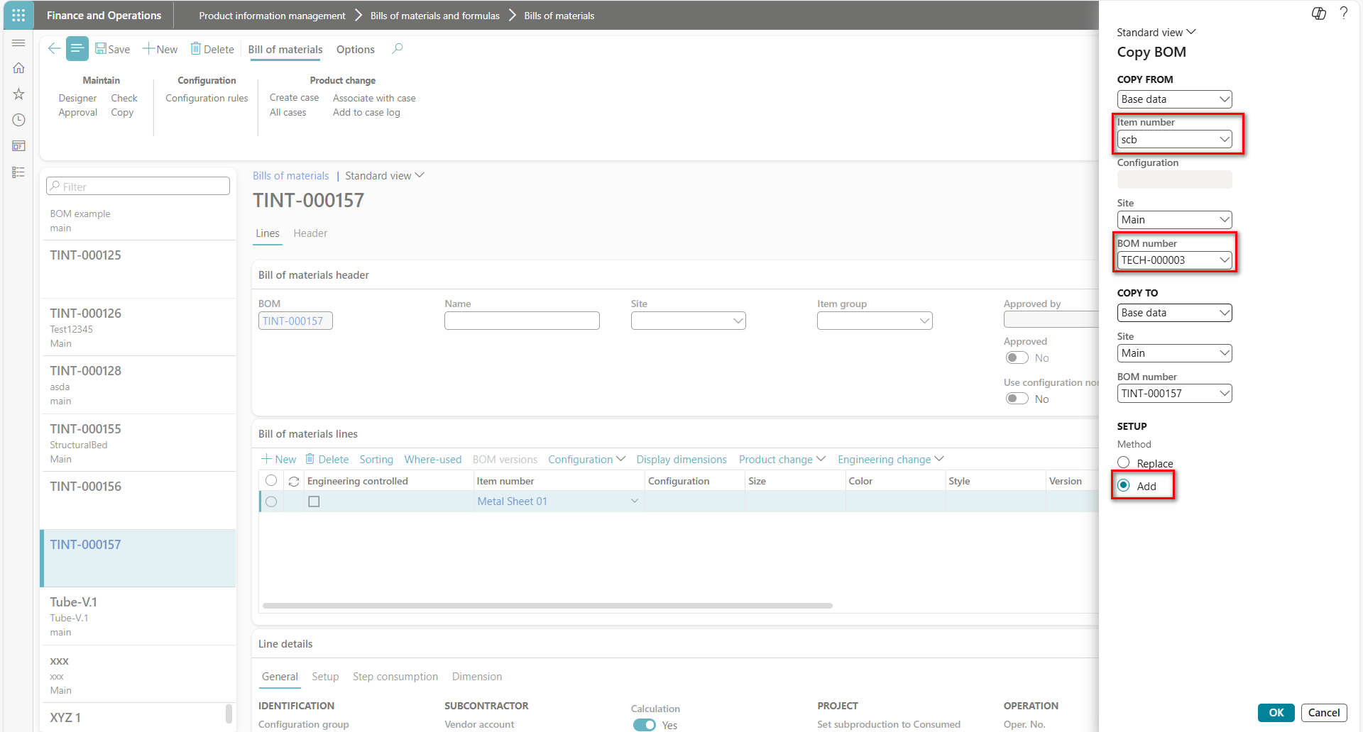

## BOM Tree

When you open the **BOM designer** page from the **Released products** page, it displays the hierarchy of bills of materials (BOMs) that are active and approved for the selected item. The BOM designer has two sections:

* The tree view of the BOM structure.
* The details section, which shows details of the selected data. When you select a node in the tree view, the FastTabs in the details section are updated based on that node
  + - 1. Navigate to Product information management > products > released products
      2. Select the required assembly and navigate to the engineer tab, under BOM section, press the “Designer”
      3. The system will display the BOM designer

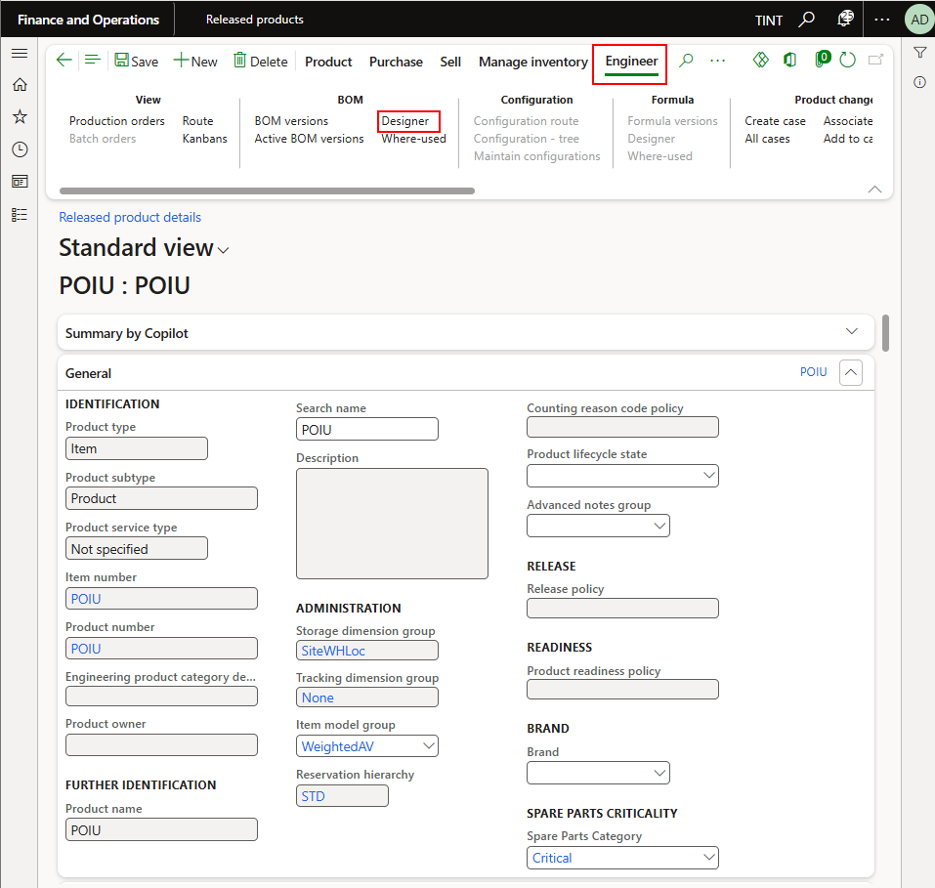

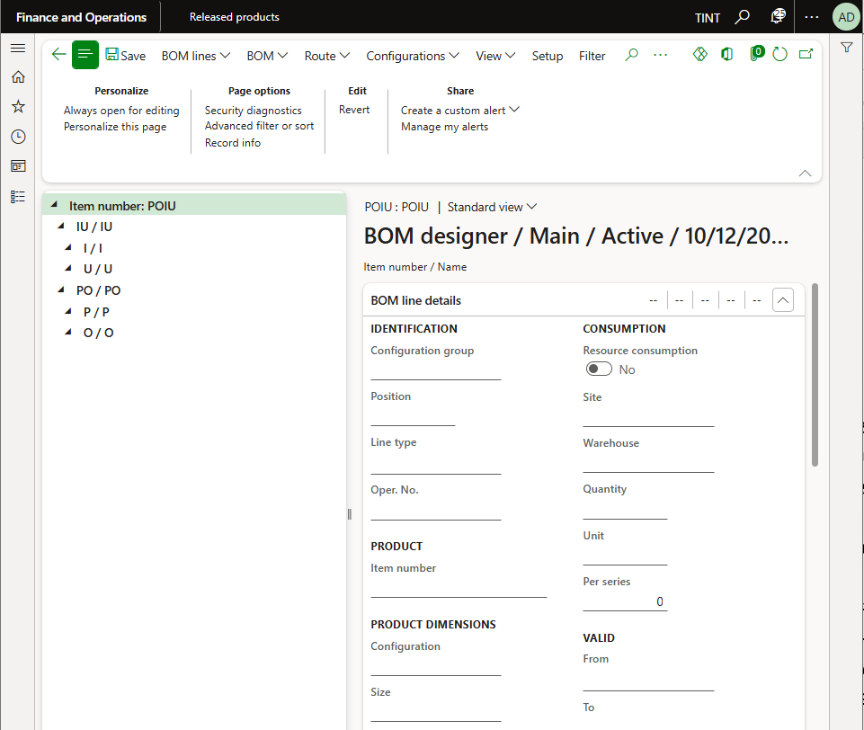

## Where used

1. Navigate to production information management > products > released products
2. Select the required assembly and navigate to the engineer tab, under BOM section, press the “Where used”
3. The system will display all the BOMs in which this specific product exists

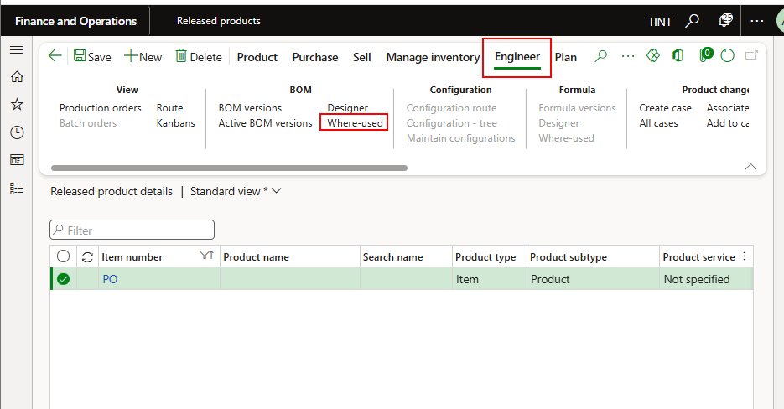

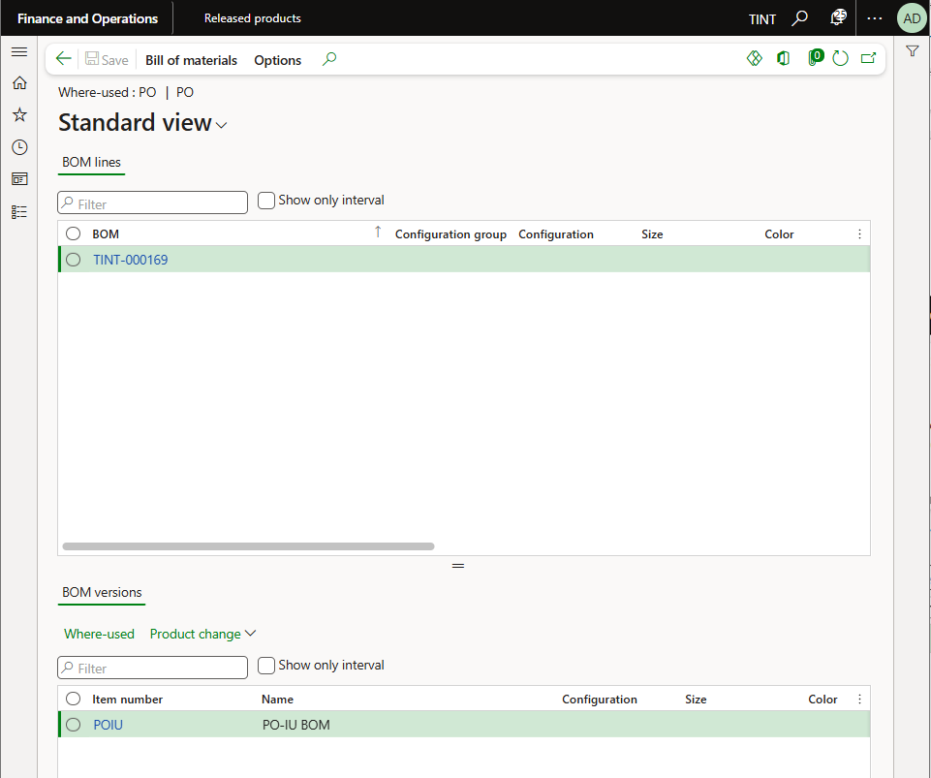

## The difference between item BOM and production BOM

Item BOM is added to the item from production information management > Products > Released products. Under Engineer > BOM >Select BOM revision

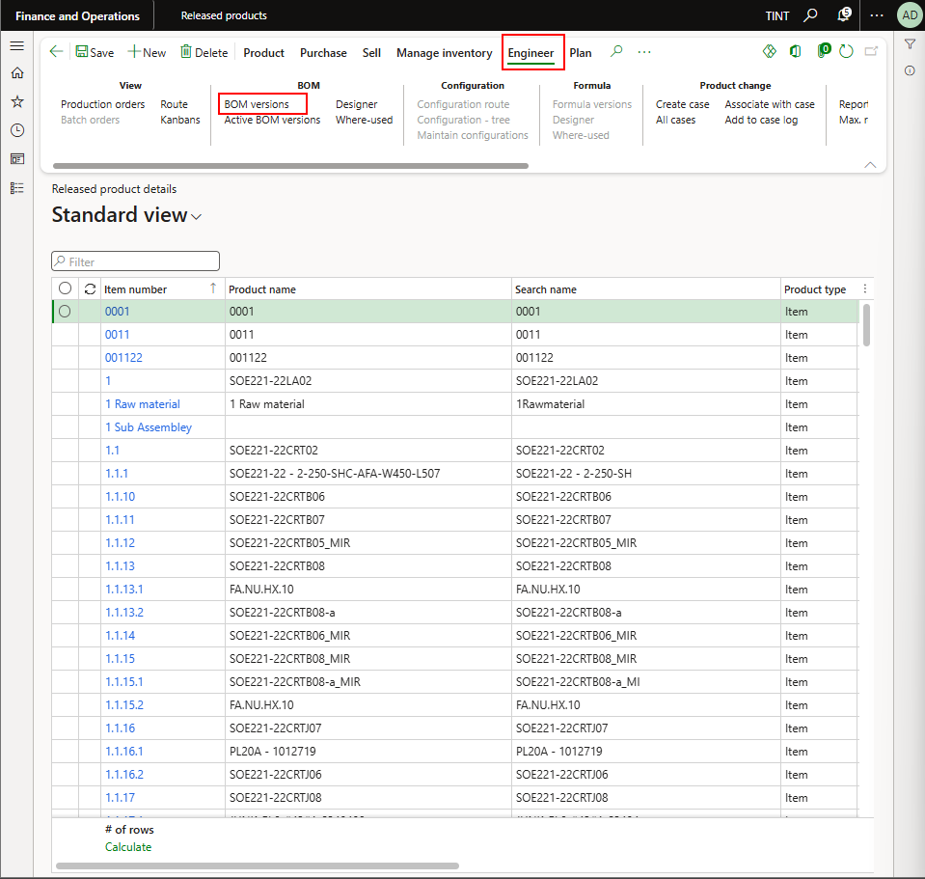

Production BOM can be accessed directly from the production order. Production control module> production orders > all production orders

Under production > production details > BOM

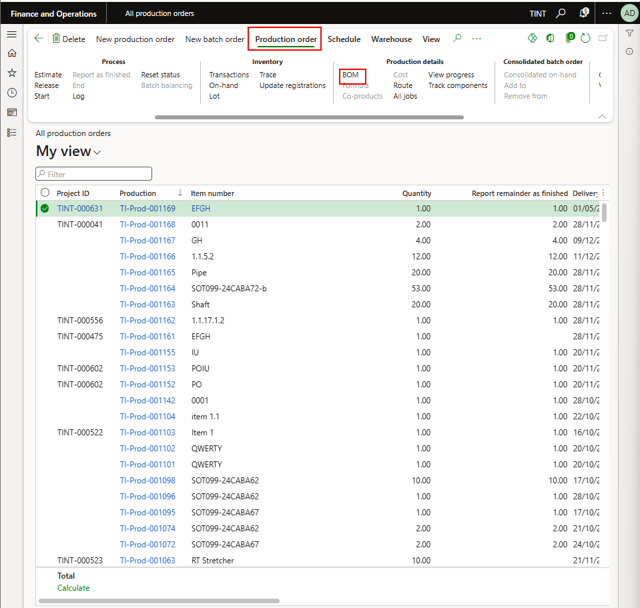

# Production Processes

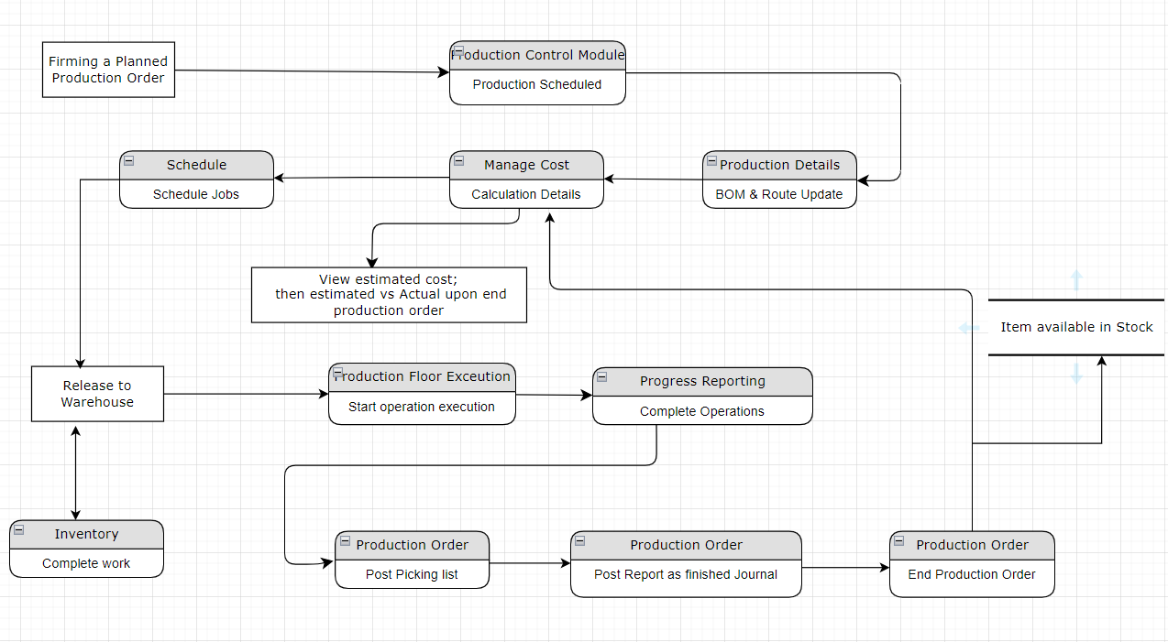

## Firming the production order from MRP and processing the production order

Firming a production order means “freezing” it so the system can no longer automatically change dates, quantities, or planning proposals. Upon firming, the components will be reserved.

* The planned production order will be manually firmed, and a production order will be created linked to the project ID.

Navigate to production control > production orders > planned production orders

Filter on the project ID you want to create production orders from

Firm the needed planned production orders

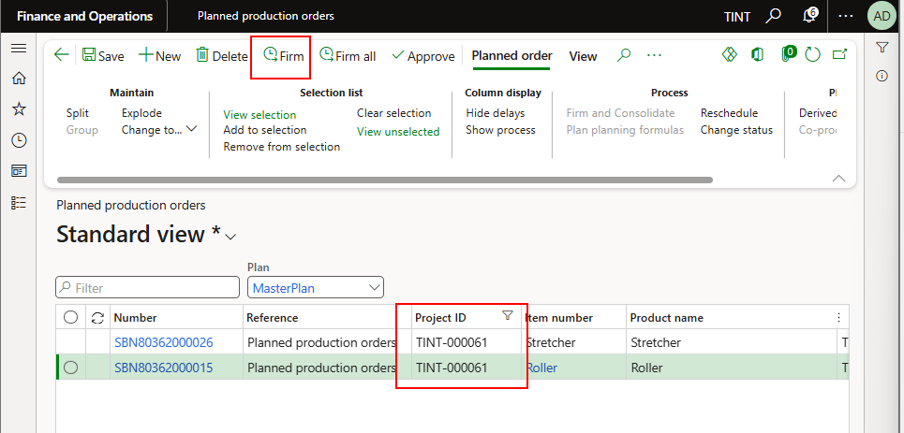

To check the requirement behind this production order, select the production order. Under view > requirements > select multi-level pegging and you will able to see the BOM

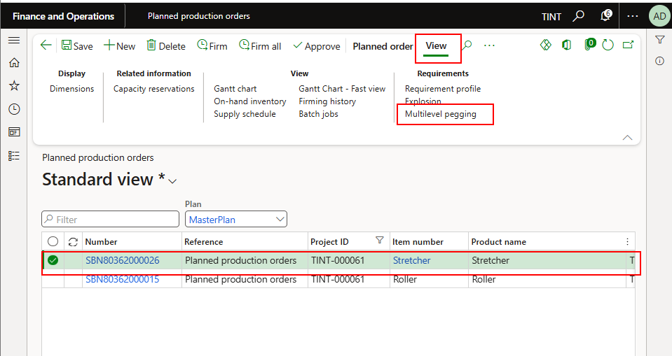

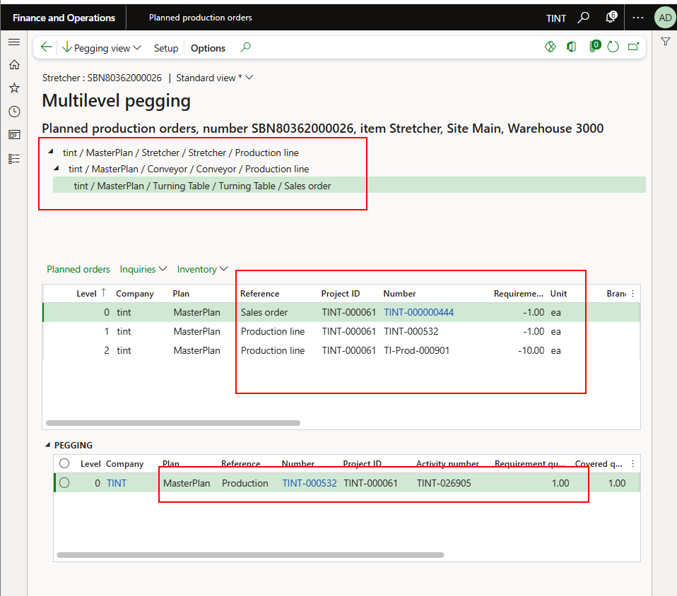

It is also possible to view the production order components through View > Requirements > Explosion. Make sure to select the Main assembly. It is also possible to view the lower levels.

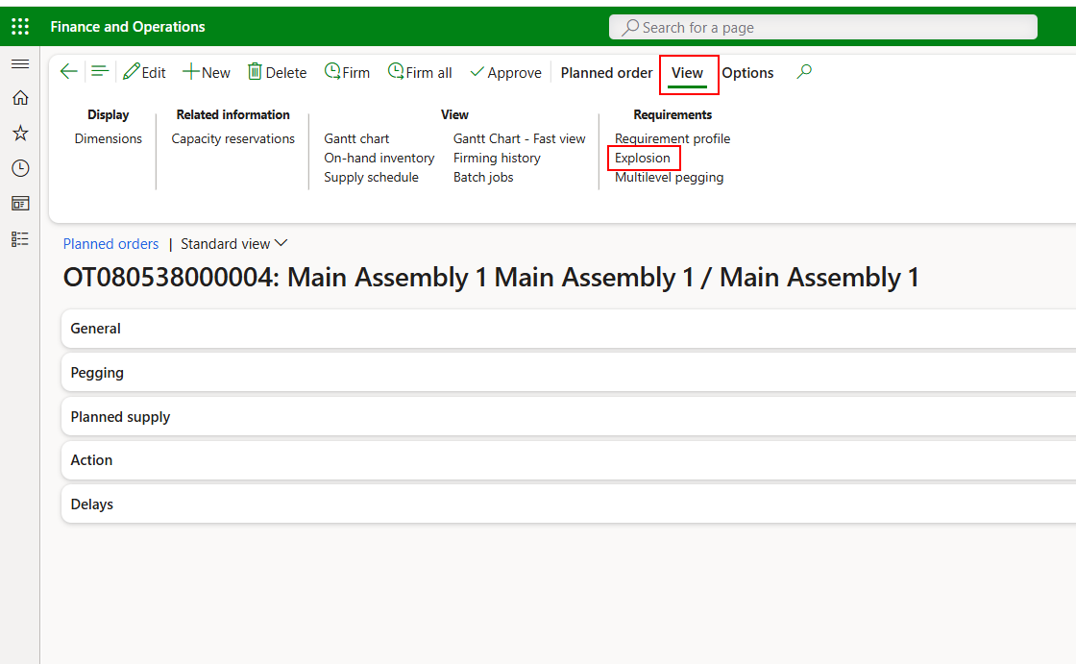

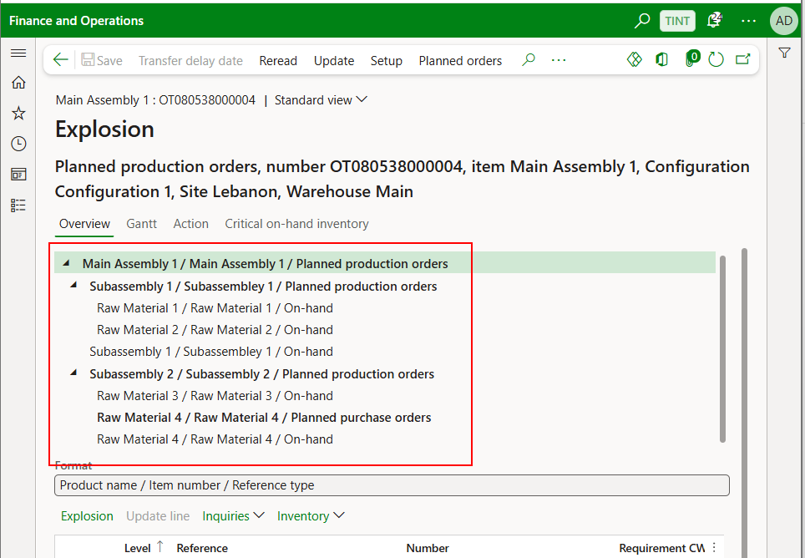

From this view, switching between the lines will highlight the corresponding line is the below table and will show the pegging table underneath.

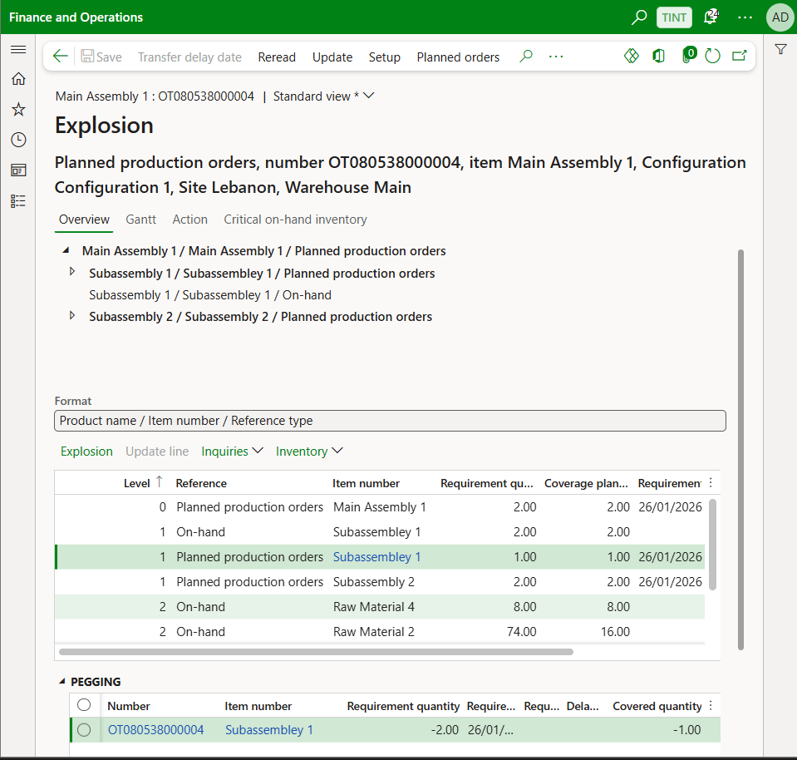

The requirement quantity shows the physical inventory of the item. For more details about the available and the reserved quantity and the coverage planned shows the amount available to fulfill ongoing orders.

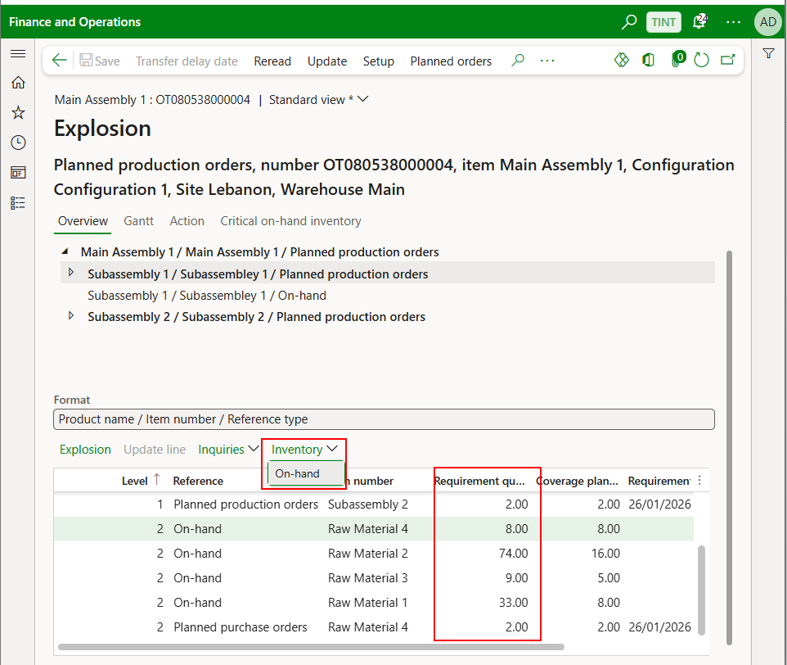

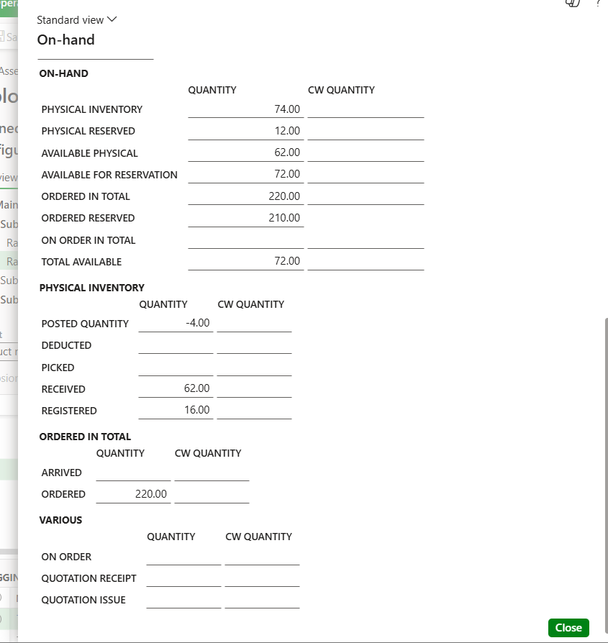

In this view, it is also possible to view what items are on-hand and what items are not and the system created planned orders for.

**Example:**

The screenshot below will be used as an example. We will see how the planned production order for Main Assembly 1 Configuration Configuration is created and what items are available.

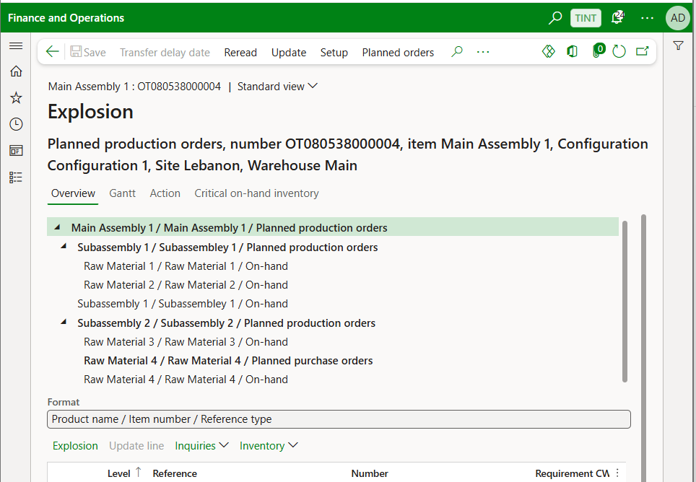

It is important to note the structure of the Main Assembly.

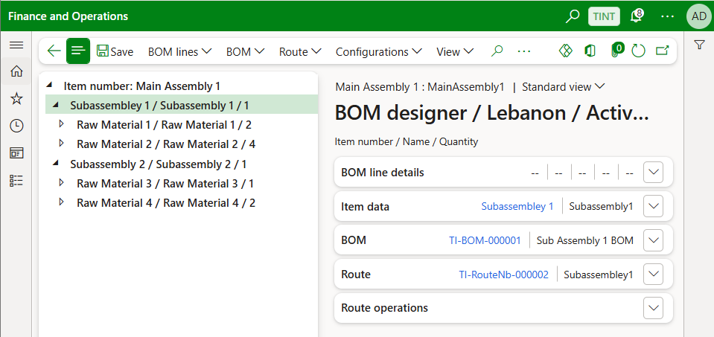

Top level: Main Assembly has **1 ea. Subassembley 1** and **1 ea. Subassembley 2.**

Subassembley 1 has **2 ea. Raw Material 1** and **4 ea. Raw Material 2**

Subassembly 2 has **1 ea.** **Raw Material 3** and **2 ea. Raw Material 4**

**Level 0**

The planned production order for **Main Assembly 1** is 2 ea. Because the related sales order (project item requirement) is 2 ea. And none are available in stock. It is also important the level number of the planned production order because it suggests that this planned production order is related to the top level of production.

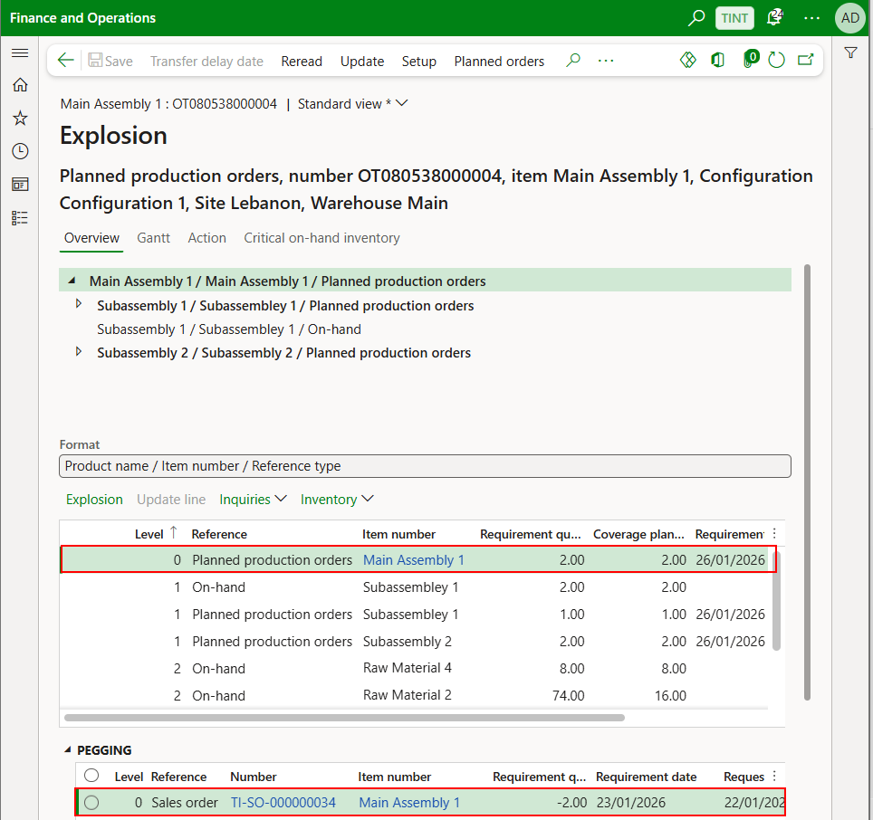

**Level 1**

Moving to the next level (Level 1; Subassembley 1 and Subassembly 2; Planned production order for Main Assembly 1 has 2 ea. then we need 2 ea. of Subassembley1 and 2 of subassembly 2 to meet the requirement of 2 ea. of Main Assembly 1). We can see that Subassembley 1 has only 1 ea. on-hand quantity and a planned production order of 1 ea, is created to complete the requirement. In addition, for subassembly 2, none exists on hand, so the complete quantity needs to be produced through a planned production order.

If we select the second line (Level 1; on-hand; Subassembley 1), we get the following information: The quantities columns are highlighted,

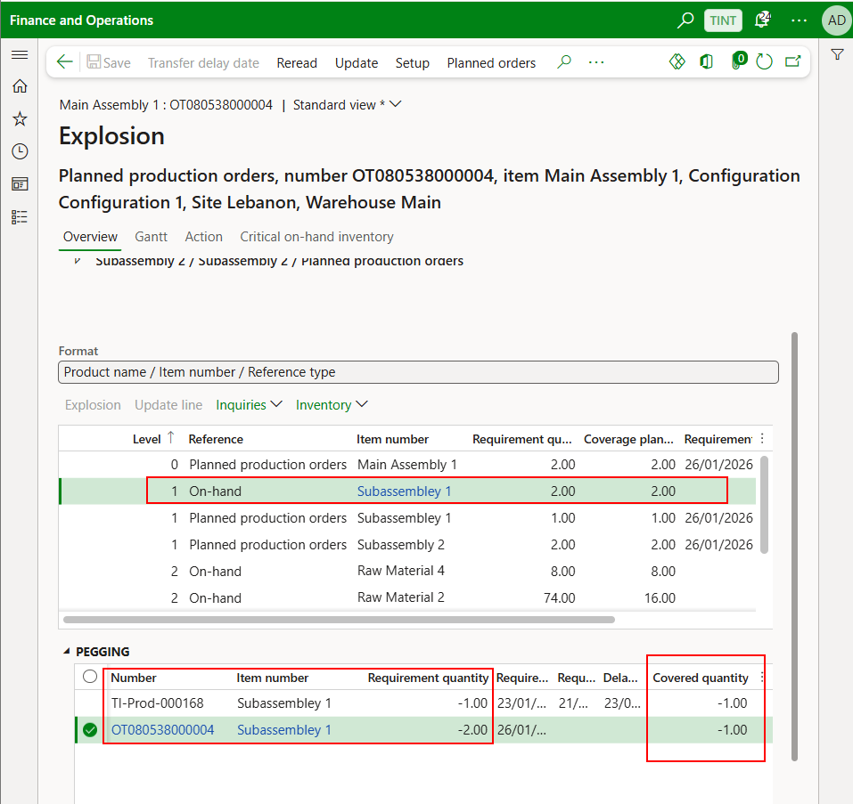

Requirement quantity is the quantity that is needed and the covered quantity is the quantity is in-stock or is processed through a production order or through a purchase order to fulfill ongoing orders.

Example: TI-Prod-000168 is a production order for the **Main Assembly 1** which requires **1 ea. of Subassembley 1 (Requirement quantity)** and the **covered quantity is 1** which means that the no planned production orders for Subassembly 1 are needed to match the requirement for **TI-Prod-000168**. The second line shows the planned order **OT080538000004** requires **2 ea**. of Subassembley 1 but the **covered quantity** is only **1 ea**. which means that a planned production order is needed to cover the full requirement quantity, and that is why we can that a planned production order (**OT080538000015**) for Subassembley 1 is created.

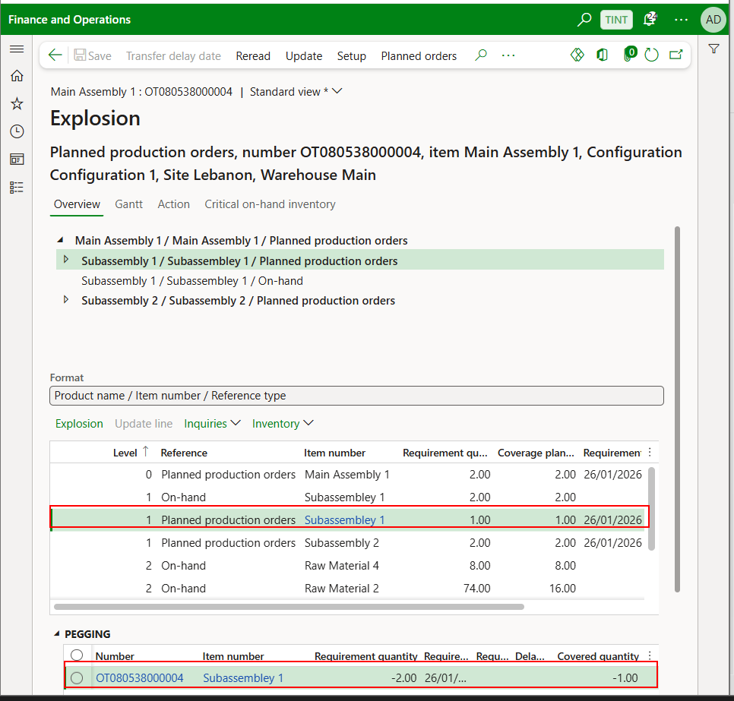

For subassembly 2, no inventory exists so a planned production order for the **full quantity 2 ea**. is created.

**Level 2**

Moving to the next level (Level 2; Raw Material 1, Raw Material 2, Raw Material 3, and Raw Material 4; a planned production order for Subassembley 1 with quantity 1 ea. required 2 ea. of Raw Material 1 and 4 ea. of Raw Material 2).

For **Raw Material 1**, in the pegging table we can see that the **requirement quantity = covered quantity** so no planned purchase order is created because all the quantities exist.

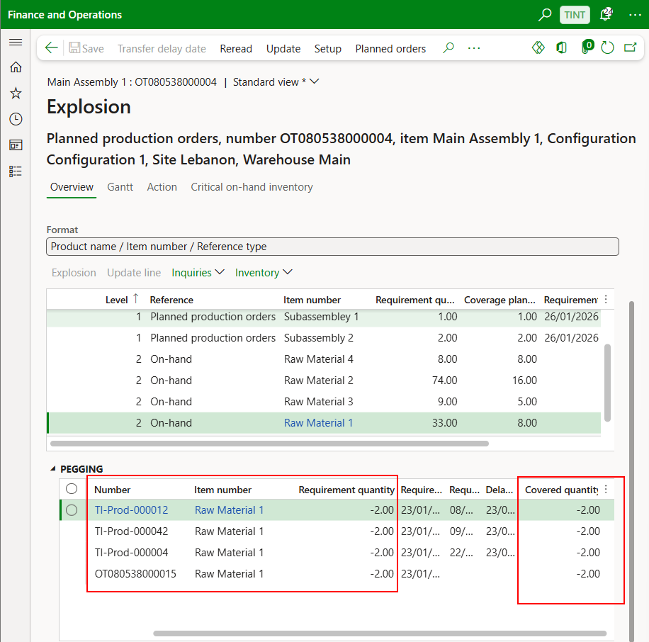

For **Raw Material 2** and **Raw Material 3**, same scenario as **Raw Material 1** is applicable that all quantities required are covered through inventory.

For **Raw Material 4**, in the pegging table we can see that the requirement quantity is equal to the covered quantity except for the last time **OT080538000016** which is the planned production order identifier for Subassembly 2. **The requirement quantity** is **4 ea.** but the **covered quantity** is only **2 ea**. Then a planned purchase order **OT080538000017** is created to fulfill the requirement quantity.

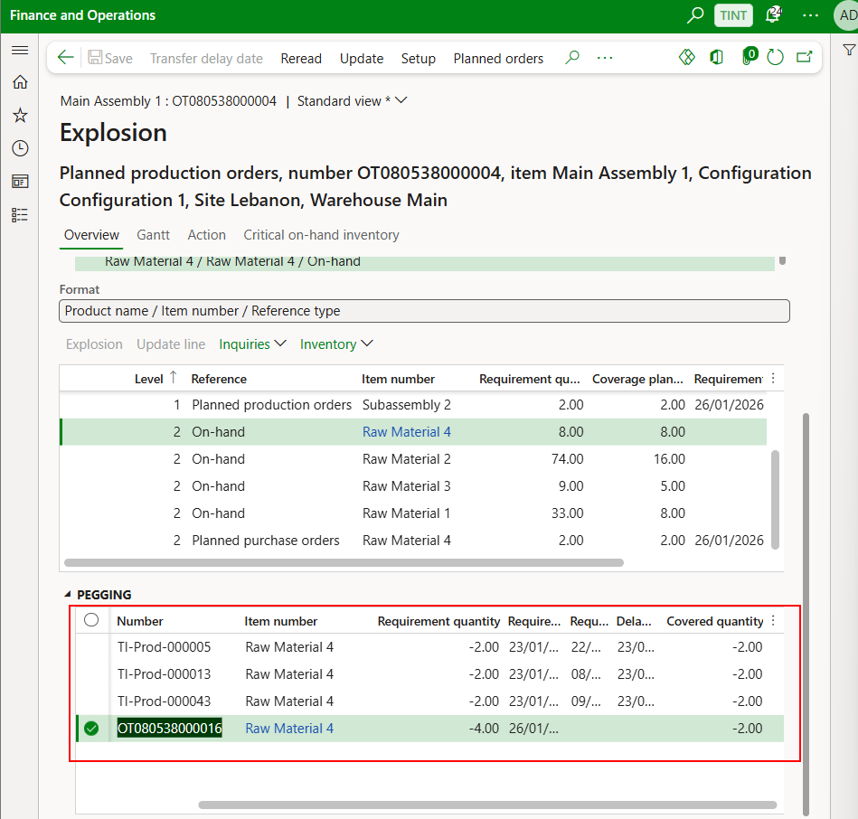

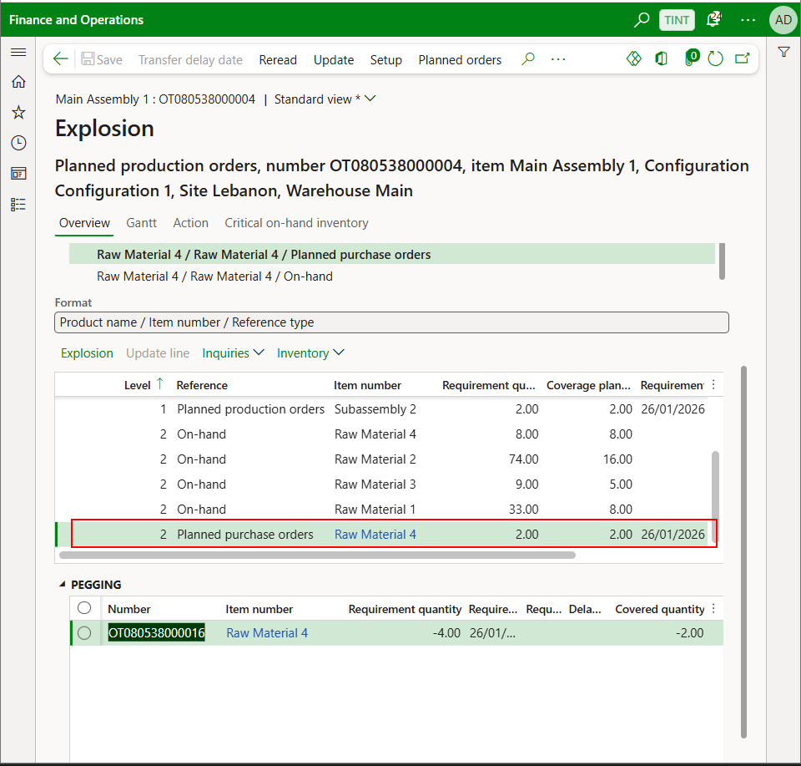

**~~Ensure to select the production orders of the lowest subassemblies with ready BOMs and don’t firm the main assembly production order since its BOM is not ready yet.~~**

**~~Whenever other subassemblies BOMs are ready, then proceed with firming their related production orders. Same applies to the main assembly.~~**

**~~It is important to ensure that main assembly or main subassemblies should not be integrated into F&O if the BOM is not ready to avoid manual updates on the production order.~~**

* To check the production order created

1. Production control > Production orders > All production orders. Filter on the project ID.

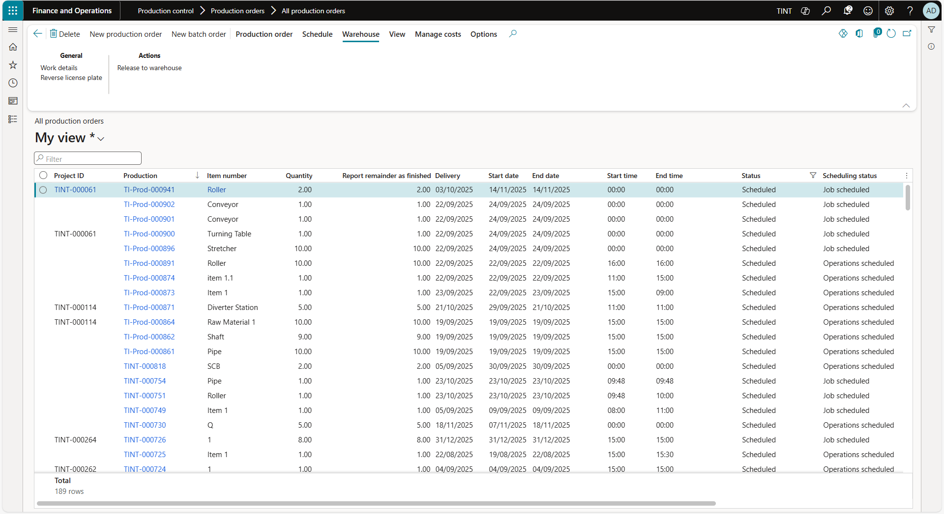

1. Select the desired production order.
2. The production clerk can access the BOM on the production order and add any missing raw materials or items directly.



1. The production clerk can modify/define the operations on the route for this specific production order.

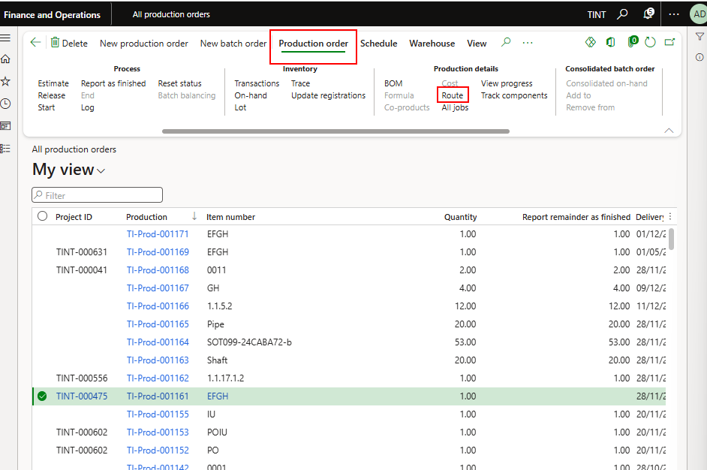

1. To view the calculation details
   1. On the Action Pane, click Manage costs.
   2. Click View calculation details.

This page displays the cost breakdown. For example, you can view the total cost price per unit for the finished product in the first row. The subsequent rows contain costs according to the bill of materials, production route, and indirect costs

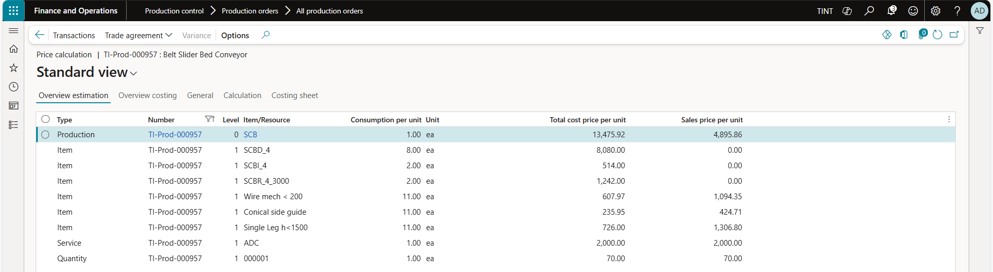

1. The production order will be in scheduled status after firming. Its scheduling status will be operations scheduled (Dates only). Production control > production orders > all production order. Select a production order. Under schedule, select schedule operations.

We need to use job scheduling (Times).

The production orders of subassemblies and main assemblies are linked to each other through reference numbers.

Please note that in case of several nested BOMs, the reference number will show the higher level, and the reference of the other production order(s) will lead to the main one.

Sub-assemblies will have reference type as production line.

Main assemblies that were added to the project will have reference type = Sales order.

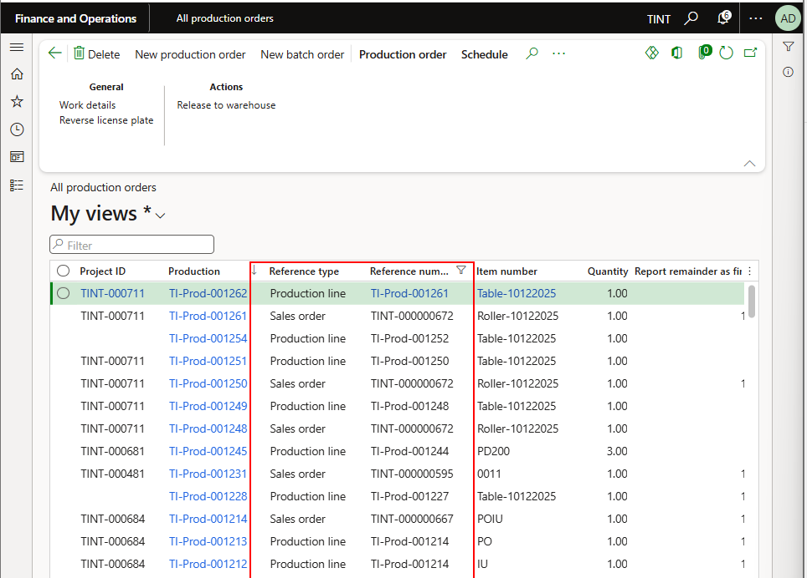

1. Schedule jobs for the production order to calculate the actual start date and end date and exact start and end time of the production order based on the capacity reservation of the machines and the availability of the raw materials. From schedule > Production order > Schedule operations then jobs.

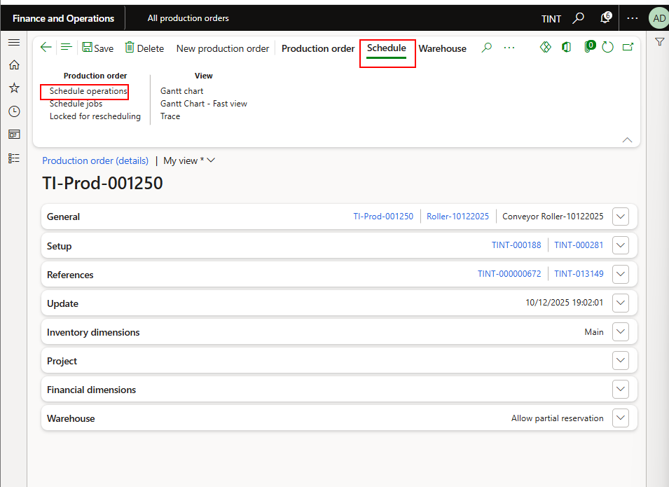

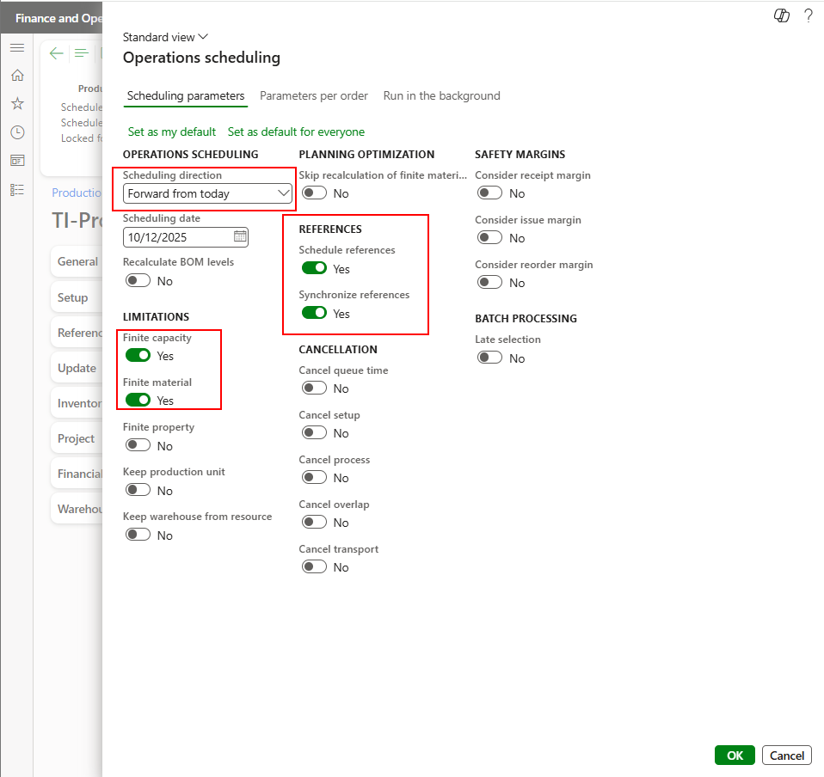

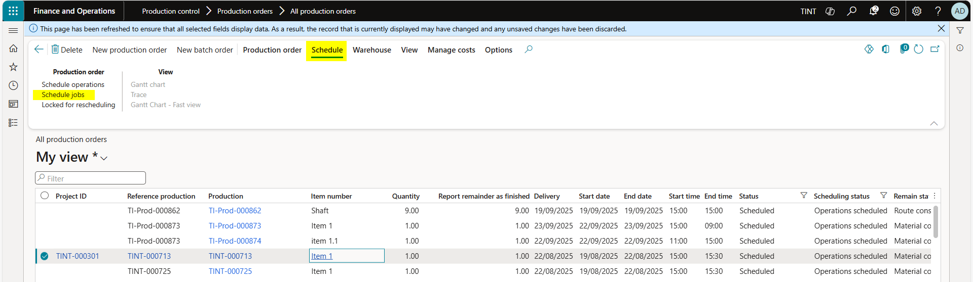

1. Select the option of scheduling then click OK.

Job scheduling options:

**Forward from today** – Schedule forward from the current date. (The current

date is the system date.)

**Forward from scheduling date** – Schedule forward from the date that you specify in the **Scheduling date** field. If you don't specify a scheduling date, the scheduling direction is forward from the current date.

**Backward from delivery date** – Schedule backward from the delivery date that you specify for the production order. If you select this option, but don't specify the delivery date, the delivery date is the current date.

Finite capacity= Yes; to consider limited availability of resources based on the schedule

**Finite material = No; in order not to consider material availability. If you select Yes, the system will not schedule the production order unless the material becomes available.**

Schedule references = Yes

Synchronize references = Yes

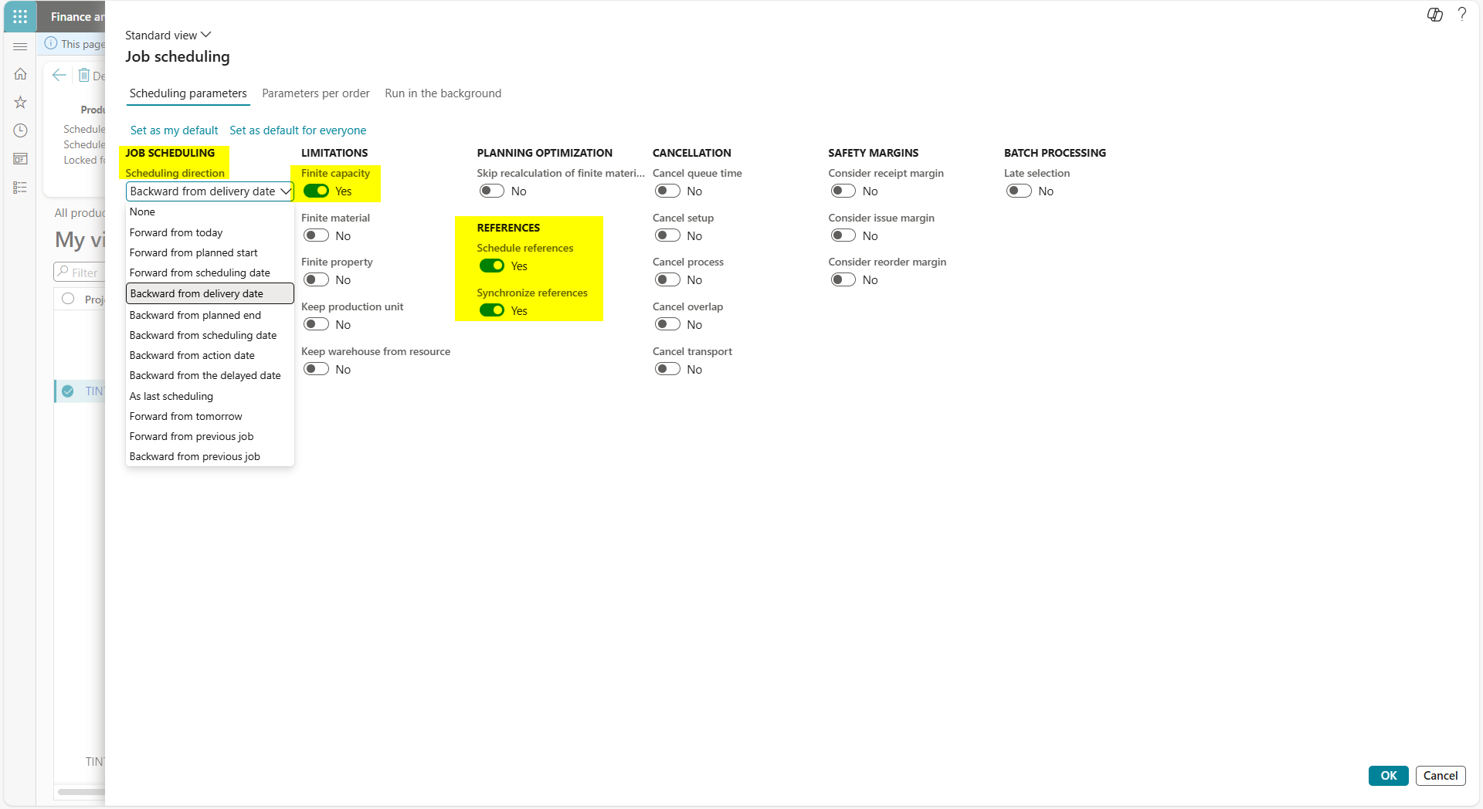

1. The system now will schedule the jobs for the production order based on the availability of the resources.

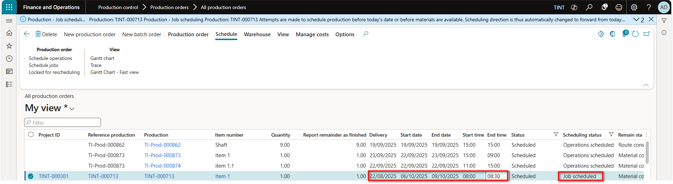

1. For easier visibility and planning, the planner can have a look at the **GANTT chart** associated with the production order(s).

Under schedule > view > Gantt chart

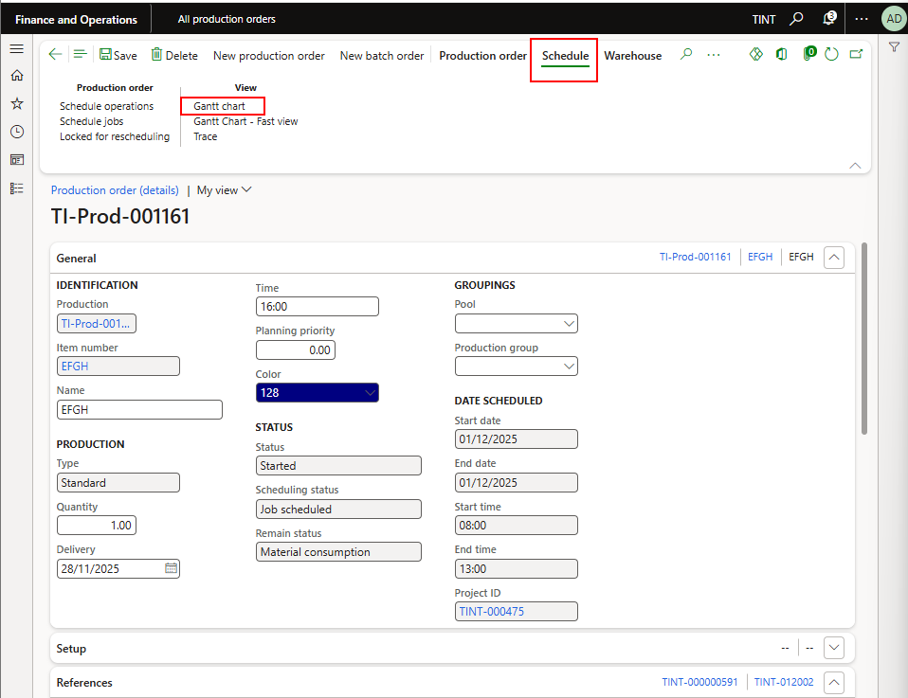

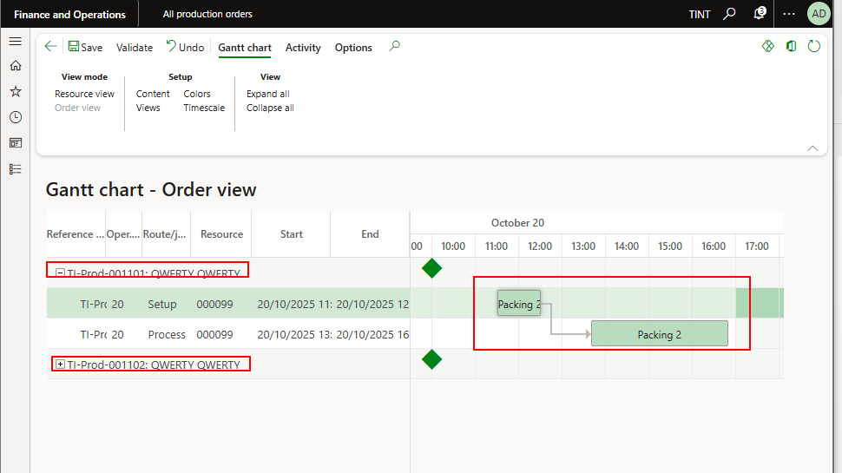

1. You can drag operation along the timeline and schedule jobs accordingly. Please note that we cannot drag operations past the working hours of the resource. The working hours are defined in the calendar associated with the resources. If required, you will have to change the calendar of the resource to be able to schedule it past the working hours (Refer to Section 2 point c to change the calendar for the resource). When you do so, right click on the job that you rescheduled and press schedule next jobs. This reschedules the connected next operations.

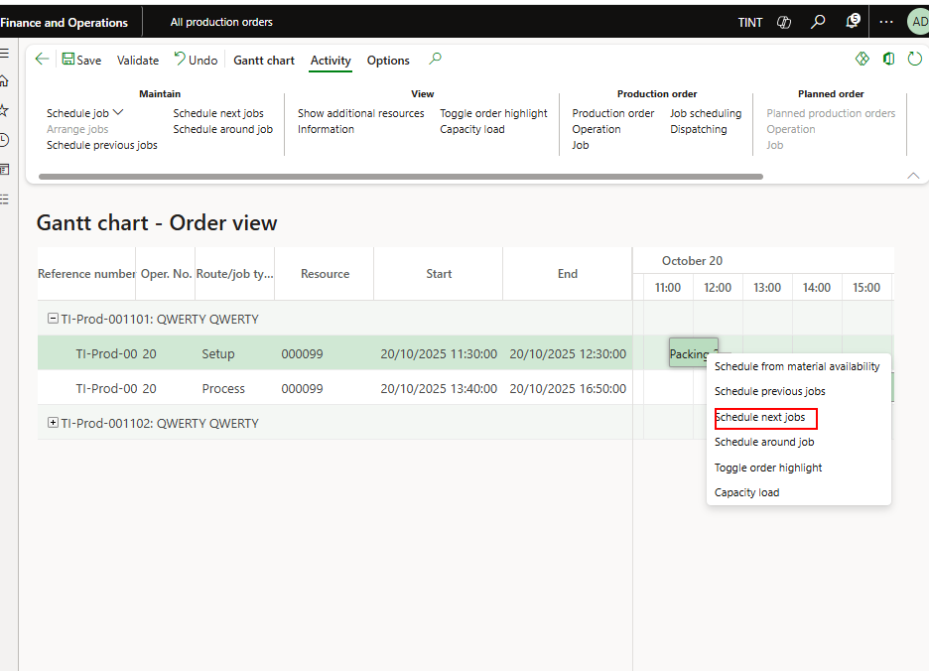

1. It is also possible to view per resource on the GANTT chart and not per production order view. It is also possible to change content (To control what to see on the gantt chart), views, colors, timescales from the Gantt chart option

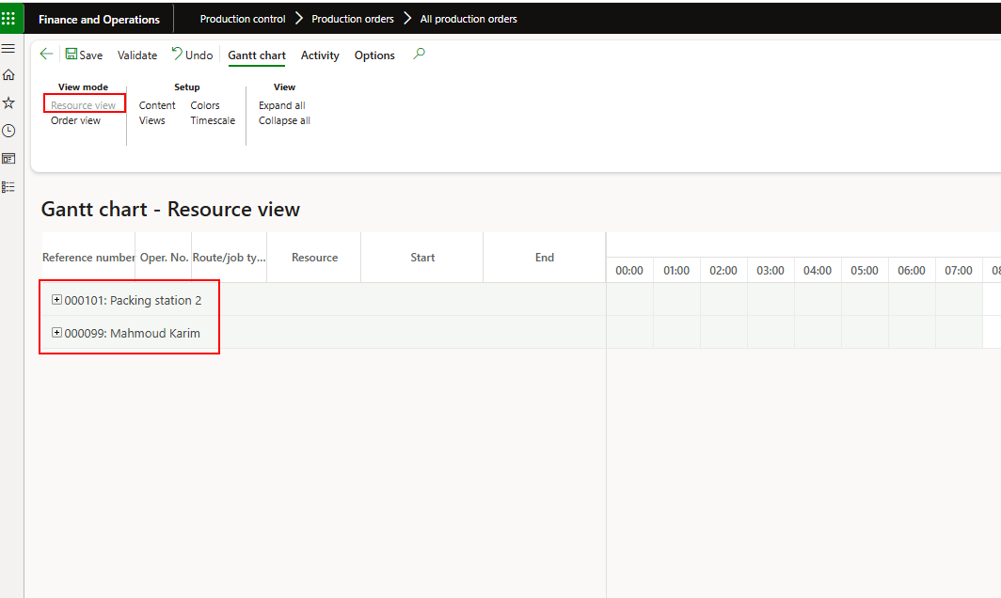

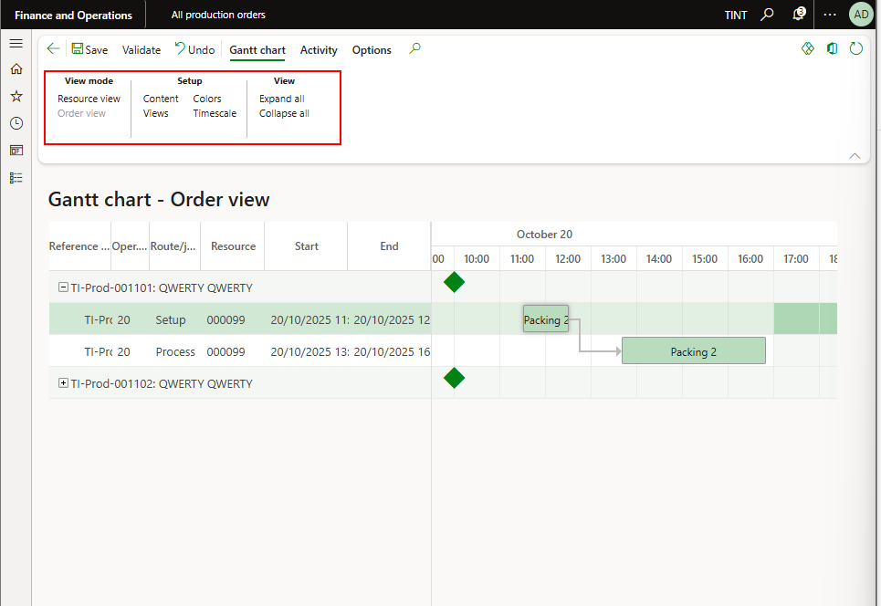

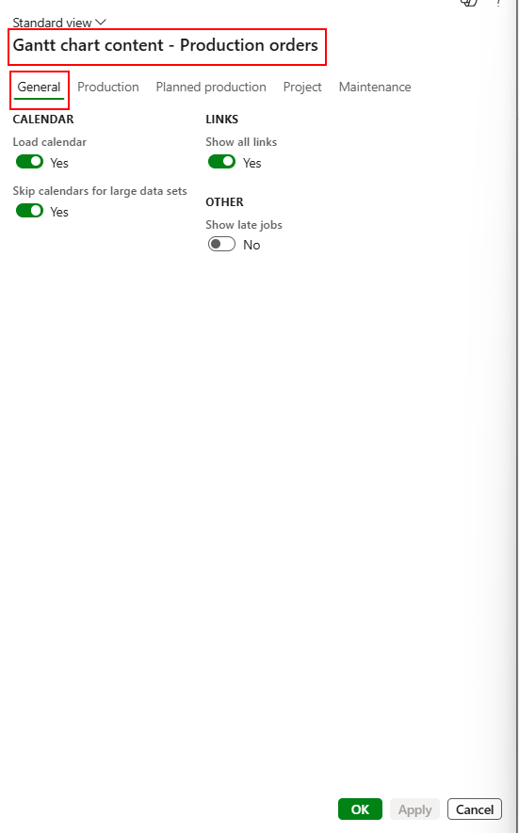

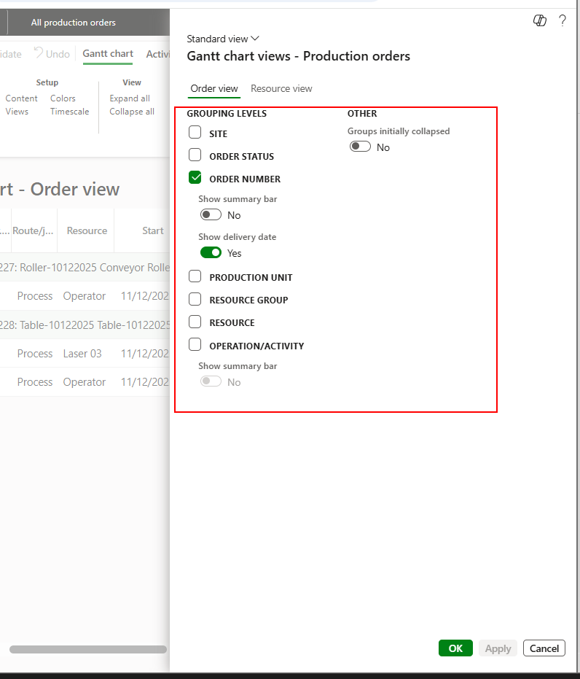

1. To view Gantt chart for multiple production orders, navigate to production control Module > Workspaces > Production floor management and select jobs to complete or specific jobs then select Gantt chart.

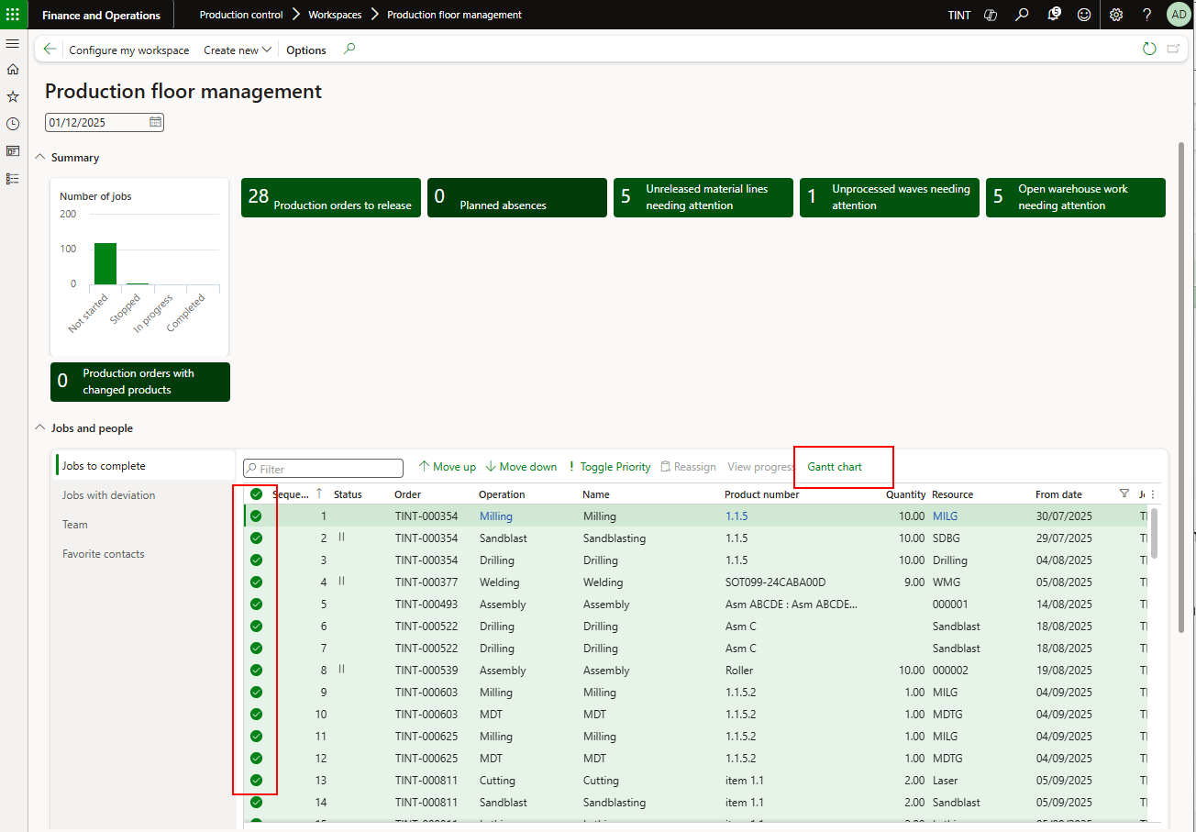

1. After planning the production order, release it to pick items from the warehouse. From production order > Process > Release.

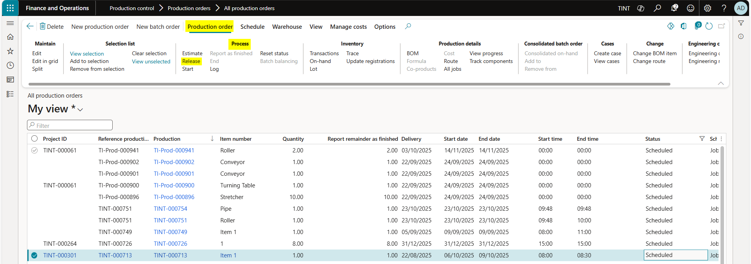

1. Warehouse work will be created. Under Warehouse > General > work details. Yan can view the work created and print the work report.

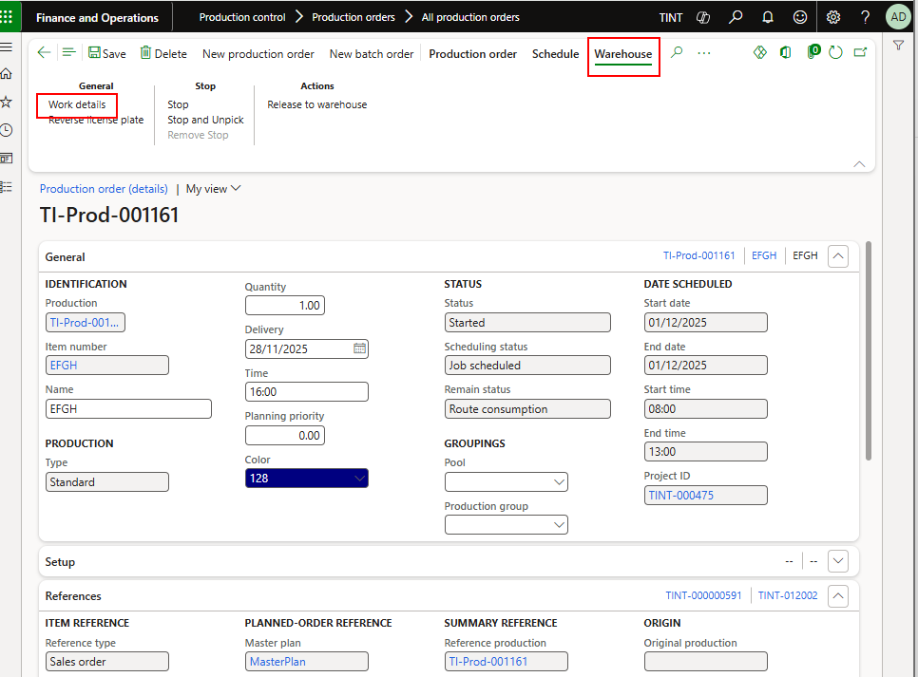

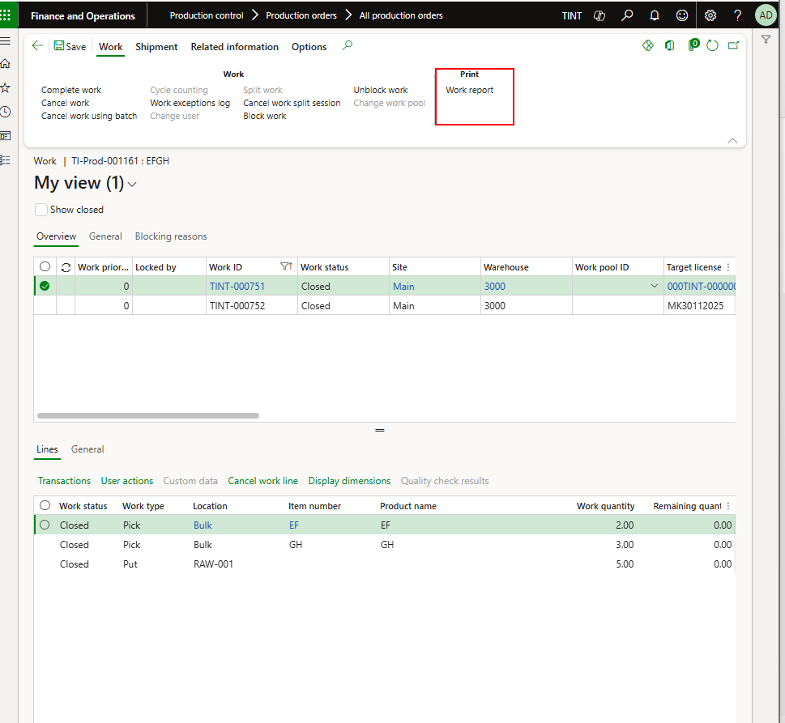

1. The printout will be the reference for receiving the stock from inventory clerk. The inventory clerk will complete the work. (This part is explained in the inventory training manual) The status of the work is open, when the inventory clerk hands the items, he needs to complete work and the status will change to close.

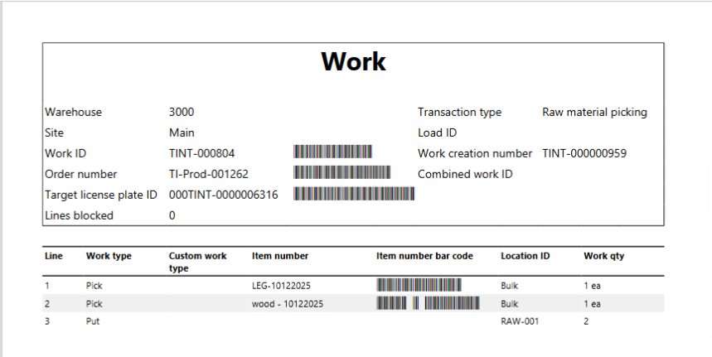

In the printout, it is stated the items that need to be picked up from the inventory with the quantity of each.

**Production floor execution**

1. Log in to the production floor execution interface using the personnel ID. Production control > manufacturing execution > production floor execution.
2. The list of jobs will show with the production order number

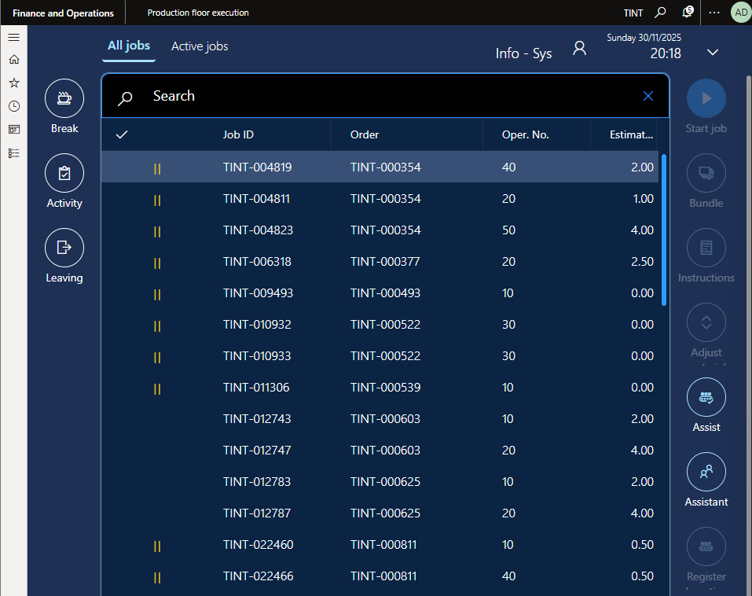

1. To start the job, select the Job and press start

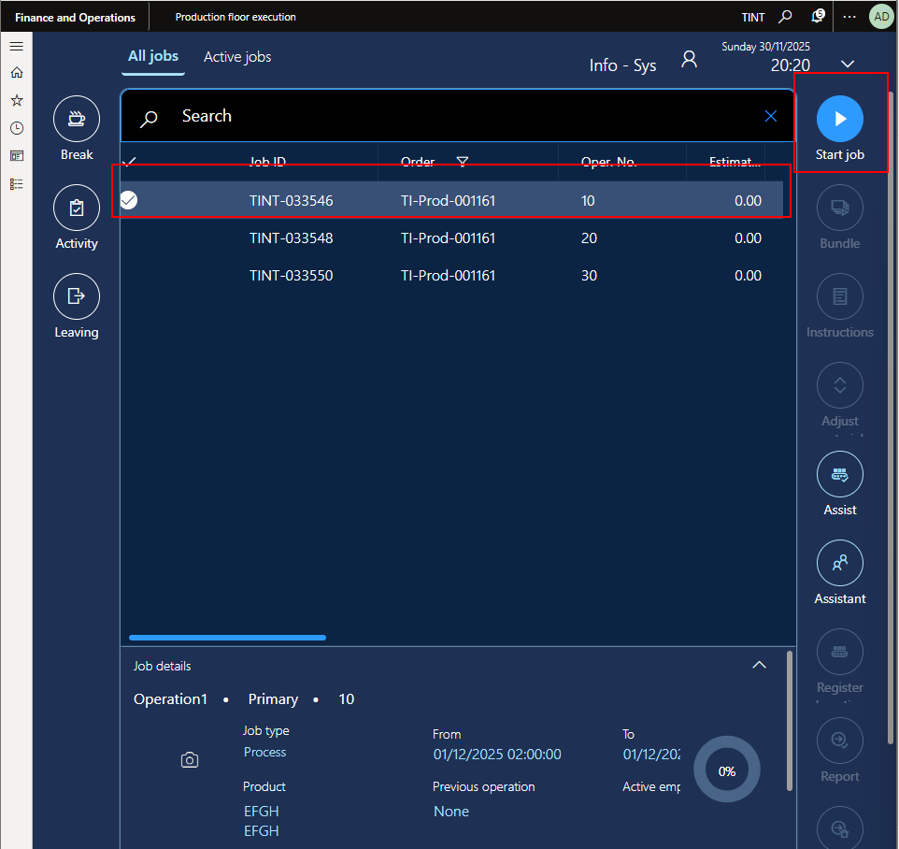

1. When pressing start job, you can specify a certain quantity to start and then the job will appear under the active jobs

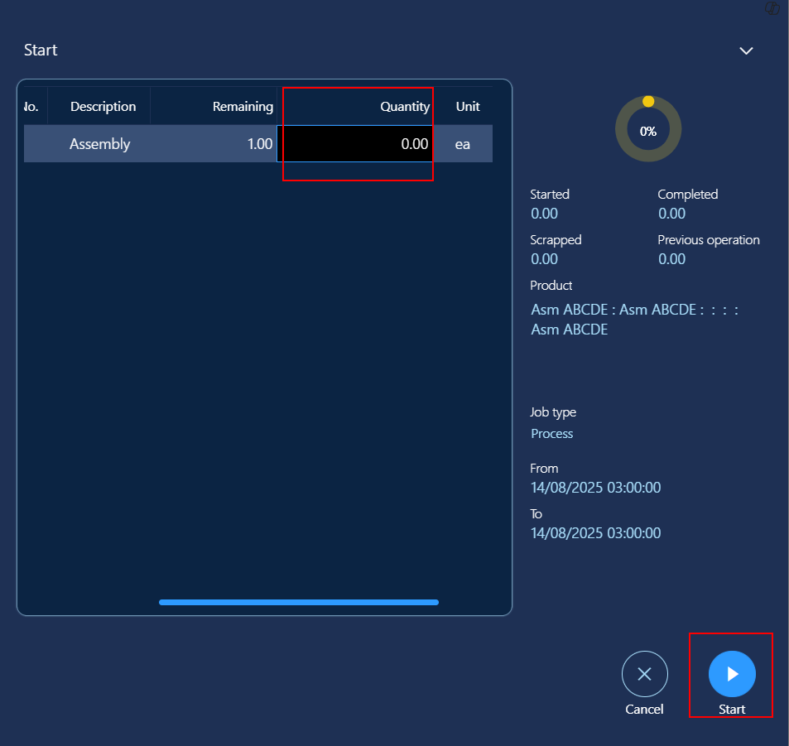

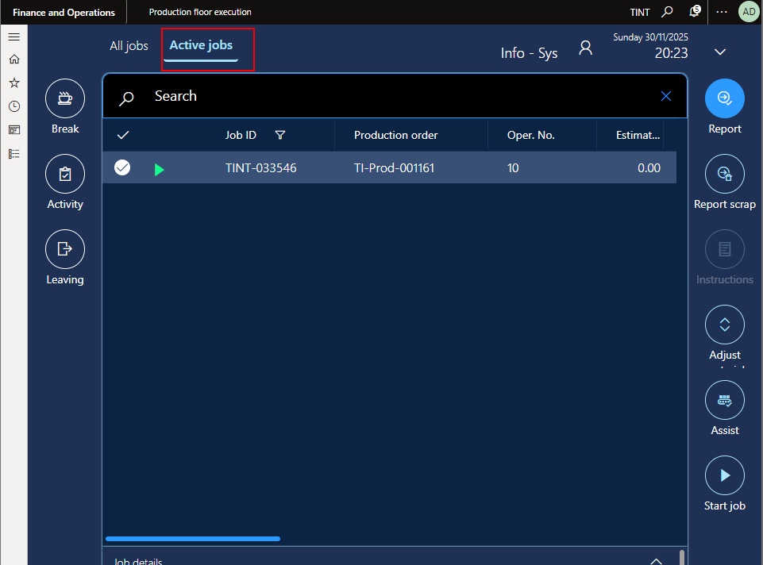

1. To report progress, press report

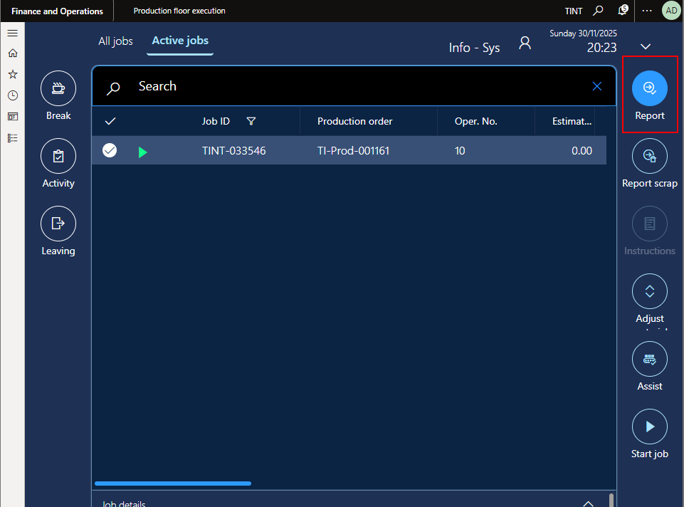

1. Enter good quantity

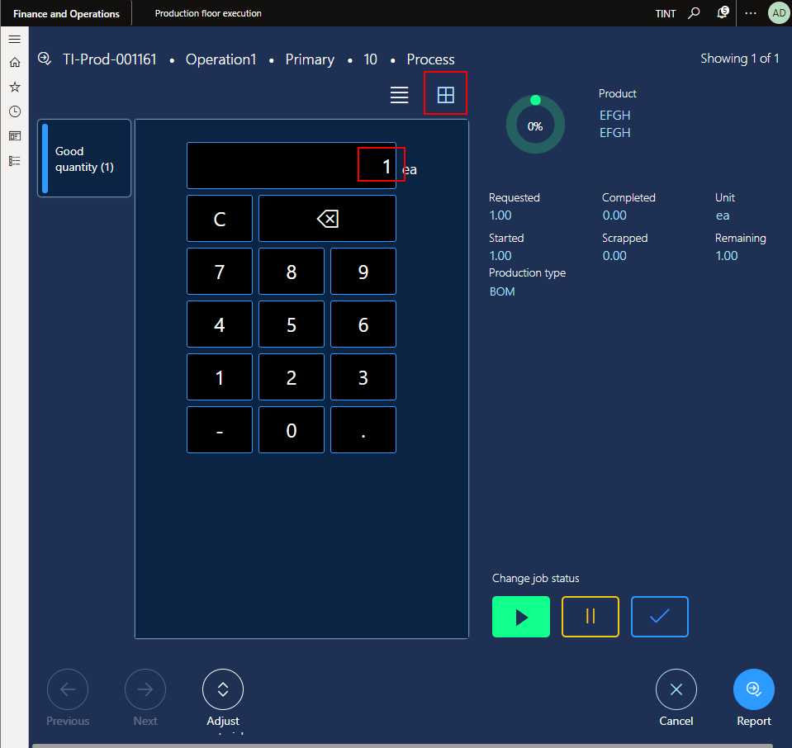

1. When the job is completed click the checkmark. If time spent on the operation exceeds the estimated time, an error will appear asking user to please fill justification reason.

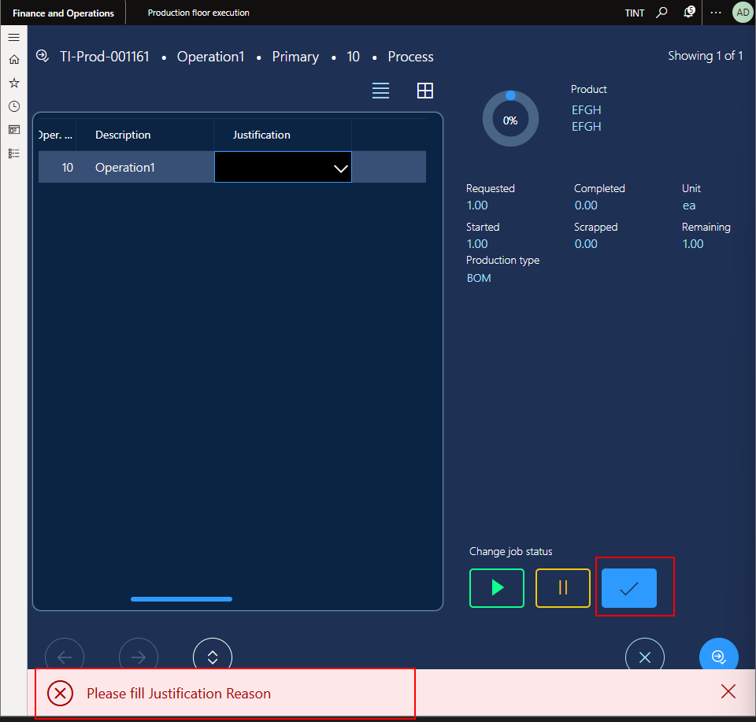

When filling in the reason, press report progress.

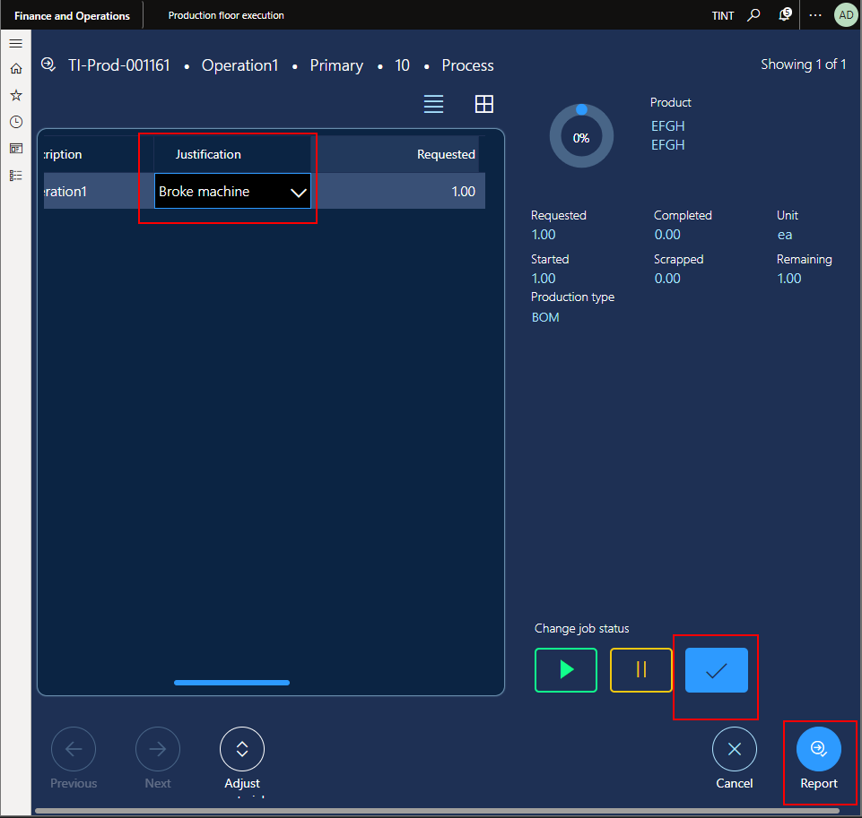

1. When clicking Report, 2 journals will be posted.

One for the quantity and one for the time spent on the job which will be calculated based on real time from the time that the user started the operation to the time the user completed the operation.

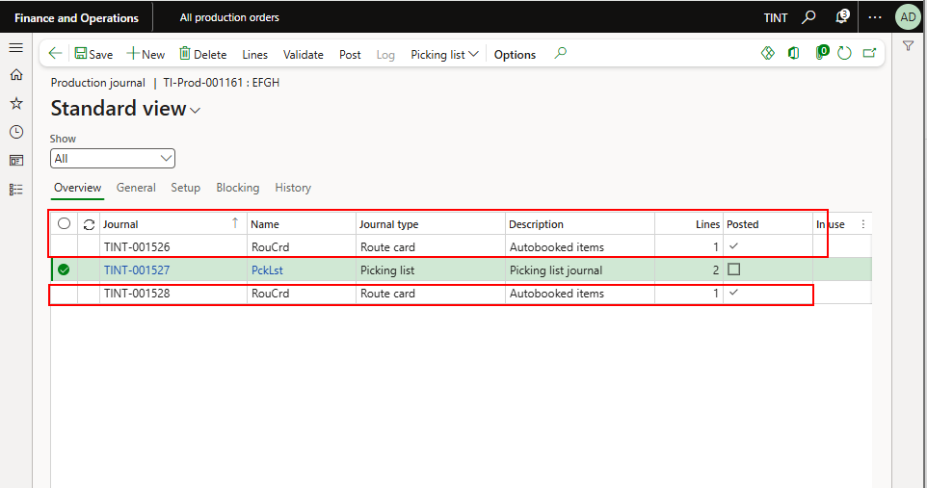

1. Complete for all jobs in the production floor execution interface.
2. If at any time, user wants to report scrap, they need to press Report scrap on the production floor execution and Report.

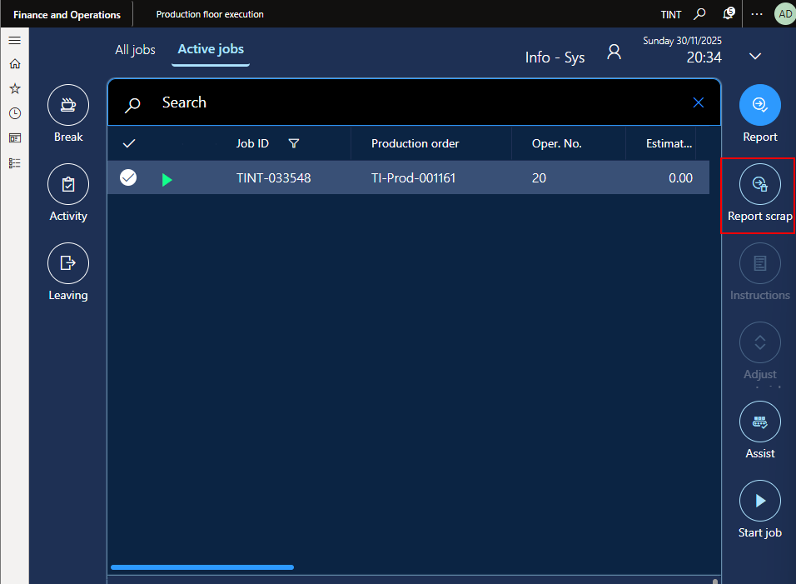

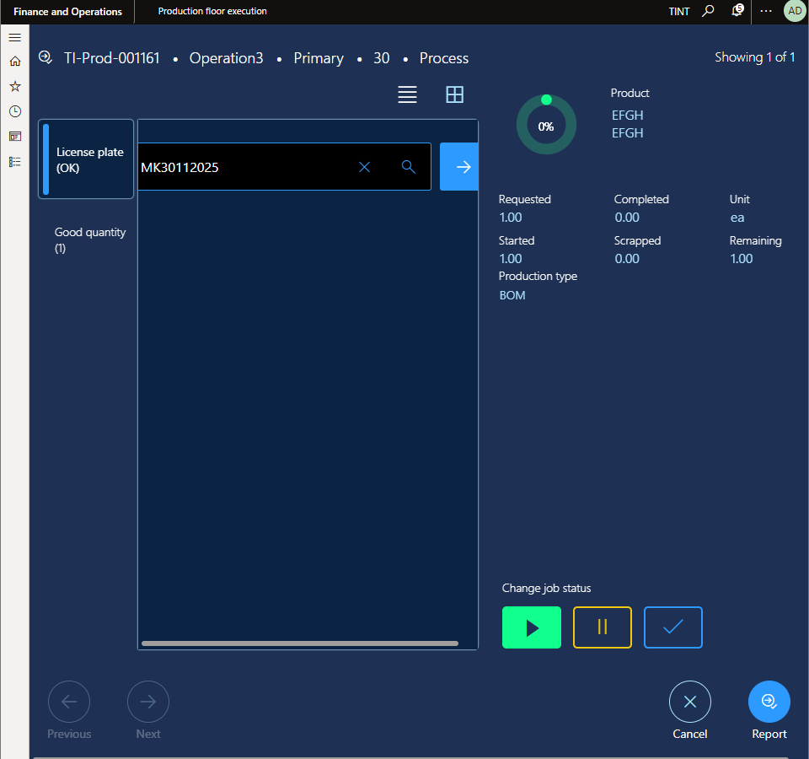

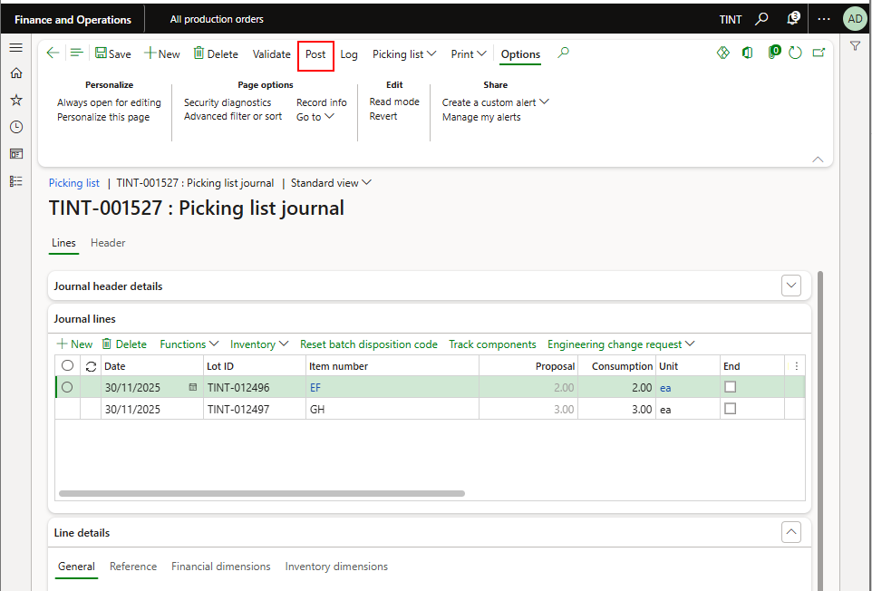

1. After finishing the last job on the production order using the production floor execution the system will ask you to enter a license plate number (Copy production order number and paste it in the license plate) , a good quantity and press the complete checkbox.
2. A picking list is generated to consume the material needed for the production order but is not posted.

Under View > Journals > All

At the end of the production order, press Post the picking list journal with the actual consumed quantity.

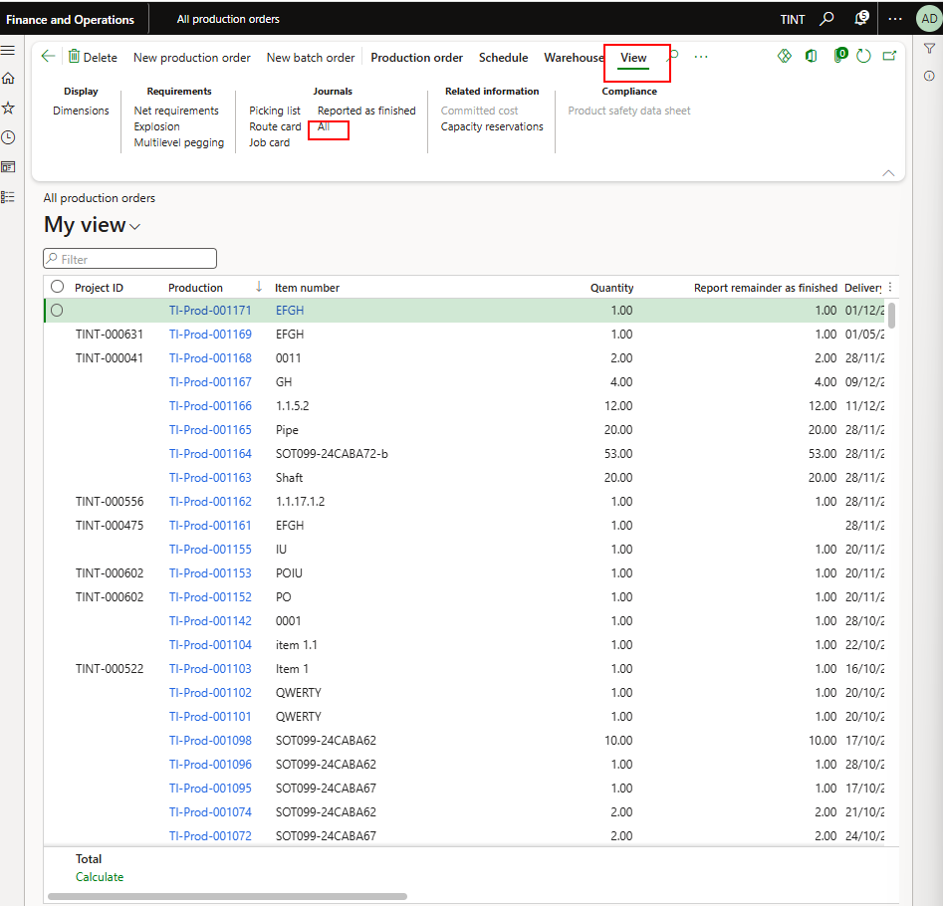

~~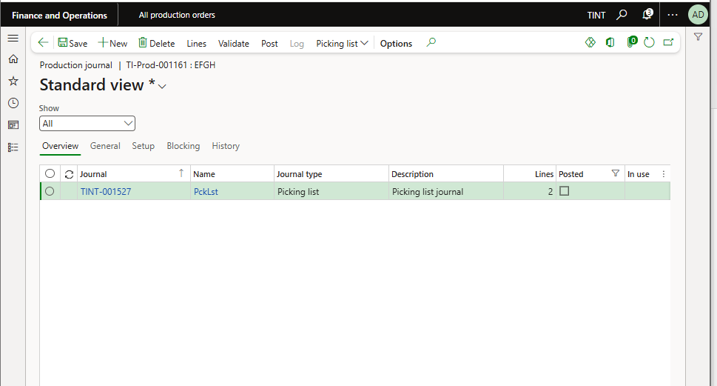~~

Press on lines and here you can change the actual consumption of the item

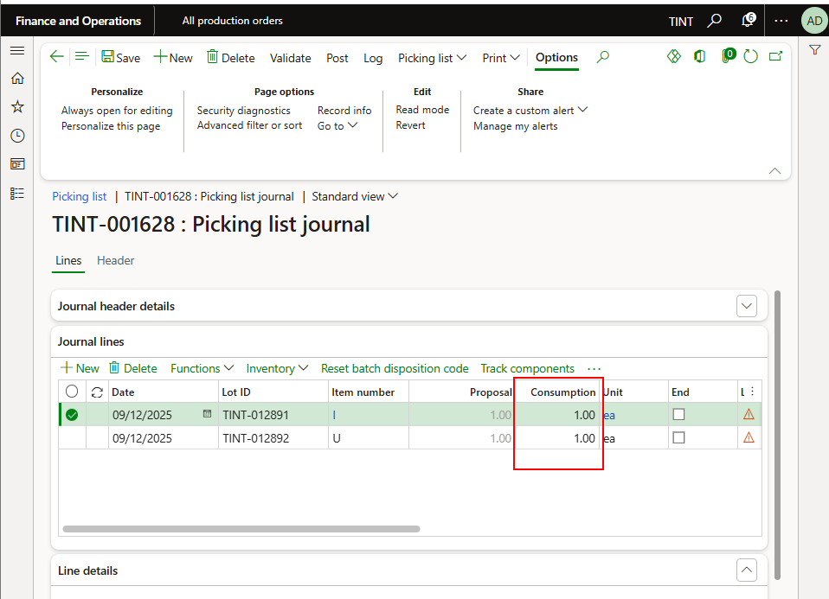

1. After posting the picking list, post the report as finished journal. Under production order > process > report as finished. Fill in the details good quantity, error quantity in case of scrap and press OK.

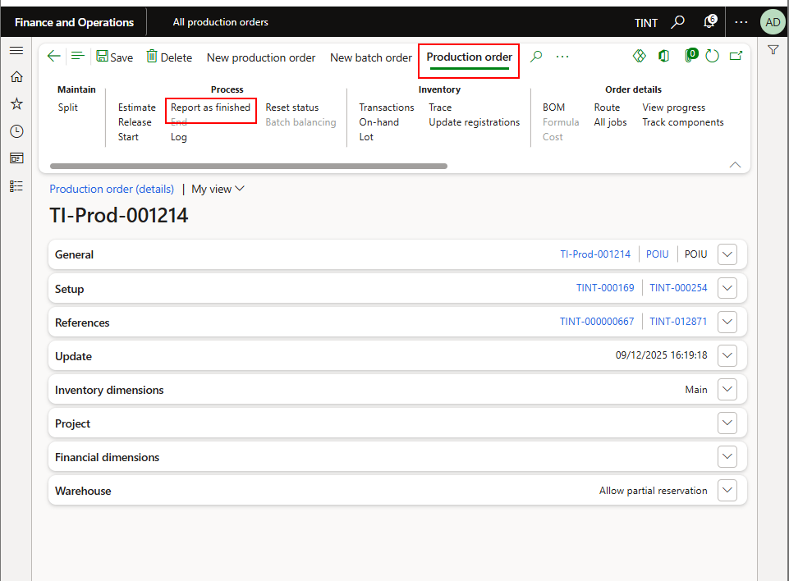

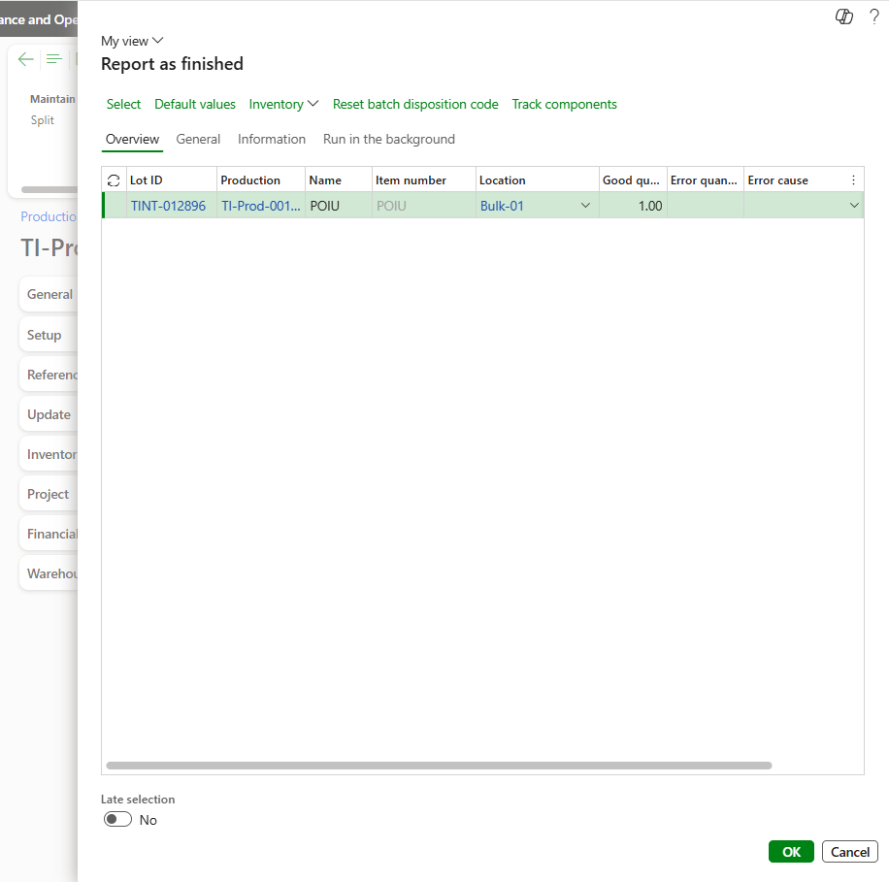

In case of error quantity, report error quantity in the report as finished journal and run MRP again so the system captures the requirement again and links it to the parent production order.

1. End the production order (Under production > process > End), after you have ended the production order you cannot edit in the production order.

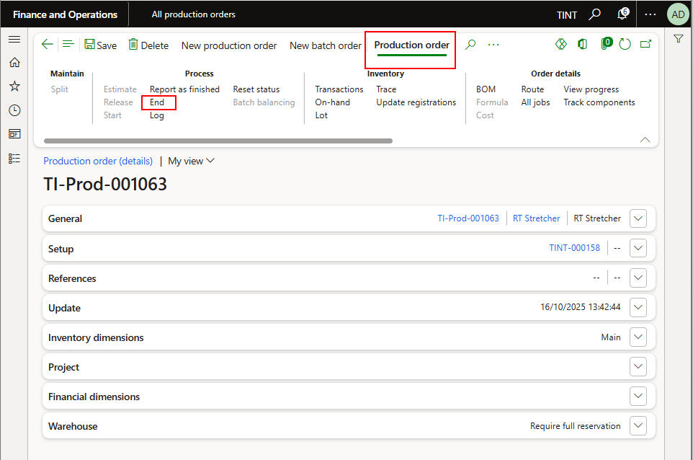

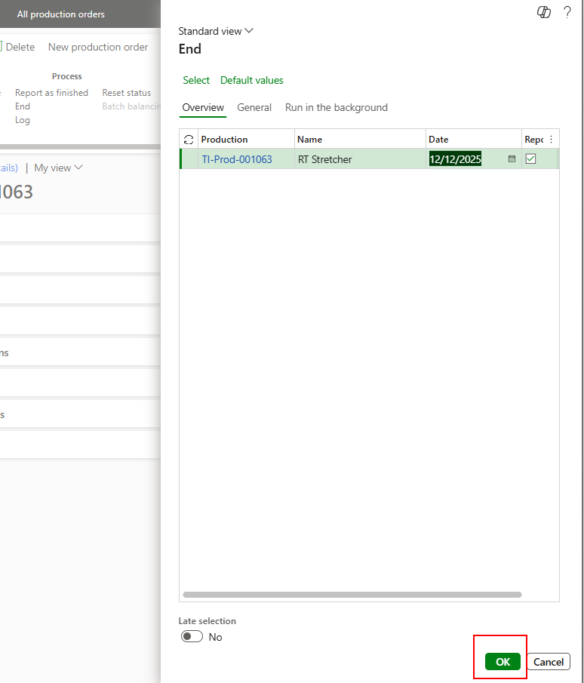

1. After ending the production order, you can compare the estimated cost price against the realized cost price to get an overview of the production variances. Under manage costs > calculations > view calculation details. Select overview costing

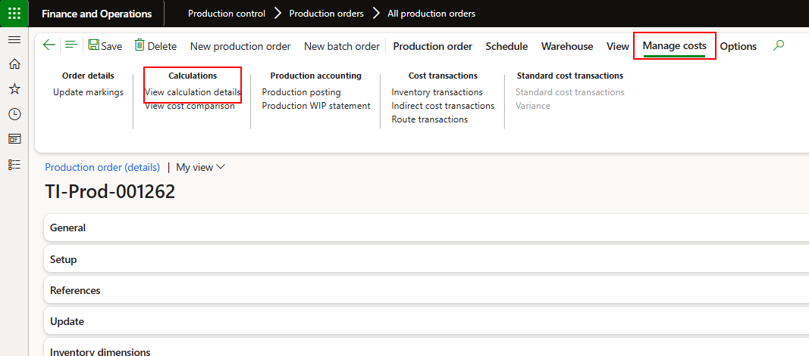

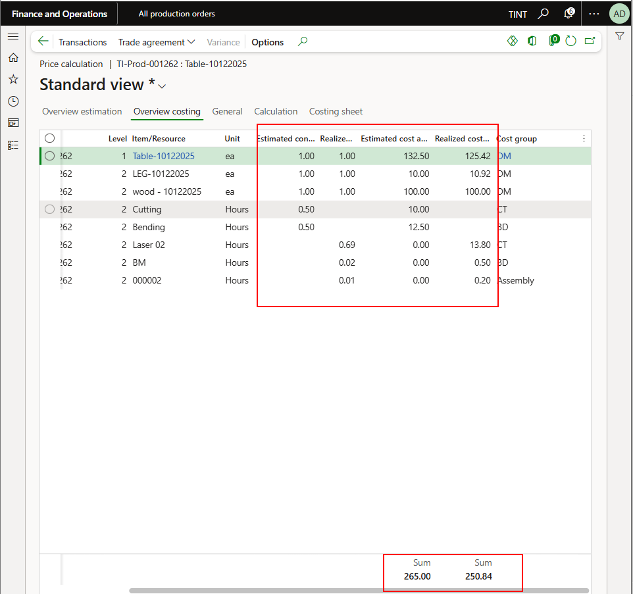

## Create a manual production order

The production order contains information about what to produce, the quantity to produce, and the planned delivery date. It also contains information about which materials to consume, and which processes to follow to produce the item. The same applies when creating a production order for items that are reported as rework.

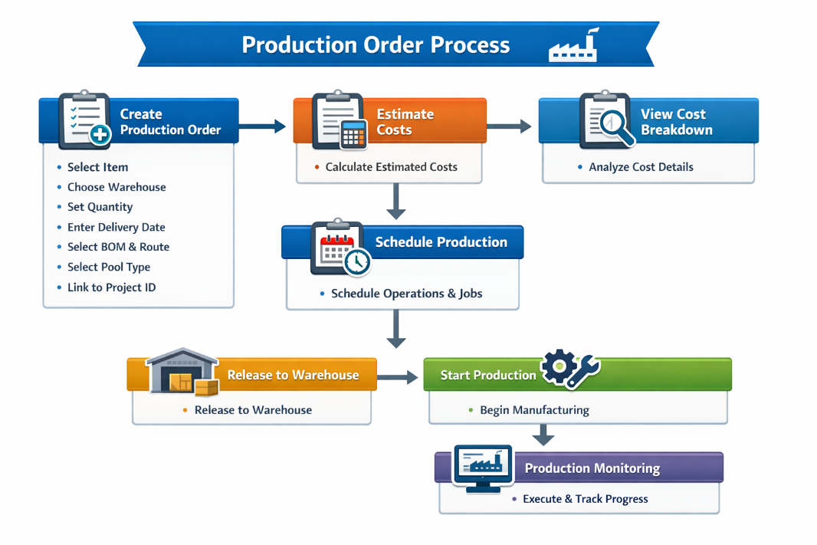

1. Go to Production control > Production orders > All production orders.
2. Select New production order.
3. In the Item number field, select the item that you want to produce.
4. Select the warehouse of the produced item.
5. Set Quantity.
6. In the Delivery field, enter a date. The delivery date indicates when the production order should end to deliver on time. This date is used when scheduling the production order.
7. Select the BOM number and route number or you can add them manually on the production order.
8. Select the required pool type (Non-conformity, customer request, snags from site, factory rework)
9. Select Create.
10. Link it to the project ID

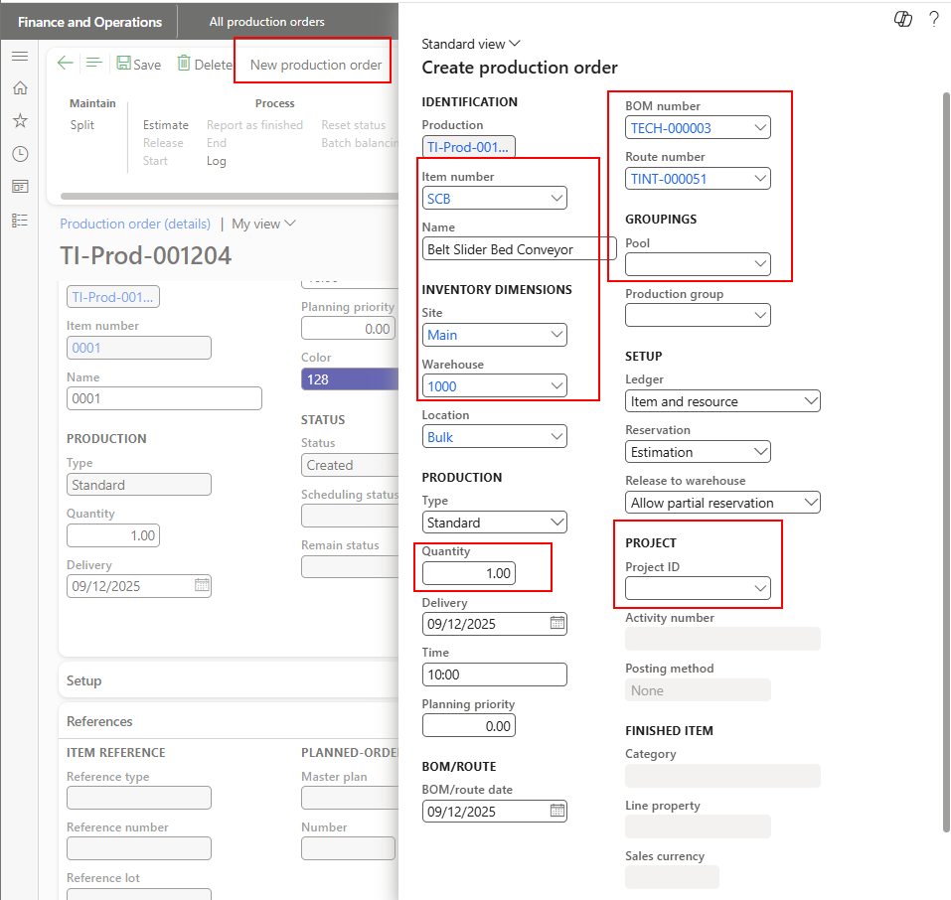

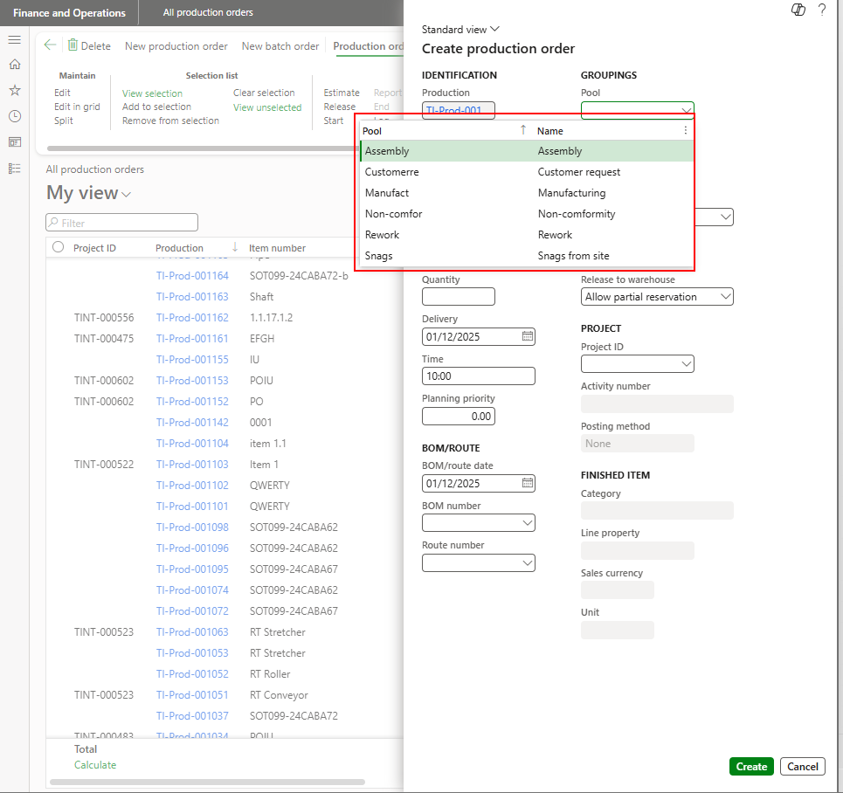

1. Estimate the production order. In this step, the estimated costs of a single production order are calculated.

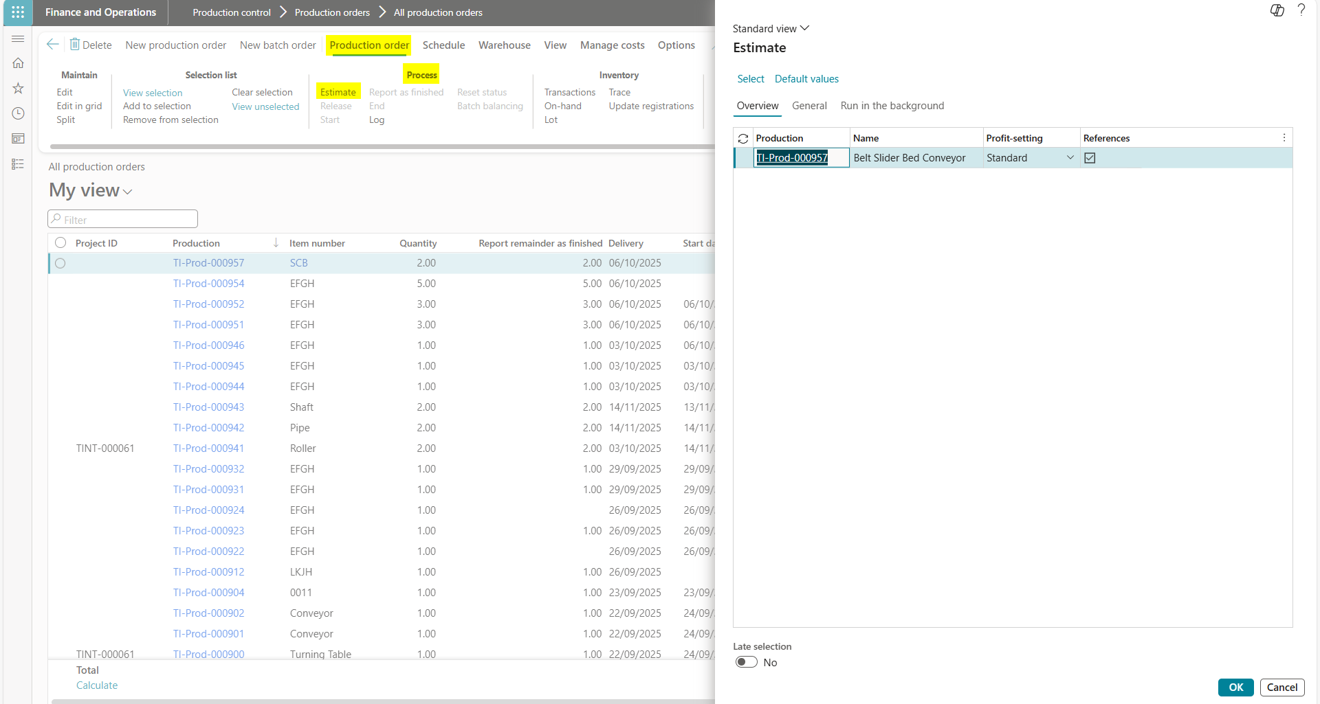

1. To view the calculation details
   1. On the Action Pane, click Manage costs.
   2. Click View calculation details.

This page displays the cost breakdown. For example, you can view the total cost price per unit for the finished product in the first row. The subsequent rows contain costs according to the bill of materials, production route, and indirect costs.



1. Schedule the production order (Schedule operations and then schedule jobs).

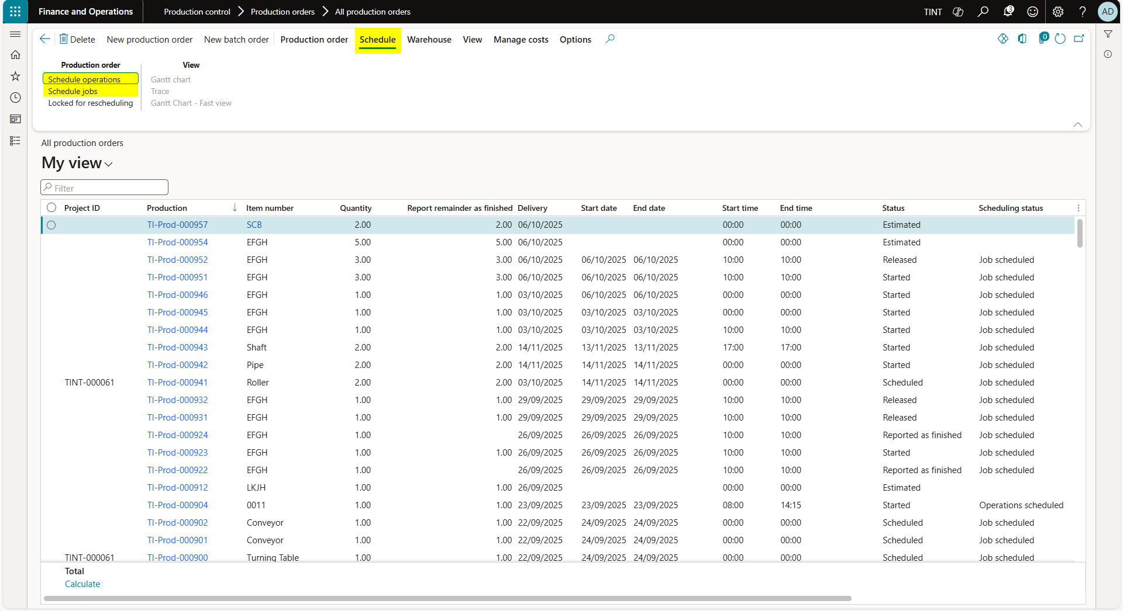

1. Proceed with the same steps for the release of the warehouse and the executing of production using the production floor execution as mentioned earlier.

## Add BOMs manually or take a copy from the existing BOM

Adding BOMs manually is mainly used when additional material is needed to complete the production process or when firming the planned production order, the BOM is not complete. If one bill of material is the same for many items, it can be copied across. The steps are explained below.

* + - 1. You can update BOM by adding or removing items from the BOM of the production order then the user should re-estimate and reschedule the production order. Re-estimate is used to estimate if this modification requires any material to be added to the production order. And rescheduling is used to schedule the jobs needed to complete the production order.

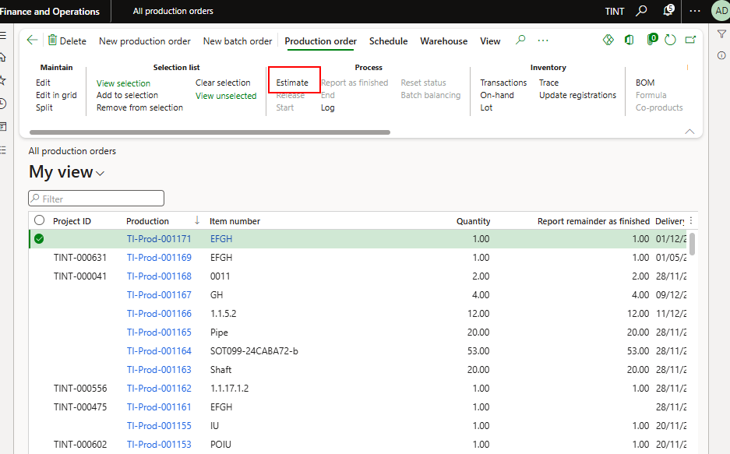

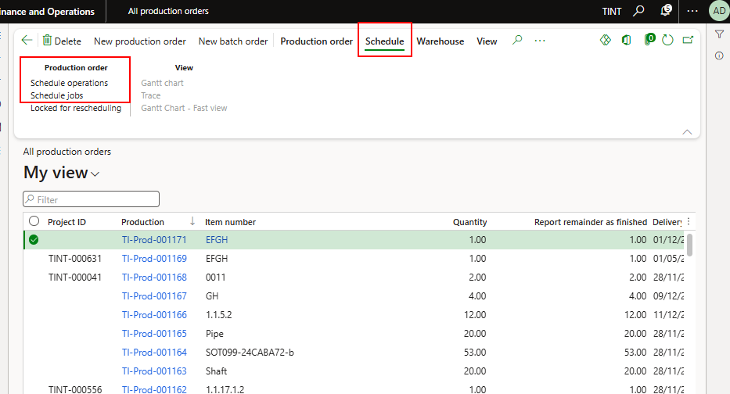

* + - 1. You should update the BOM before releasing the production order to the warehouse for the inventory to know the exact material needed for production.
      2. In case the user wants to copy a BOM in case the same BOM is used for many assemblies (Production order > Production details > BOM, then select Copy), the production order needs to be in Created state. You can reset the status to created (Production order > process > Reset status).

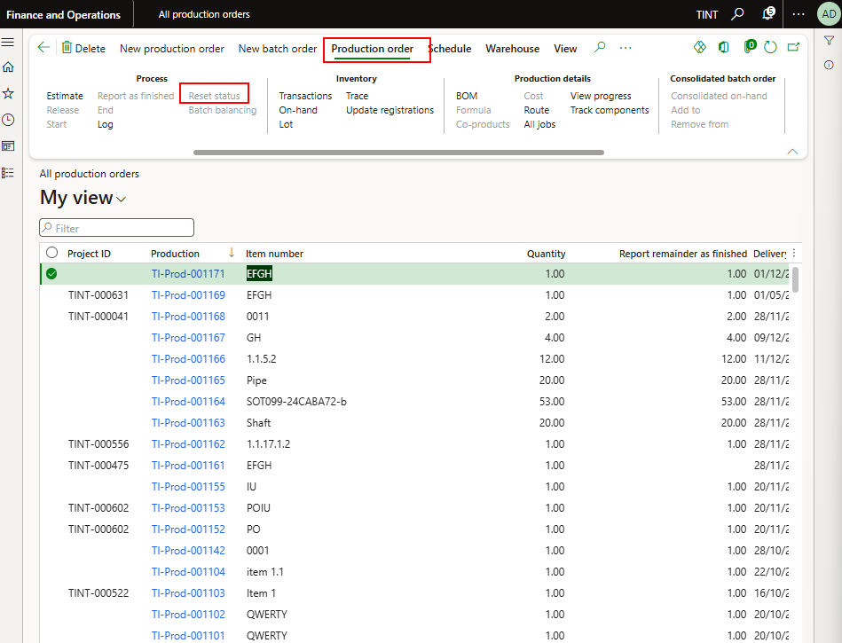

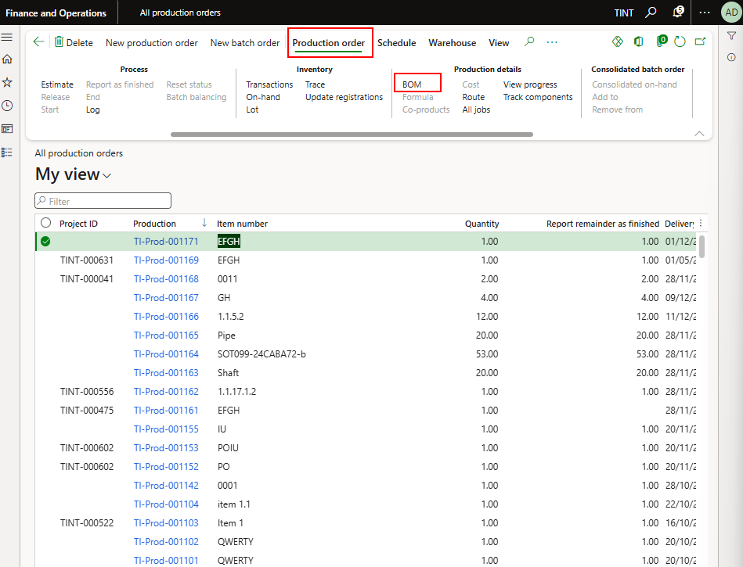

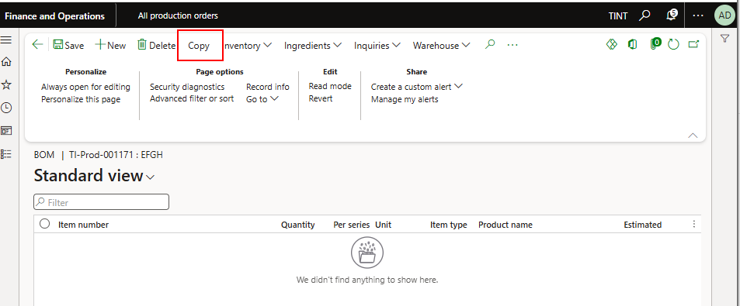

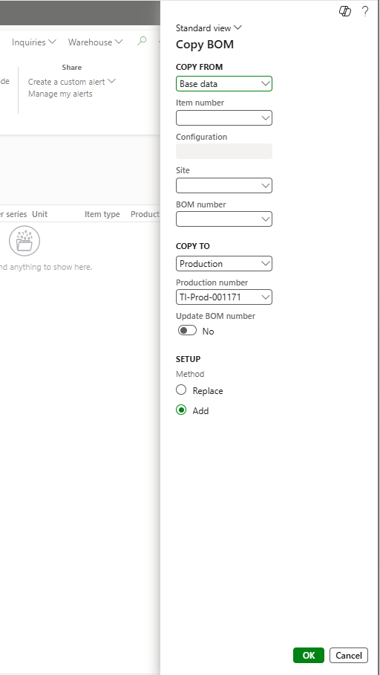

* + - 1. After successfully copying, the production order needs to be estimated (Check the availability), scheduled again (For production jobs to be scheduled after the update), and then released (To pick the material from the inventory) before starting the production

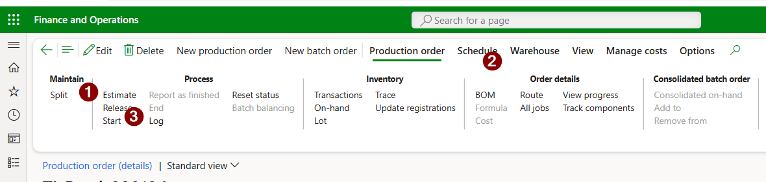

## To edit any BOM for a production order

Modifying an existing BOM can happen for many reasons such as material substitution, customer customization, exception, and quantity adjustment. If any of these occur, a modification of the BOM is needed.

1. Select the production order.
2. Production order > Production order details > BOM.
3. You can delete any line or add new line in the BOM.

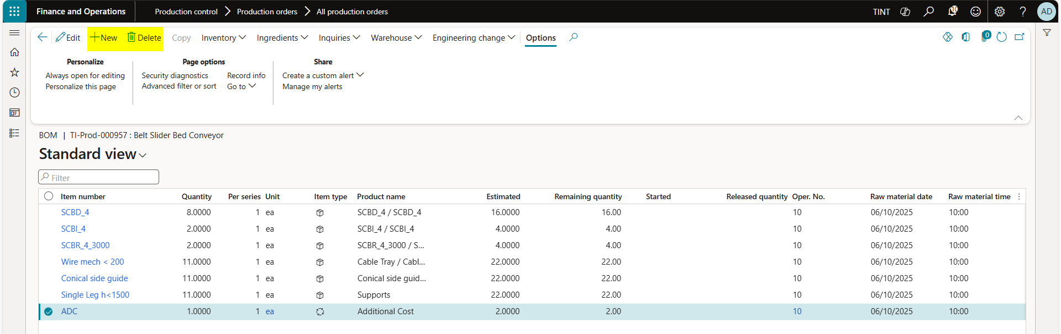

1. Click new to add new line.
2. Choose the item number that you want to add, line type (pegged supply), quantity, unit of measurement and the inventory dimensions.

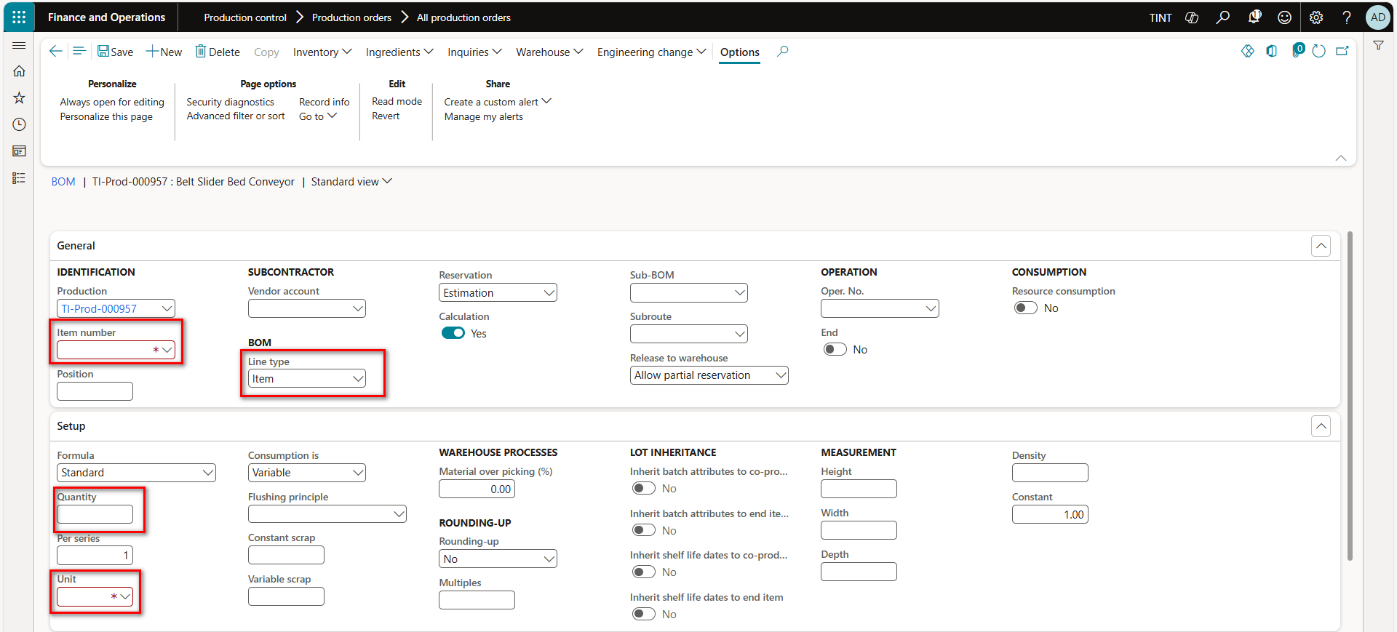

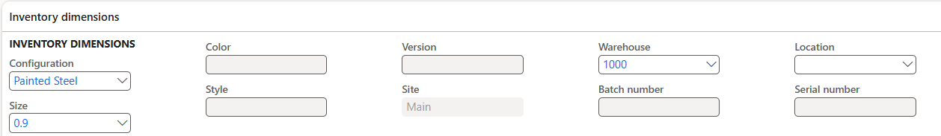

1. Click save.
2. The system will give you a prompt message to re-estimate the production order based on the new BOM.

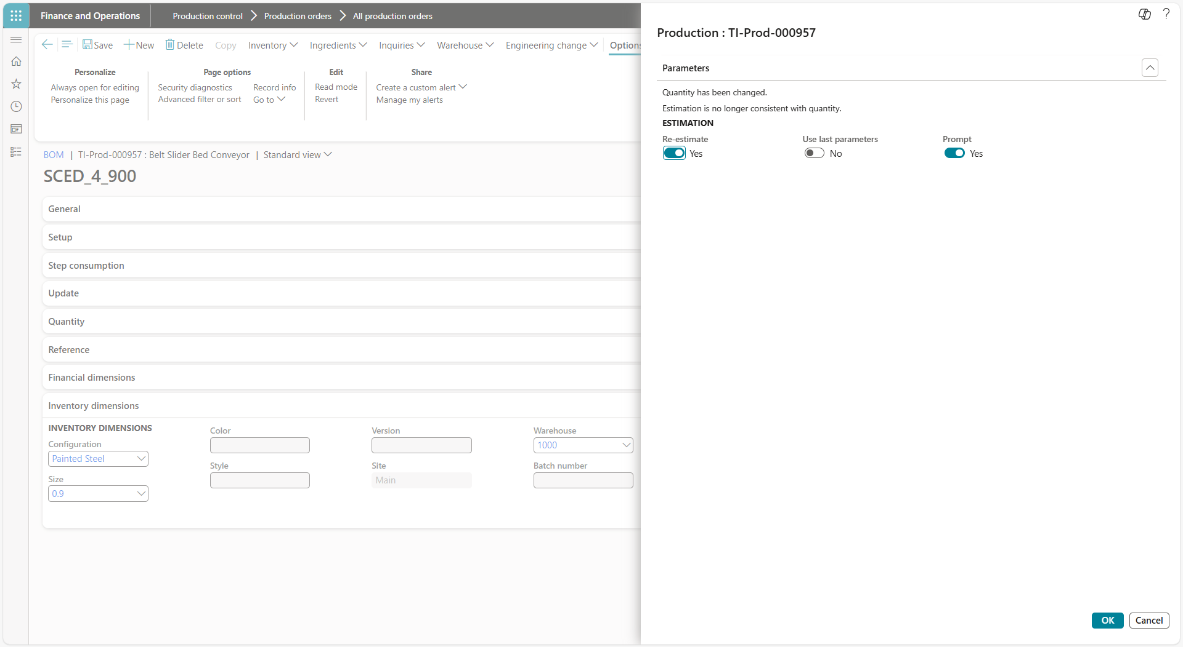

## Add routes manually or take a copy from existing route.

When you have a special or a one-time production, rework orders for any reason, different process is needed to achieve a better result than adding routes or even operations to an existing route might be needed. Copying from existing route is helpful when items undergo the same operations to be produced or when a common route is used mainly called the Master route, but small modifications are needed. It is optimal to copy the master route and then edit the route on the production order to fit the specific item.

1. Manual Route
   1. Select the production order.
   2. Production order > Production order details > Route.
   3. Click on new to add new operation.

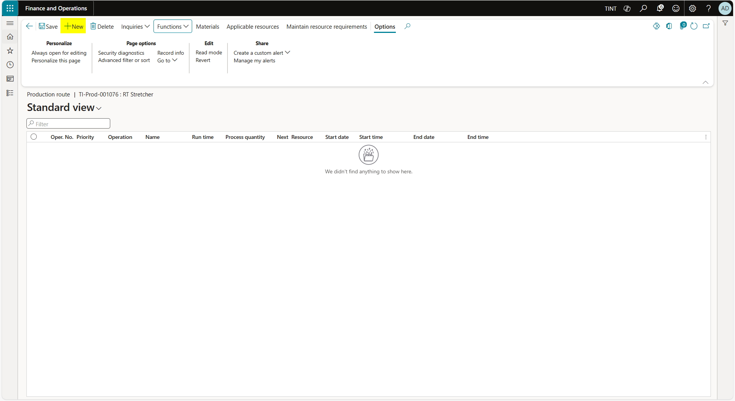

* 1. Enter the operation number.
  2. Choose the operation.
  3. Choose the route group. (we will only have 1 route group named Discrete manufacturing). Route group is defining what times are considered when scheduling the production orders. It is a one-time setup.
  4. Enter run time cost category. The run time category is needed to calculate the estimate and the realized cost for the operation.
  5. Enter run time and the setup time of the operation to produce 1 quantity. Choose the resource requirement of the operation.

The most used resource requirements are:

Resource group: the resource group can contain a mix between machines and human resources. Upon scheduling the production order, the system will consider the availability of a specific resource in the resource group and book the operation against it.

Resource: choose resource if a specific resource is needed to perform the operation.

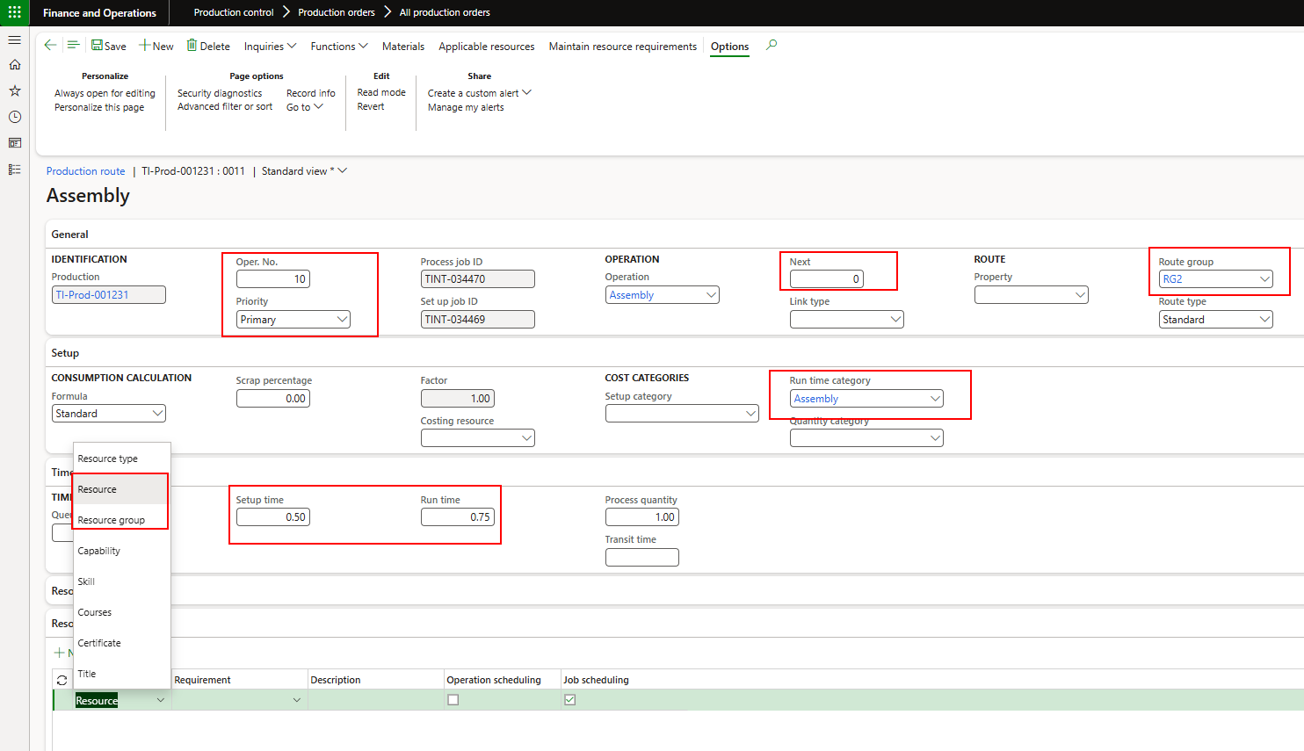

Copy Route

* 1. From Functions > Copy. The production order needs to be in Created status (You can reset the status from production order > process > reset status)
  2. Select the item number that you want to take a copy from.
  3. Select the route number that you want to take a copy from.

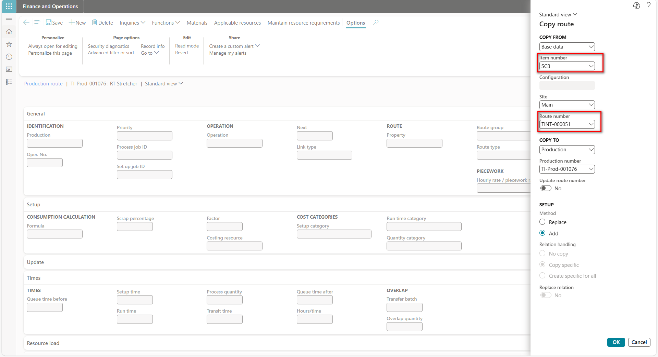

* 1. After successfully copying, the production order needs to be estimated, scheduled again, and then released before starting the production



## Removing an already produced item (Stock adjustment)

It may happen that a subassembly is removed from a main assembly and this subassembly is already produced. The production clerk needs to do a stock adjustment to remove this subassembly from inventory if it is not required anymore or else transfer it to main stock if it might be used later on.

When you use an inventory adjustment journal, you can add cost to an item when you add inventory. The extra cost is automatically posted to a specific general ledger account, based on the setup of the item group posting profile. Use this inventory journal type to update gains and losses to inventory quantities when the item should keep its default general ledger offset account.

1. Navigate to Inventory management > Journal entries > Inventory Adjustment

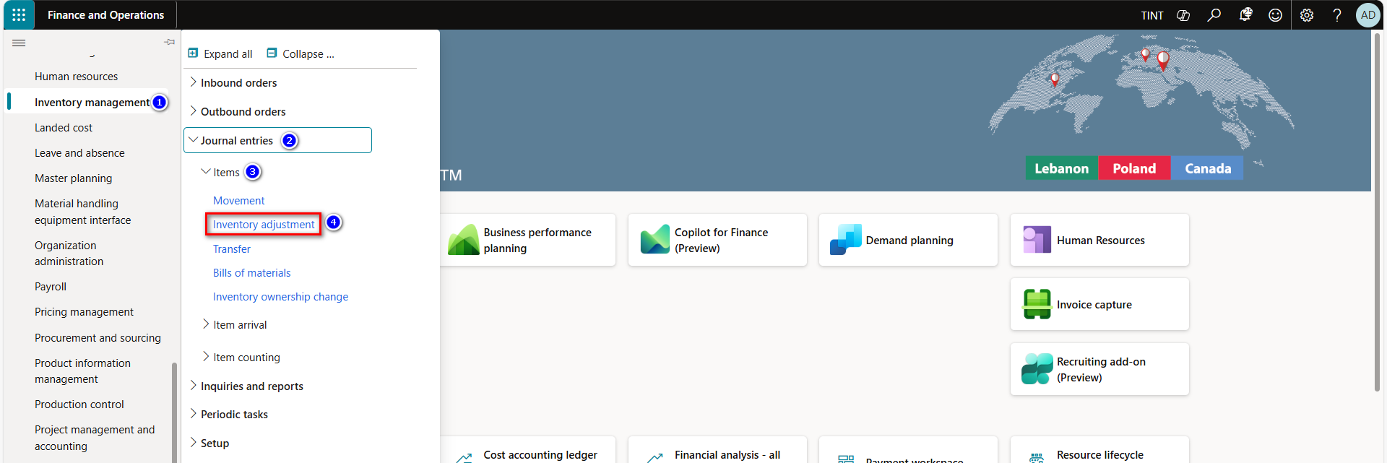

1. Click New, to create new journal.

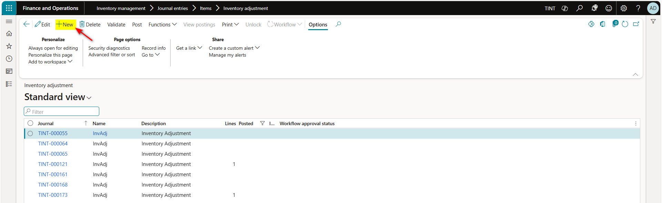

1. In the journal lines Fast tab, click New to create a new journal line.
2. In the Item number field, select the item number.
3. In the Warehouse field, select the warehouse.
4. In the Quantity field, enter the quantity.
5. In the Cost price field, enter the cost price for the item.
6. Click on Post, to post the journal.

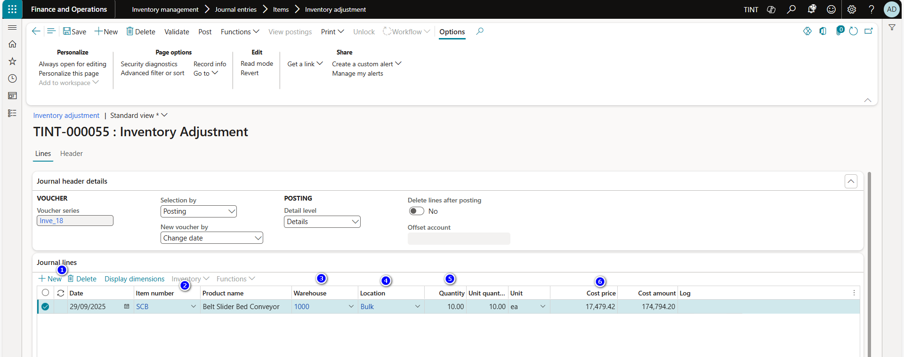

## BOM journal for dismantling

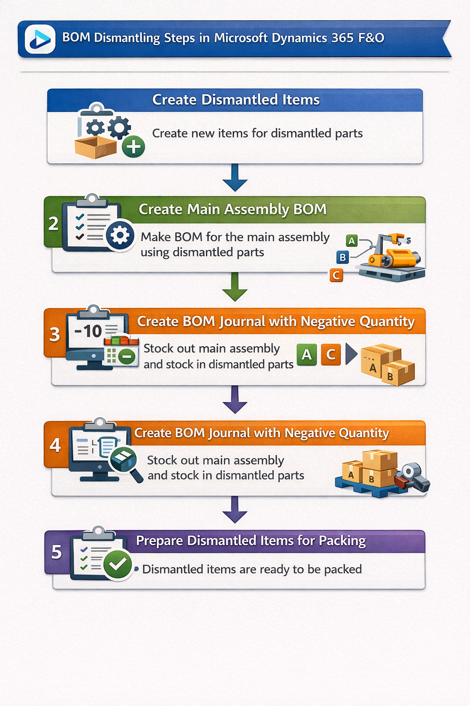

**Create Products for Dismantled Parts**

* + Create new products for dismantled assembly/assemblies if not already in the system.
  + Create a new BOM for the main assembly containing the dismantled assemblies. Approve and activate the BOM. Refer to the BOM creation in this manual. BOM is the link between the main assembly and the dismantled items. In this step, you are telling the system that I need to dismantle the main assembly into item 1 and item 2 ..
  + Add the selling price of the assembly/assemblies ensuring that they sum up to the total selling price of the initial assembly. This step is needed to keep the financial inventory and the cost of the main production aligned,
  + Under tab engineer > process > report as finished; enter negative Qty as needed (Negative quantity details a stock out of the main product) and select the updated BOM and add product location bulk.

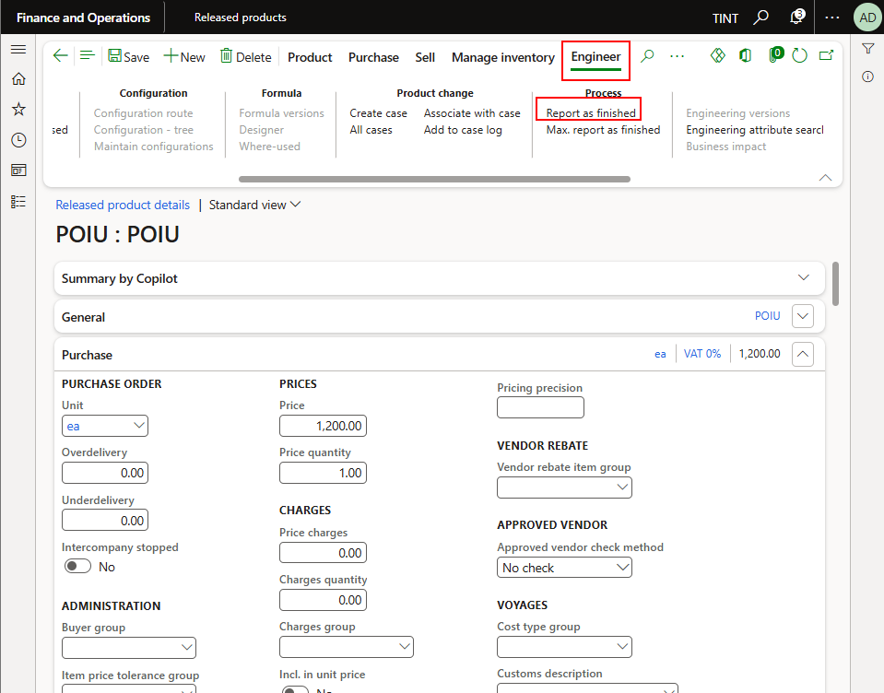

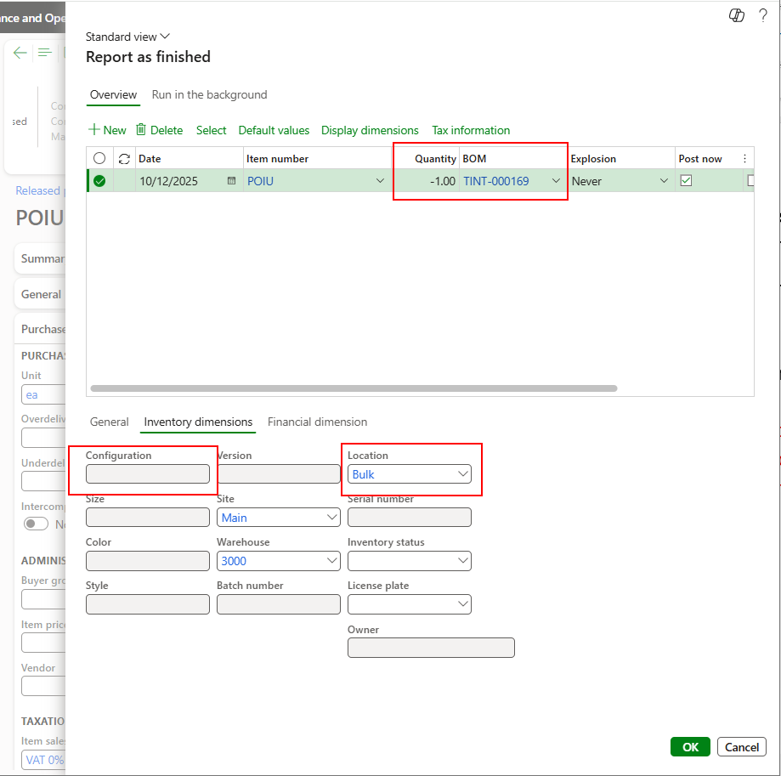

* The system will auto create BOM Journal notifying us of the BOM journal number & that the locations of the BOM lines are missing.
  + Navigate to Inventory management, Journal entries, Items, Select Bill of Material, open the BOM journal number and update the locations accordingly.
  + Post the BOM Journal (When posting the BOM journal, the main assembly is removed from the inventory and the dismantled items that are added to BOM of the main assembly are added to the inventory).

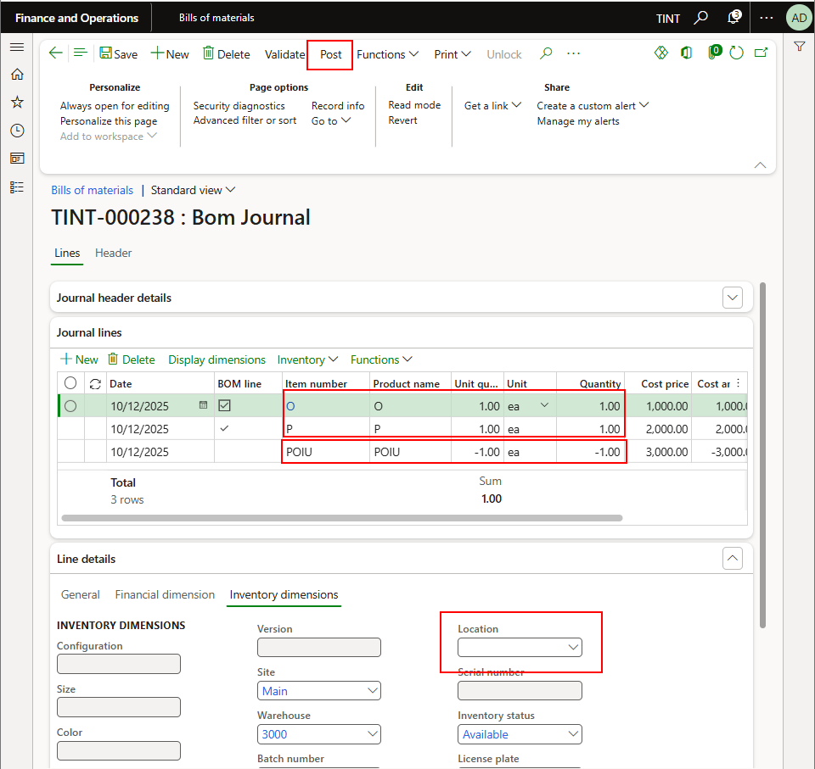

## Release Sales order, Packing and containerization

When the product is ready to be packed, it needs to be moved from the inventory to the packing location. Moving it from inventory to the packing location is done by releasing the sales order to warehouse.

After the items are in the packing location, the packing and containerization process will start in order to pack the final products into containers.

Dismantling the main assembly requires “Explode > BOM lines” on the initial the project sales order before releasing it for packing and containerization. Releasing the sales order:

* + - * 1. Navigate sales and marketing > sales orders > all sales orders. Filter on project ID for easier selection of the corresponding sales order.
        2. Select the sales order line.
        3. Under sales order line > explode > BOM lines. (If the item is shipped without being dismantled, disregards this step. If the item needs to be broken down into BOM items whether the original BOM or the dismantled BOM then this step is applicable)

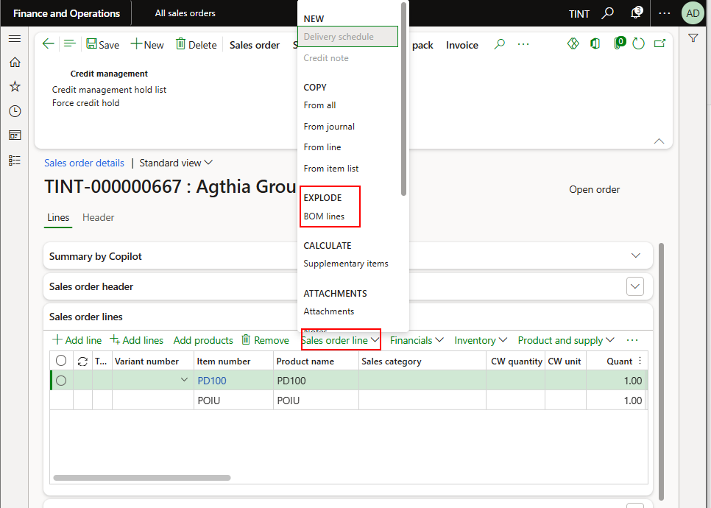

Select the BOM items that are dismantled

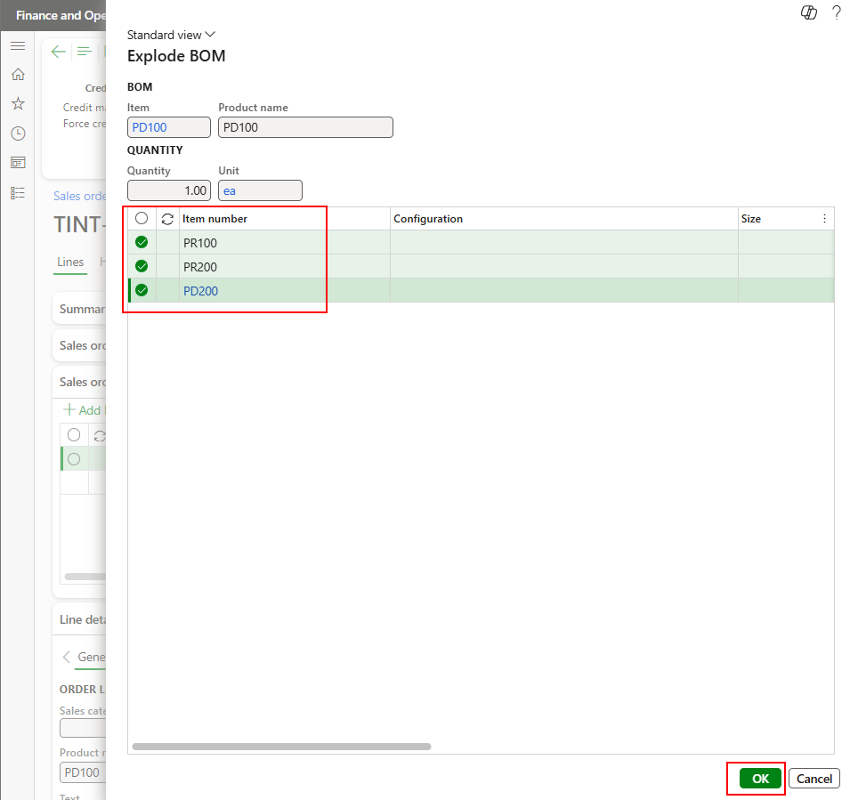

* + - * 1. The project manager/user releases the sales order;

Navigate sales and marketing > sales order > all sales order

Select the sales order

Under warehouse > actions > select release to warehouse

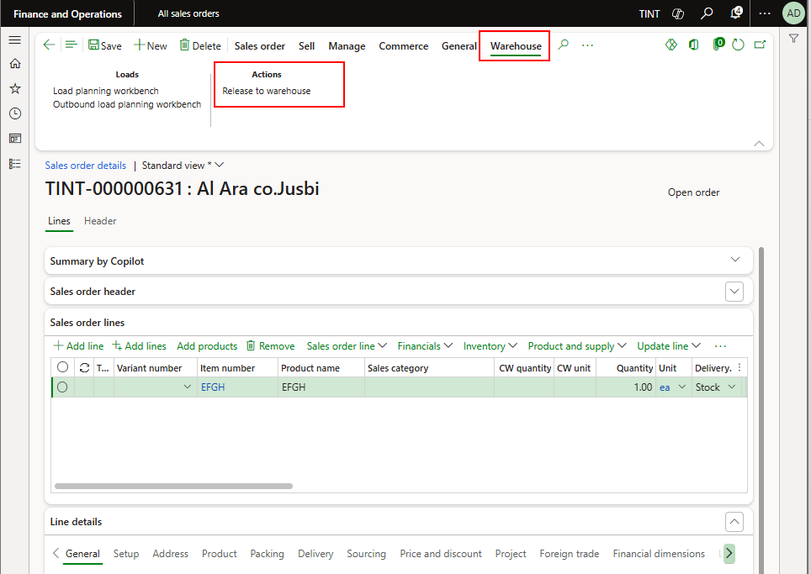

* + - * 1. To start the packing process, the shipment ID is required. The shipment ID can be located on the sales order from the line level or from the active shipments screen. The packing and containerization process is based on the shipment ID.

From the sales order screen:

Select warehouse on line level > shipment details

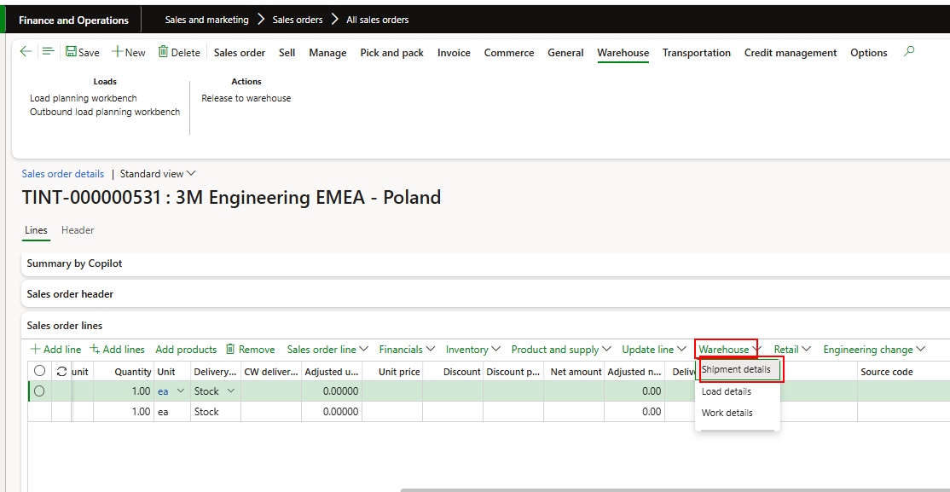

* + 1. From the active shipments screen:

Navigate to warehouse management > Shipments > Active Shipment

Insert the sales order column. Filter on the order number

Take note of the shipment ID

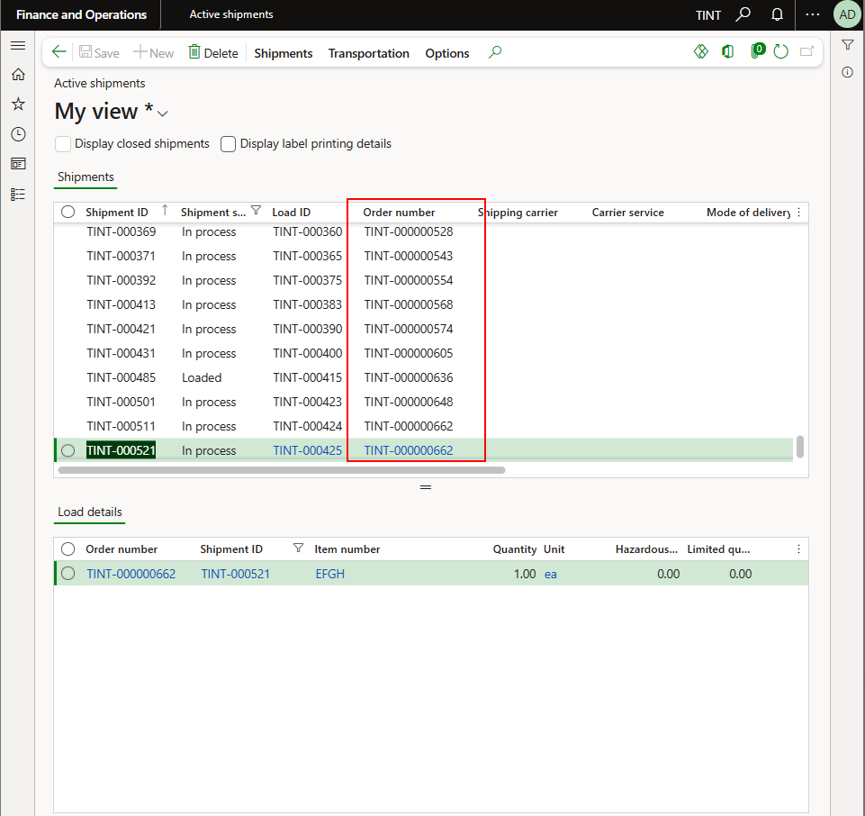

* + 1. Navigate to warehouse management > packing and containerization > pack
    2. Enter the shipment ID

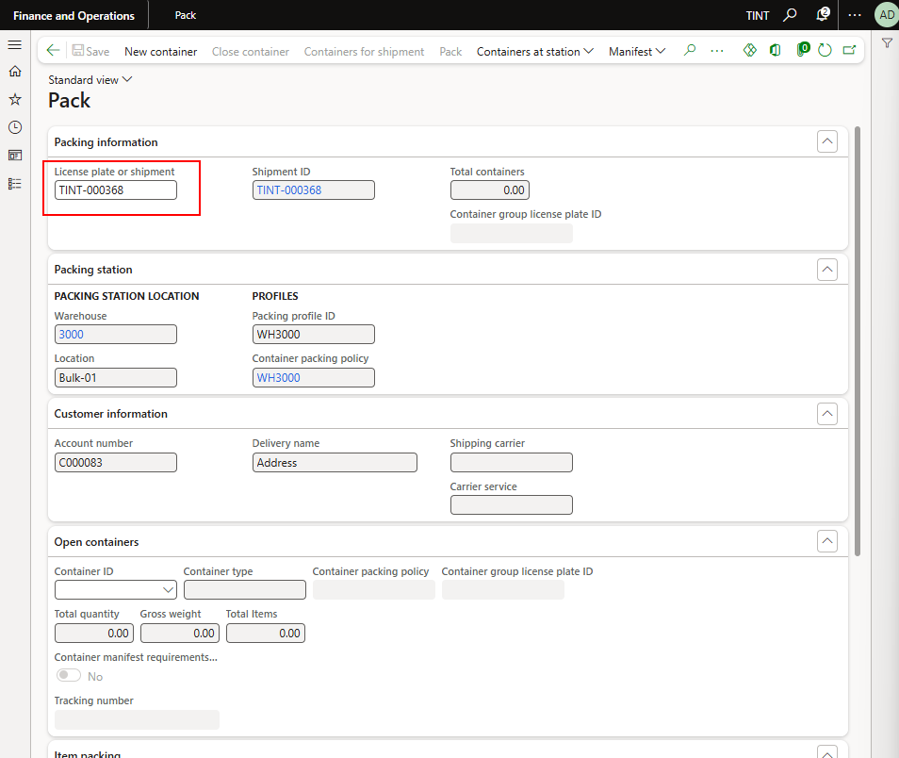

* + 1. When selecting the shipment ID, it will show the open lines.
    2. To pack them into containers, select new containers

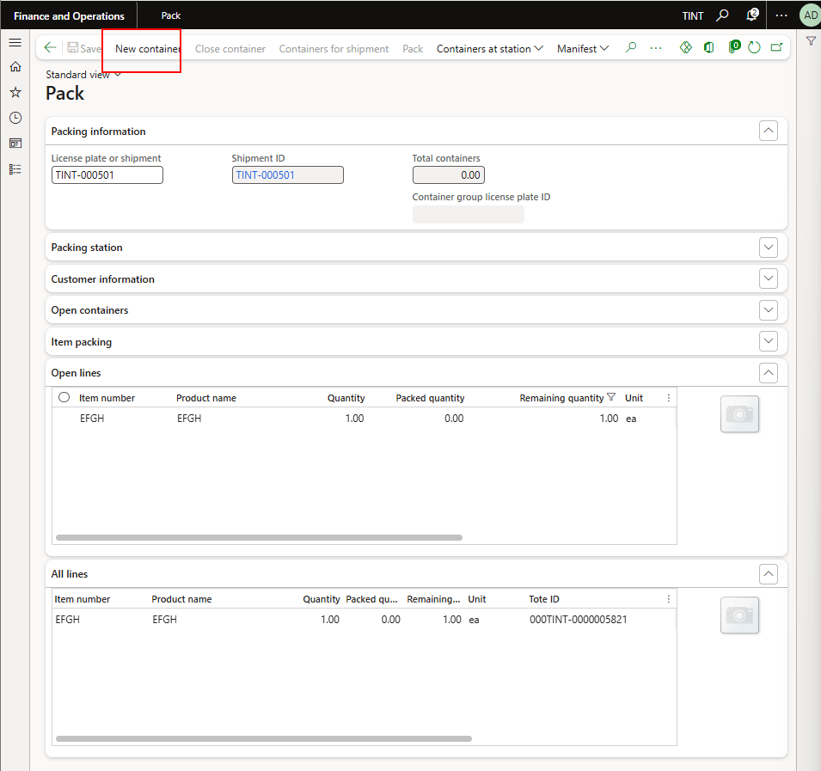

* + 1. Under item packing you can select the desired quantity and an item

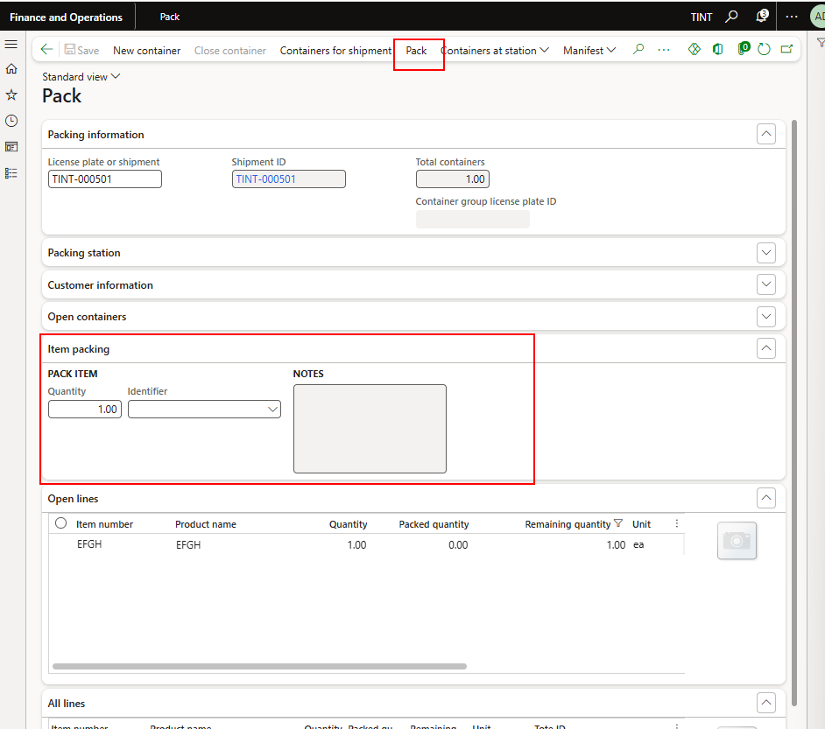

* + - * When selecting the item, it will disappear from the open lines
      * Select containers for shipment to see the container contents

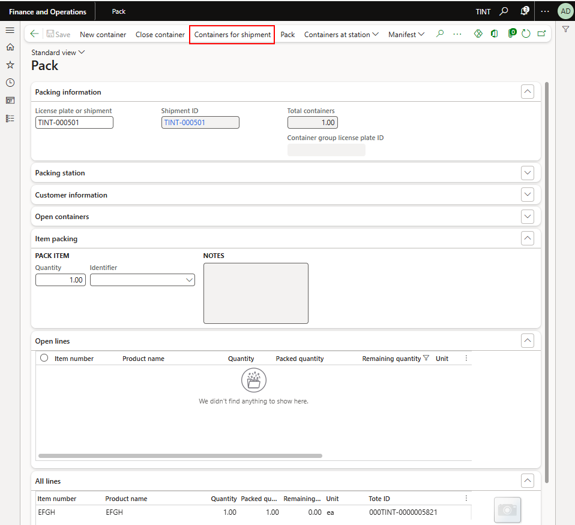

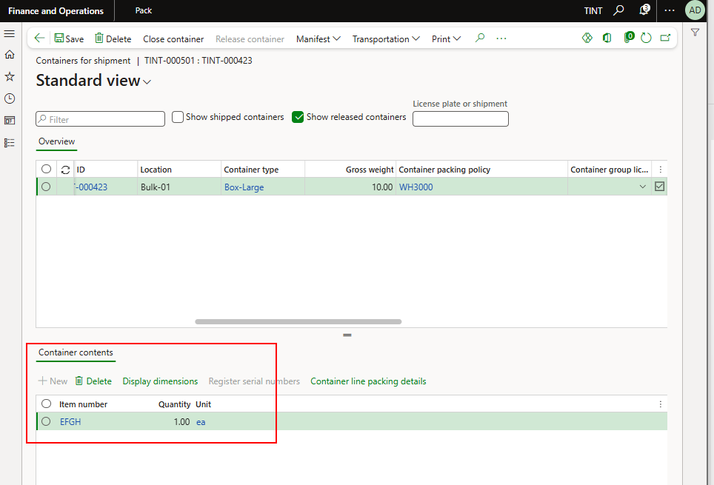

* + 1. Select Close container if the container is complete and specify the weight of the container or get the system defined weight.

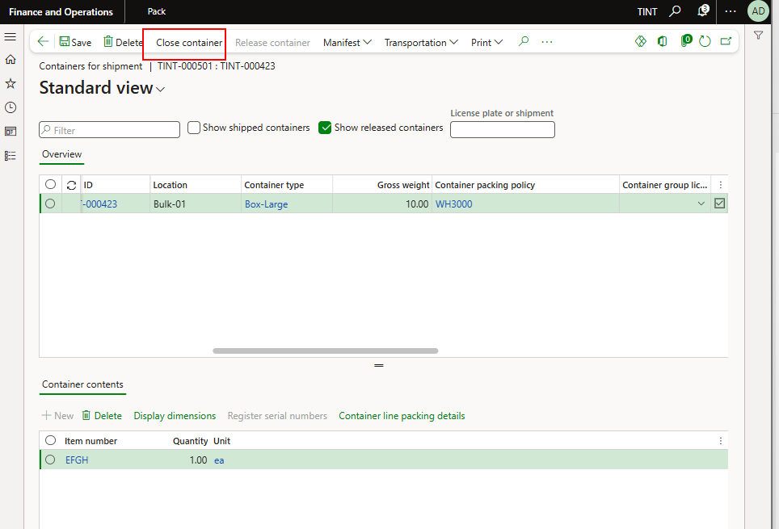

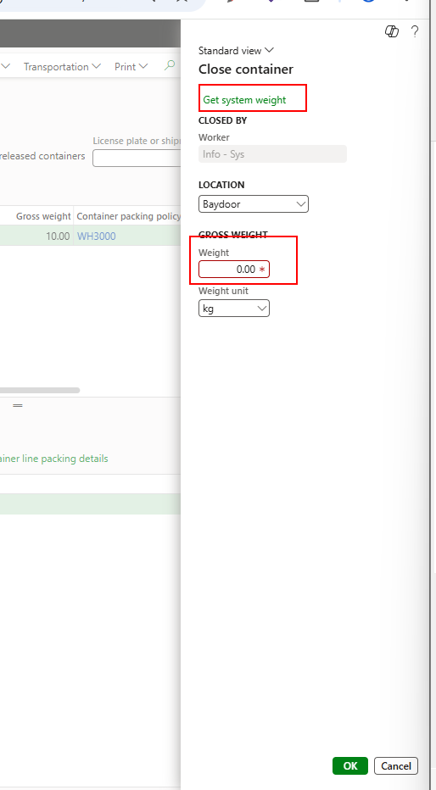

* + 1. Select release container to release the container to the last location

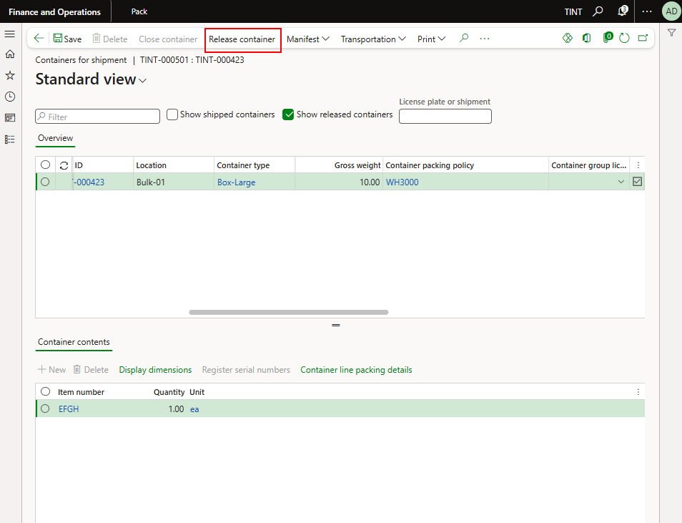

* + 1. After releasing the container, logistics will generate a packing list, collect transportation tenders, and printing the commercial invoice.

## Returning the unconsumed raw material to the inventory (Transfer journal)

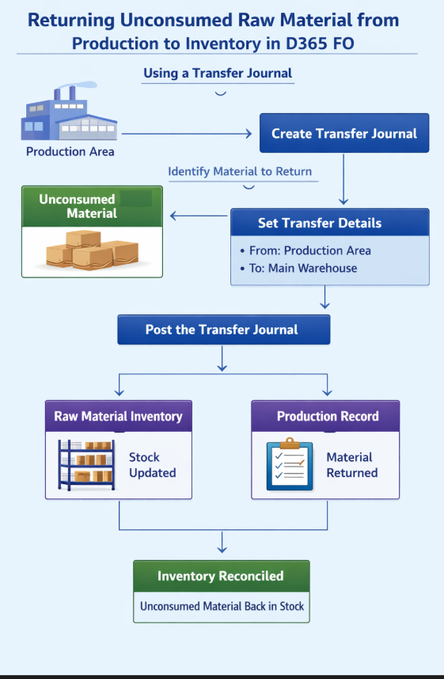

The process starts by identifying the unused material in the production area and creating a transfer journal to move the items back to the inventory. The transfer journal is an inventory journal mainly used to move items from one location to another. The transfer details are entered in the journal and specify that we are moving from the Prod-In location, which is the production area to BULK location, which is the main warehouse. Once the journal is posted, the stock is updated and the material becomes available for use.

1. Production will post the picking list for the production order with quantities less than the quantities that are needed initially. To return the unconsumed remaining quantity from factory to the inventory, a transfer journal is needed.
2. **Remaining items report should be developed to reflect the on-hand remaining quantities of a specific project.**
3. Navigate to Inventory management > Journal entries > Transfer

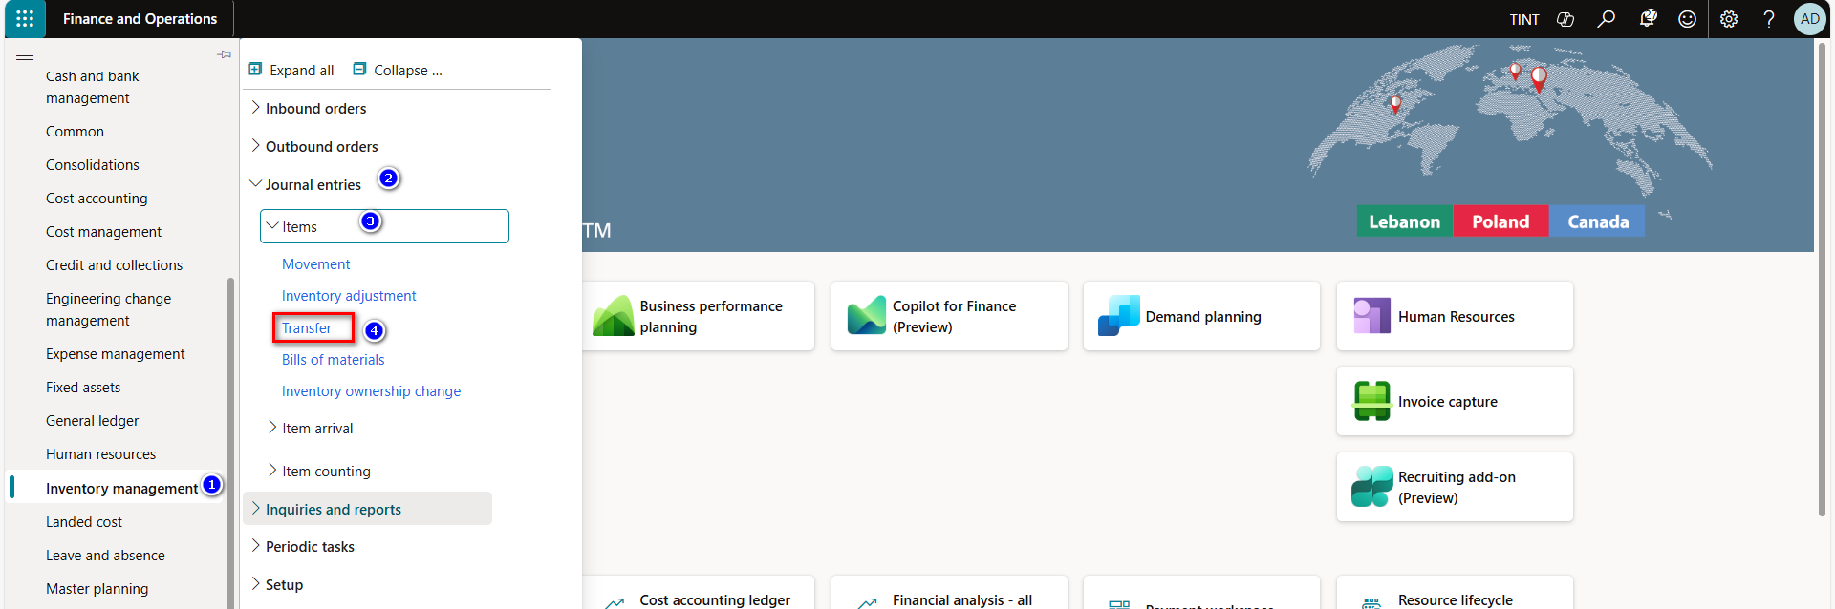

1. Click New, to create new transfer journal.
2. In the journal lines Fast tab, click New to create a new line.
3. Select and specify the Item number and Quantity that would be transfer from warehouse to another.
4. In the from site field, select the site.
5. In the to site field, select the site.
6. In the from warehouse field, select the warehouse.
7. In the to warehouse field, select the warehouse.
8. In the location to, select the production floor (Prod-In)
9. In the location from, select BULK
10. Click on Post, to post the quantity.

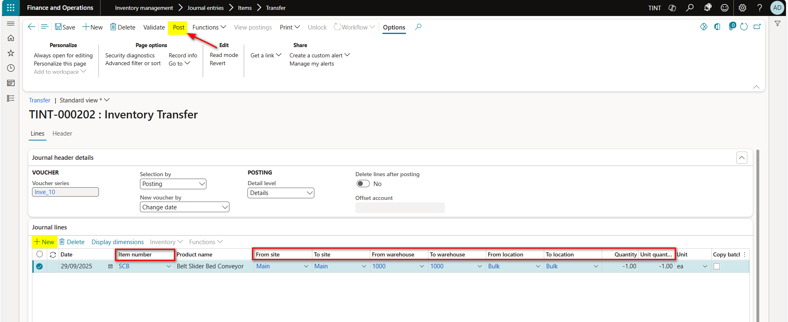

# Revision Cases

In case a BOM revision is released, the following needs to be applied. Note that manufacturing a semi-finished or a finished product follows the same process.

1. Before firming a planned production order, any modification or revision for the item BOM will be taken into consideration upon running master planning again.
2. New BOM revision **before** ending the production order (New item added to the BOM):

- Create new picking list journal, add the newly consumed items then post the picking list. This ensures that the items added after the BOM revision are consumed in the production order.

**OR**

- Add the item to the **production BOM** and run Master planning

- If the item is a purchased component, a planned purchase order will be created by the system to meet the requirement.

- If the item is a manufactured part, a planned production order will be created by the system to meet the requirement,

- If the item is available in stock, it will be added to the work upon release to warehouse process.

**AND**

- Adding an operation (for example if additional bending or additional finishing are needed) during the production process is feasible & follows the same process explained for operations.

1. If the technician realized that the production order has a fault, enter an error quantity when posting the report as finished journal (This step is needed so the system is notified that an item in this production order is fauly and cannot be used anymore) and run MRP again. This will create a new planned production order linked to the parent production order automatically.
2. New BOM revision **after** ending the production order: New item added to the BOM:

* Create a new production order
* Specify a production pool (rework Factory or rework design)
* The BOM (after revision) will be inherited to the production order
* If the produced item is damaged, the production clerk needs to consume that item, by adding it to the new BOM or a stock adjustment is required.

For example, while manufacturing item POIU, it got damaged so we need to create a new item with a reviewed BOM. When creating the production order, the BOM is inherited but we also need to consume the damaged POIU that we manufactured for 2 reasons:

Consume the cost

Correct Inventory transactions

* In case this subassembly is usable, a stock transfer is required to keep it in inventory.

1. Removing an item from the item BOM (new BOM Version released):

* Remove the item from the production BOM if it is not consumed yet.
* In case Picking list is posted, the cost of the item to remove is already incurred.

# Production control reports and workspaces

## Production floor management

Production floor management is a helpful workspace to check the status of the jobs, to reassign jobs and to toggle priorities (change sequence in the grid).

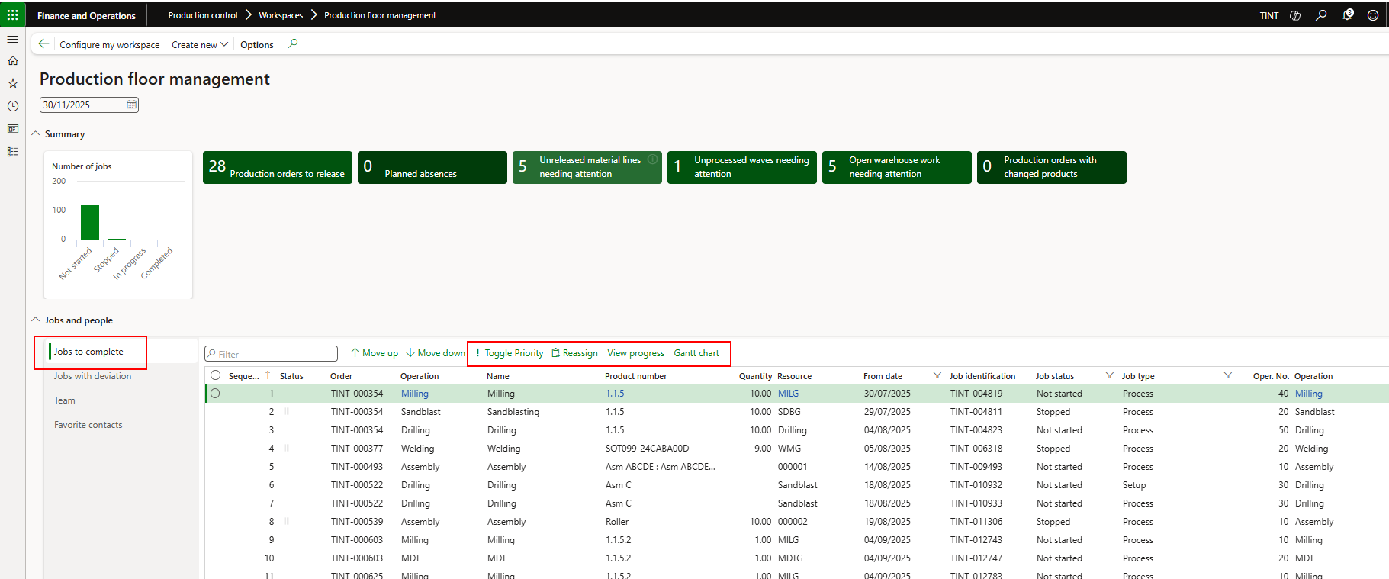

Production floor management also helps you to check the jobs with deviation. Meaning the jobs that deviate from the estimated consumption, quantity, hours.

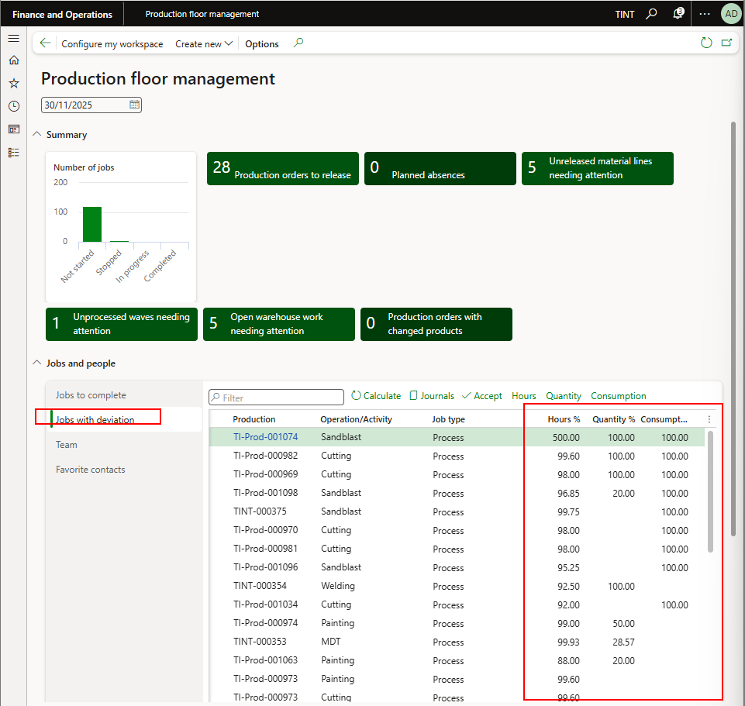

Calculate jobs with deviation

When pressing calculate on the jobs with deviation grid, a dialogue will open where the user needs to specify a start and end date for the details in the grid, an hour, quantity, and consumption threshold after which the system will not consider in the grid.

Formula to calculate = Absolute value ((Estimated – actual)/ Estimated)

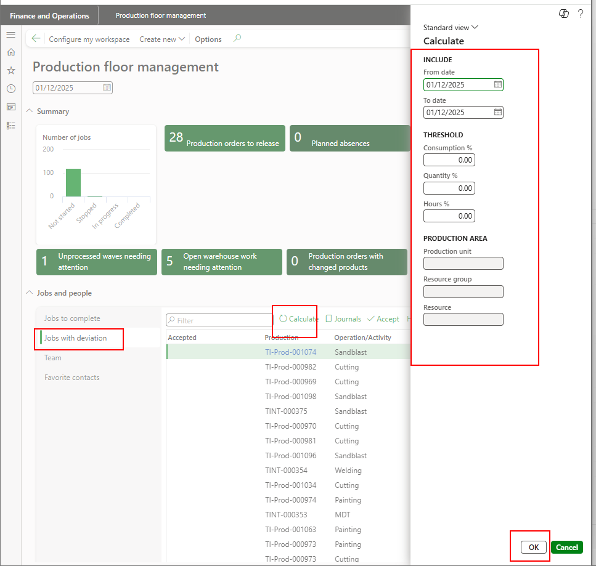

## Productions started

It shows the production orders that are started but not reported as finished yet.

Production control > production order > Productions started

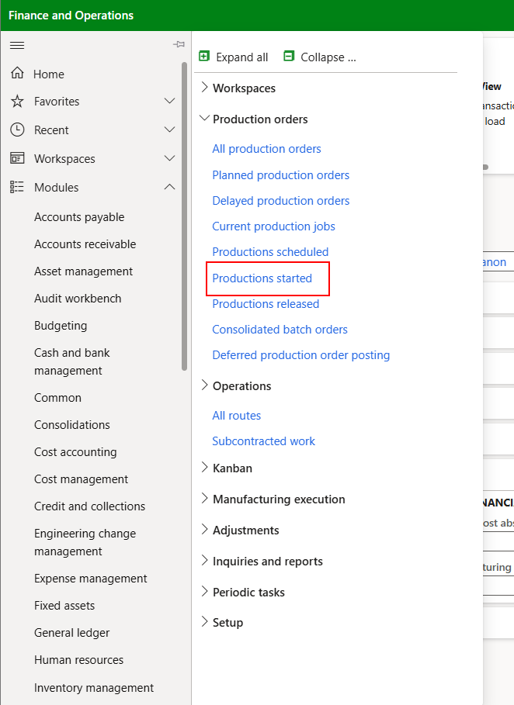

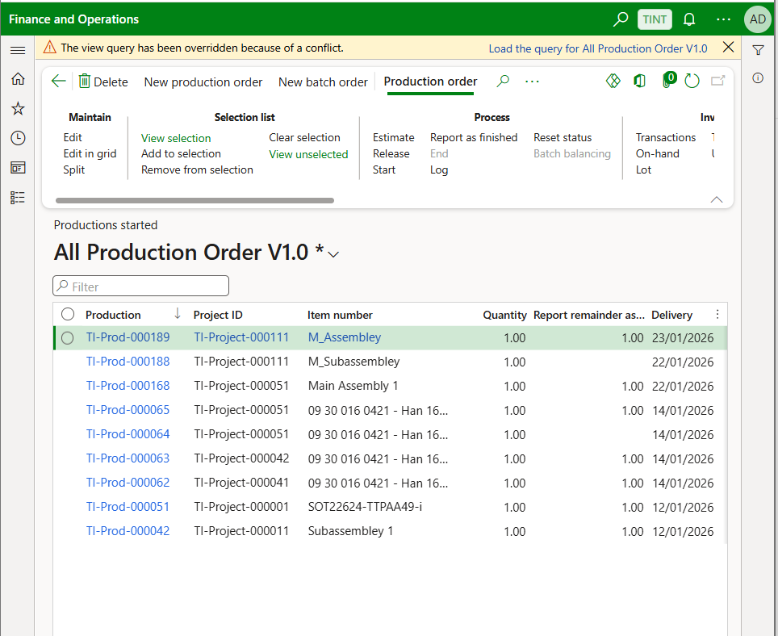

## Current production job

It shows the jobs that are started. By jobs, it means that the production order is scheduled and started.

Production control > production orders > current production jobs

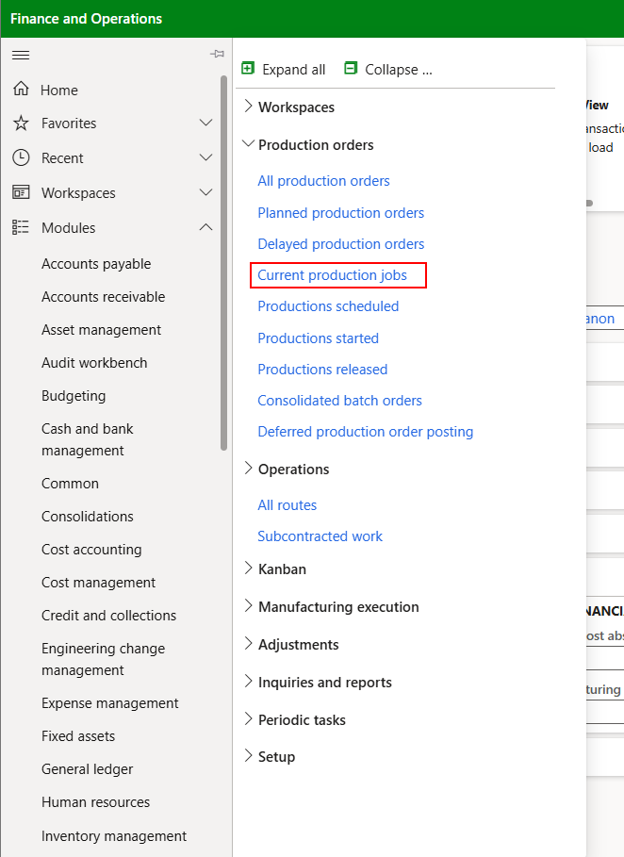

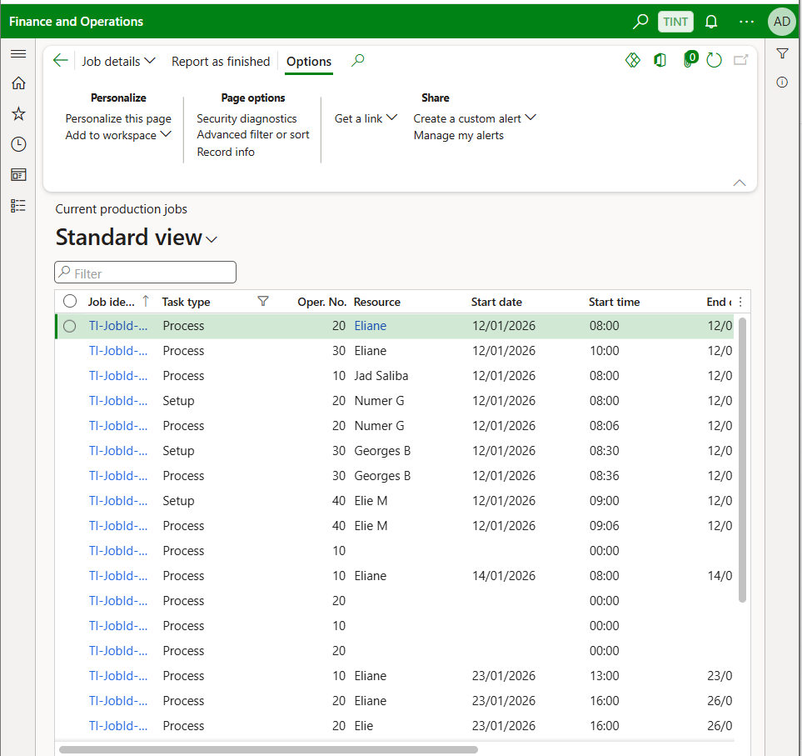

## Delayed production orders

Shows the production order where the delivery date is less than today’s date.

Production control > production orders > delayed production orders

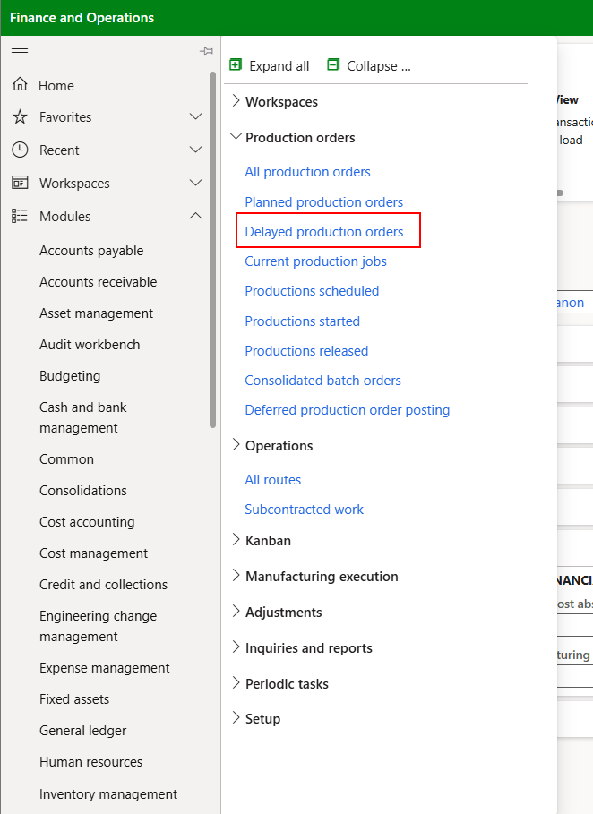

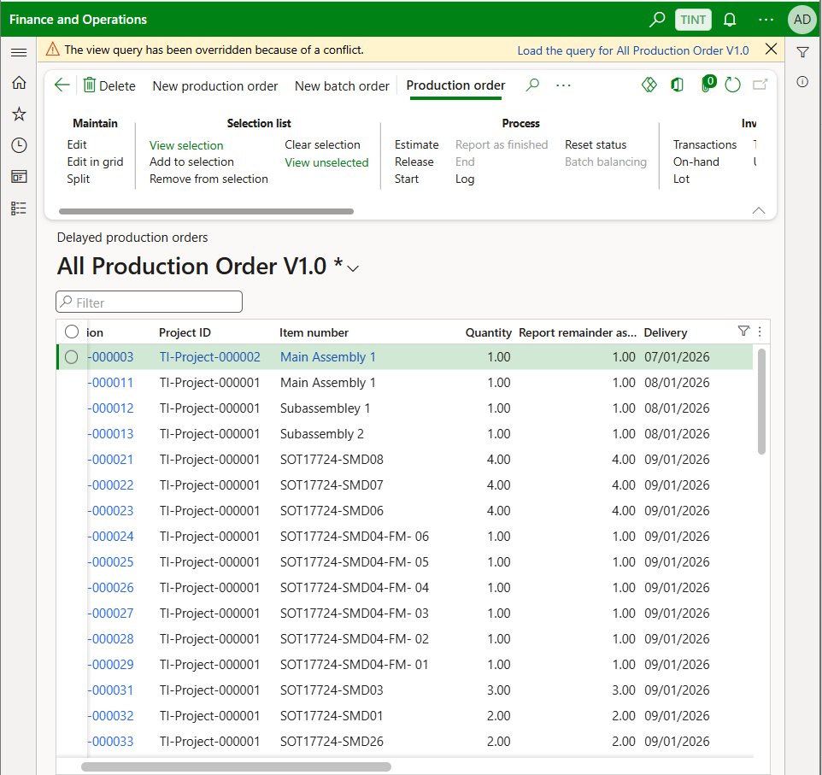

## Cost estimates and costing

This report provides detailed information about the estimated and actual costs associated with production batches or production orders. It breaks down material, labor, and overhead costs to help compare the planned versus actual production expenses. It is also used by production and finance teams to analyze cost variances, control production spending, and ensure product costing accuracy. It helps management evaluate whether the actual manufacturing cost aligns with expected cost estimates.

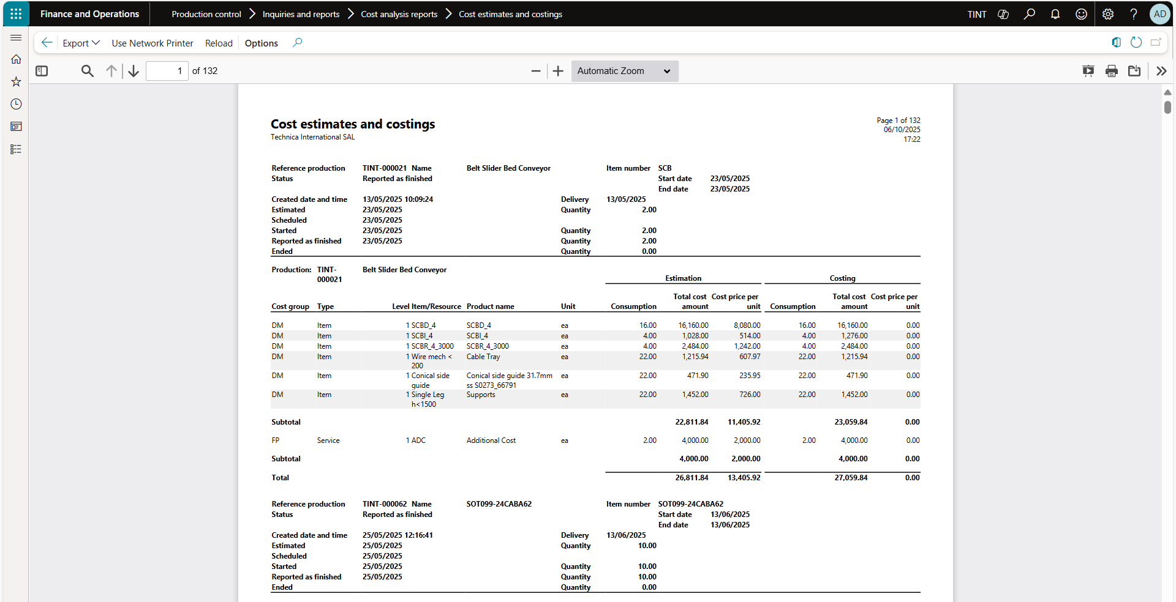

## Overview costing report.

The Overview Costing report provides a summarized view of production order costs, including estimated, realized, and remaining costs. It allows users to monitor cost performance across for a production order.

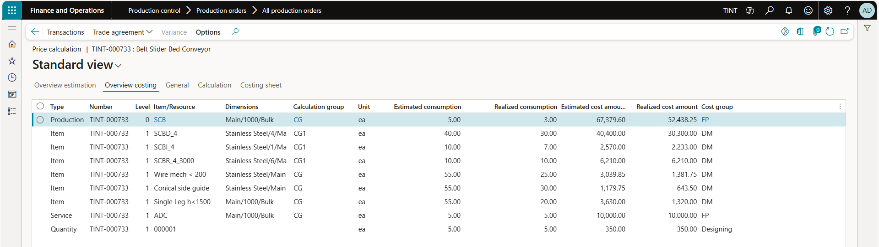



## Capacity reservation screen and report.

This report displays information about resource capacity that has been reserved for current or upcoming production orders. It shows details such as resource group, operation, order number, and the duration of reserved time. Used by production planners and schedulers to review workload distribution and identify available capacity. It supports better resource planning, helps prevent overbooking, and improves production scheduling accuracy.

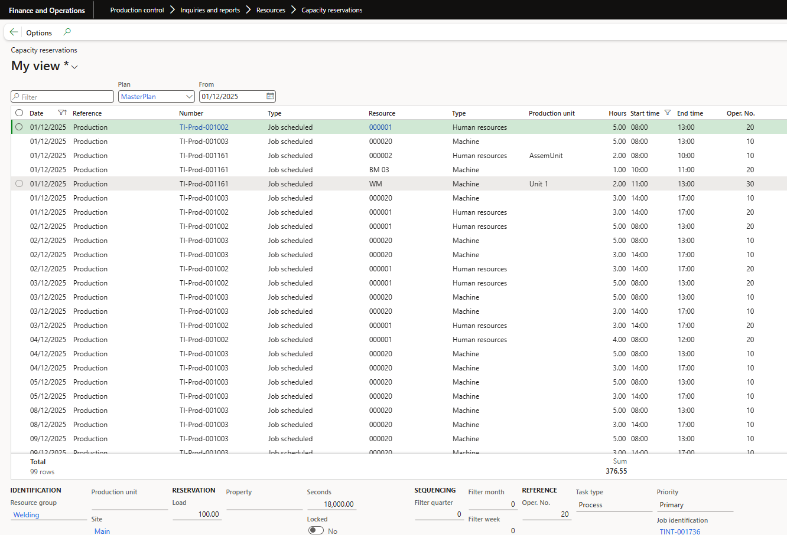

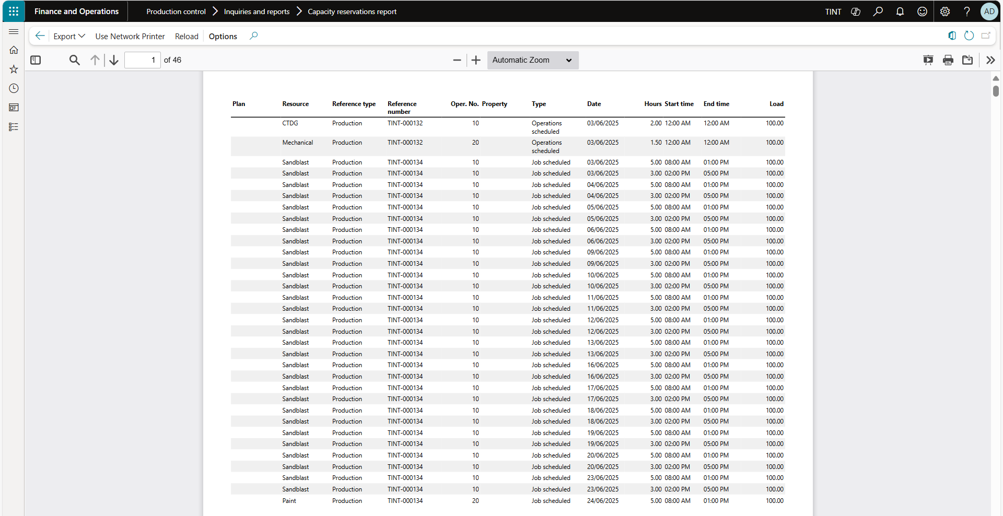

## Production overview.

This report provides a summary of all production orders within a selected period or status. It includes details such as order number, item, quantity, status (Created, Released, Started, reported as finished, Ended), and progress information. Gives production supervisors and planners an overview of current production activity. It’s ideal for tracking the status of orders, monitoring workflow progress, and ensuring timely completion of manufacturing tasks.

